Thomas Berry Manchester
Season of Creation
Summer 2022

Only One Earth
by Kelvin Ravenscroft ©

Photograph by Porapak Apichodilok
www.pexels.com
“The human venture depends absolutely on this quality of awe and reverence and joy in the Earth and all that lives and grows upon the Earth. As soon as we isolate ourselves from these currents of life and from the profound mood that these engender within us, then our basic life-satisfactions are diminished.”
- Thomas Berry in ‘The Great Work’
Photograph by Nadi Lindsay
www.pexels,com
Sunday 5 June 2022 was World Environment Day, hosted by Sweden, the theme of which was ‘Only One Earth’.
The foundation of the Day was the recognition and affirmation of the perspective that:
“In the Universe there are billions of galaxies.
In our galaxy are billions of planets.
But there is only one Earth.”
This document was written during the period June to August 2022, summertime (in the northern hemisphere), and it aims to reflect upon a range of, for example, ecological, aesthetic, literary, and spiritual perspectives and it considers ways in which individuals, groups and communities can respond creatively to the challenges and opportunities which face the world today.
This is the first significant Thomas Berry Manchester (TBM) mailing of 2022, and it follows the document I sent out to the TBM group during December 2021.
In this summer 2022 document I revisit some material, the reflections, which I have incorporated into TBM mailings during the period September 2015 to December 2021. However, this material is complemented by, and incorporates, newly written material which builds upon what I have written and shared previously. Much of the material that I have shared with the TBM community since 2015 is incorporated into a book exploring Contemplative Education which I have been writing during the past ten years or so. Hence the rationale for all the documents that I have shared with TBM over the years being copyright by, and to, me.
This TBM Summer 2022, in effect, explores perspectives, ways of seeing and being, which respond to the Earth Day declaration presented above:
“In the Universe there are billions of galaxies.
In our galaxy are billions of planets.
But there is only one Earth.”
It can be suggested that this statement provides a clear and concise summary of Thomas Berry’s Ecozoic vision and his understanding of the Universe Story. To unpack, to consider the meaning(s) of this statement, can be regarded as providing us with an entry point into Thomas’ philosophy.
This document aims to make connections with, a range of other perspectives including, for example, from artists, scientists, philosophers, and writers.
This TBM Summer 2022 document, therefore, represents an interdisciplinary approach and, from a teaching and learning perspective, it articulates a cross-curricular philosophy and pedagogy.
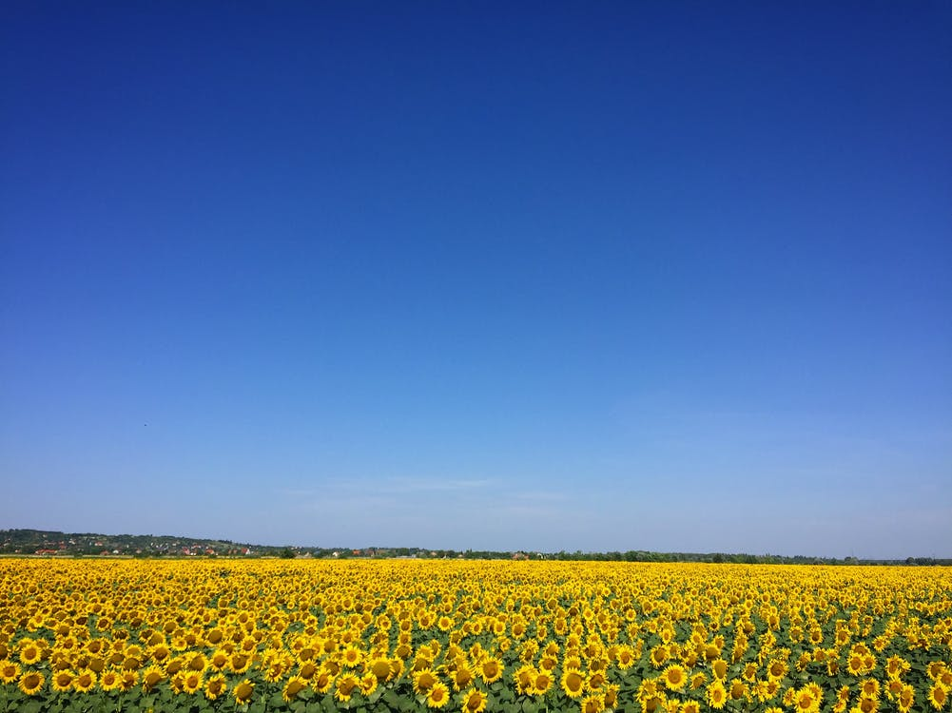
Photograph by K Zoltan
www.pexels.com
Alongside perspectives from Thomas Berry this document explores ways of seeing from artists Edel Adnan, Vincent Van Gogh, and David Hockney, music from Jan Kaczmarek, philosophy from Martin Buber, ecology from James Lovelock, spirituality from Patriarch Bartholomew and pedagogy from Janusz Korczak and Vasily Sukhomlinsky, who are all complemented by a chorus of those to whom it is possible to ascribe the term ‘Ecozoic’, which is a word used by Thomas Berry to refer to an era, and people, who develop and affirm the values and actions which bring about such an era, in which humankind lives in a harmonious relationship with the Earth and its glorious abundance and diversity of life.
Photograph by Robert Nickson www.pexels.com

Reflection 1:
A Year in Normandie 2020-2021

In previous Thomas Berry Manchester (TBM) newsletters I have explored the paintings that the Bradford-born artist David Hockney created during the coronavirus pandemic from his base in Normandy, France.
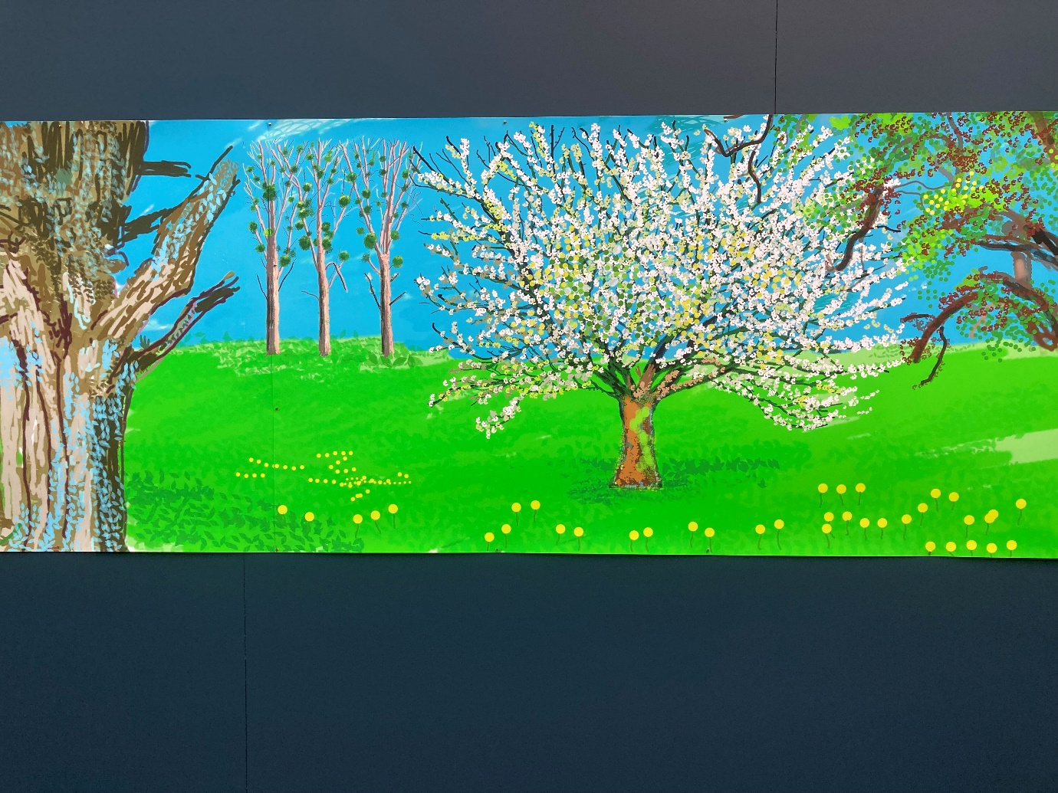
David Hockney from ‘A Year in Normandie 2020-2021
Photograph by Kelvin Ravenscroft
During early April 2020, Hockney contacted the BBC’s Art Correspondent Will Gompertz to share with him news of ten of his current paintings undertaken during the pandemic ‘as a respite from the news’. Hockney had shared some of his paintings with friends who responded that they were uplifted by his work and, during 2021, a major exhibition of Hockney’s portfolio of Normandy paintings was held at the Royal Academy, London. For many people, these vibrant, colourful, and life-affirming paintings provided a deep sense of peace, solace, and inspiration during the dark days of the coronavirus pandemic.
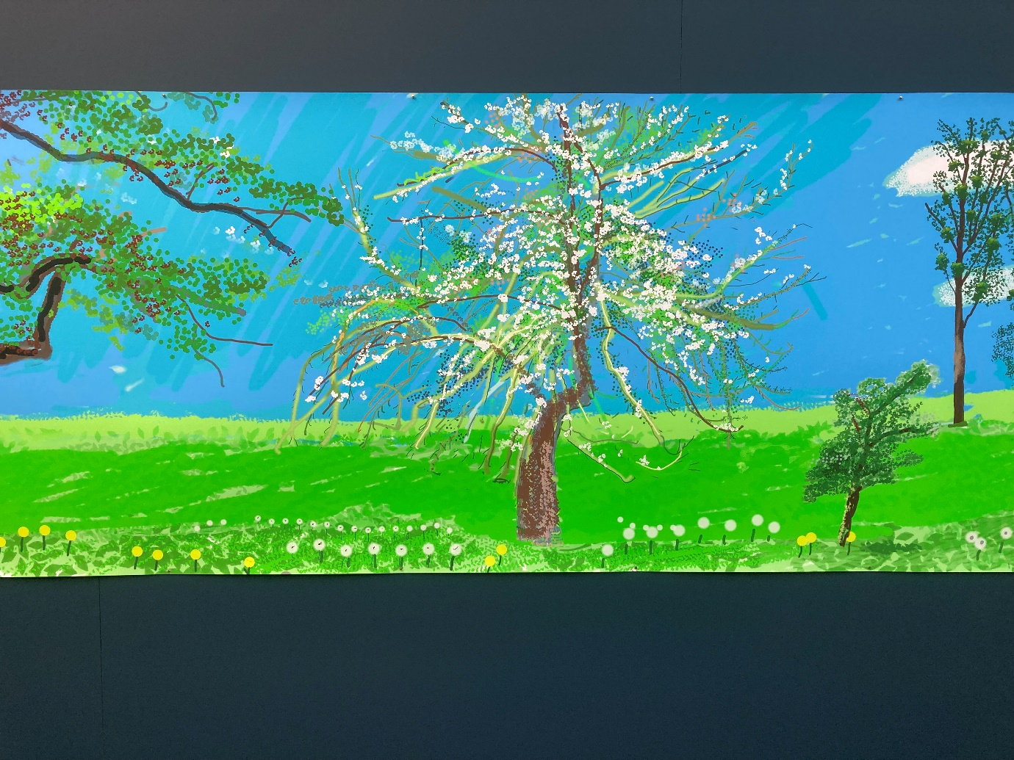
David Hockney from ‘A Year in Normandie 2020-2021
Photograph by Kelvin Ravenscroft
The artworks celebrated the restorative power of nature and, indeed, were in harmony with the experience of many, who, during covid restrictions and isolation, found that spending time in the natural world was a deep source of support, encouragement, and motivation.
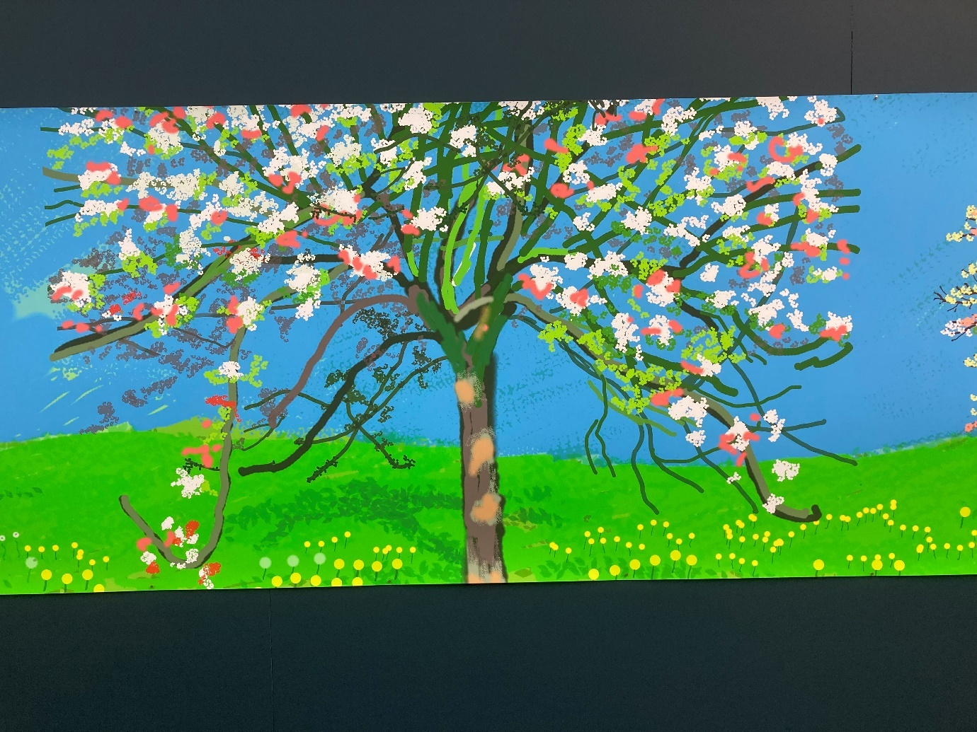
David Hockney from ‘A Year in Normandie 2020-2021
Photograph by Kelvin Ravenscroft
In effect, Hockney was reminding us that, however challenging the cold, and often bleak, days of winter may be, in due course the Spring always returns.
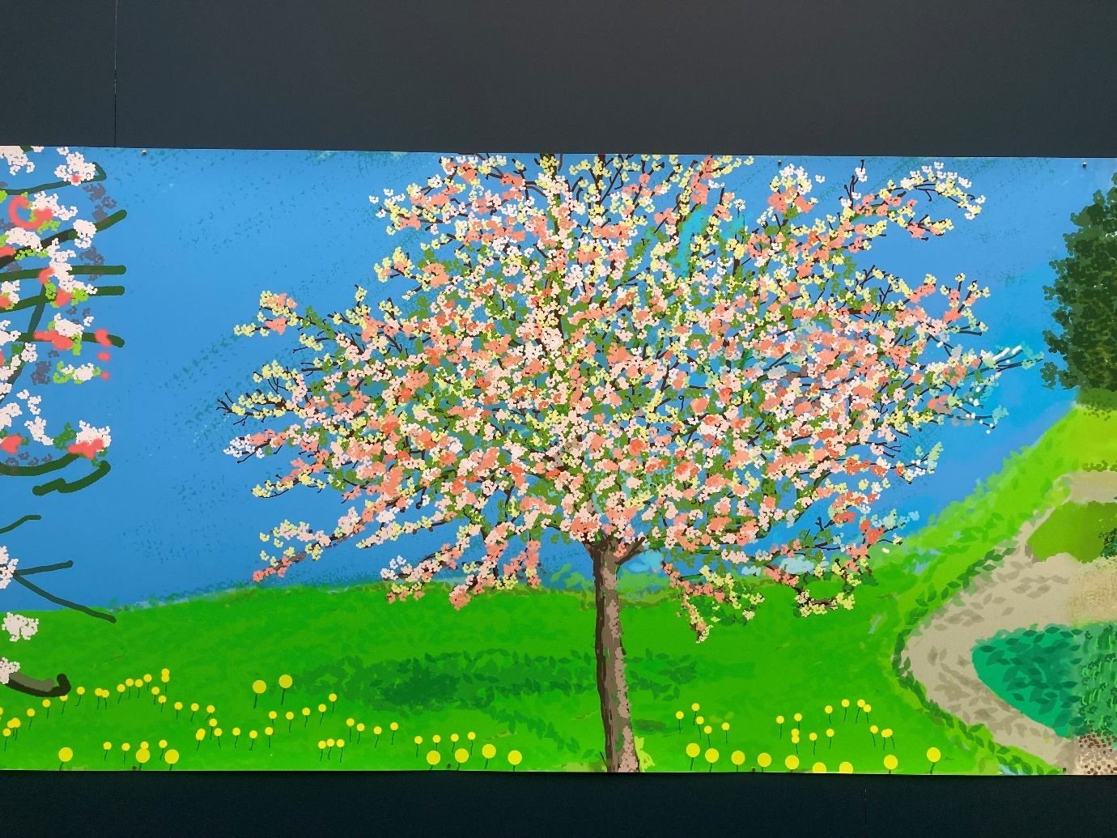
David Hockney from ‘A Year in Normandie 2020-2021
Photograph by Kelvin Ravenscroft

His Normandy paintings, therefore, affirm the power of the life-impulse in all its glorious diversity and nature’s deep fecundity which, throughout the ages, painters, sculptors, poets, playwrights, musicians, composers, and actors, for example, have striven to express their responses to the natural world, their ways of seeing the Earth, which can, in turn, inspire and empower us to reflect upon questions of meaning, value, and purpose. We can be led to reflect upon, for example, what is it that we find in nature that uplifts and restores us? Where are those places and spaces which nurture us? In what ways should we respond to the glorious, abundant diversity of life forms which depend upon the Earth for their very existence? In what ways can humankind live in harmony with nature and what does it mean to be an Earth citizen or what Satish Kumar has termed an ‘Earth Pilgrim’?
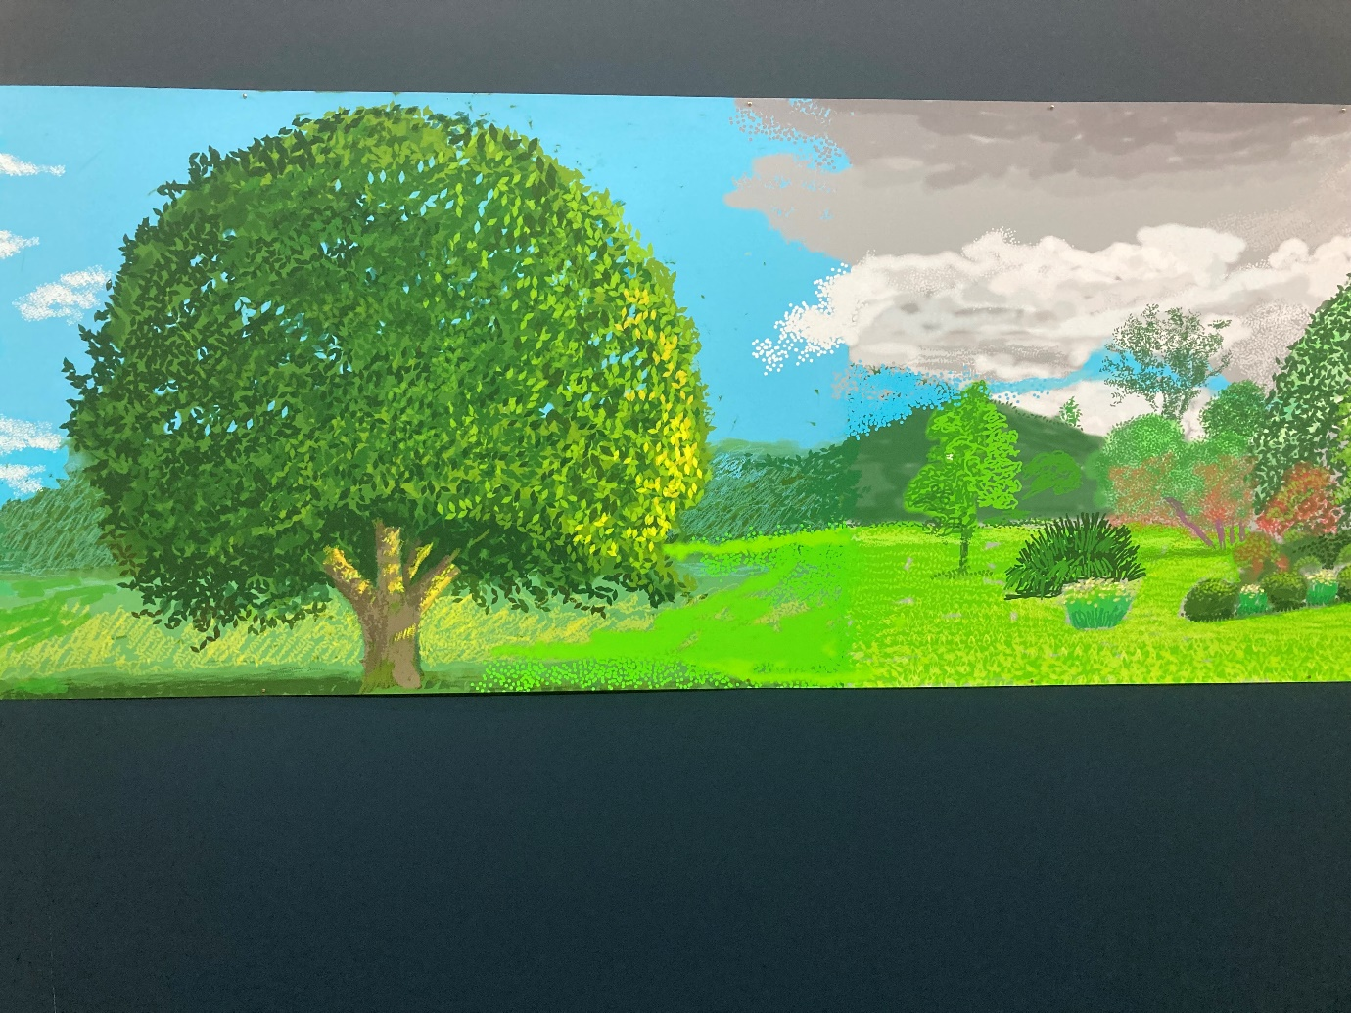
David Hockney from ‘A Year in Normandie 2020-2021’
Photograph by Kelvin Ravenscroft

In what ways can we travel lightly on the Earth showing our respect, reverence, appreciation, and thanksgiving for the gift we have, indeed, the privilege, of being temporary residents, passing visitors, who are able to experience the very miracle of being?
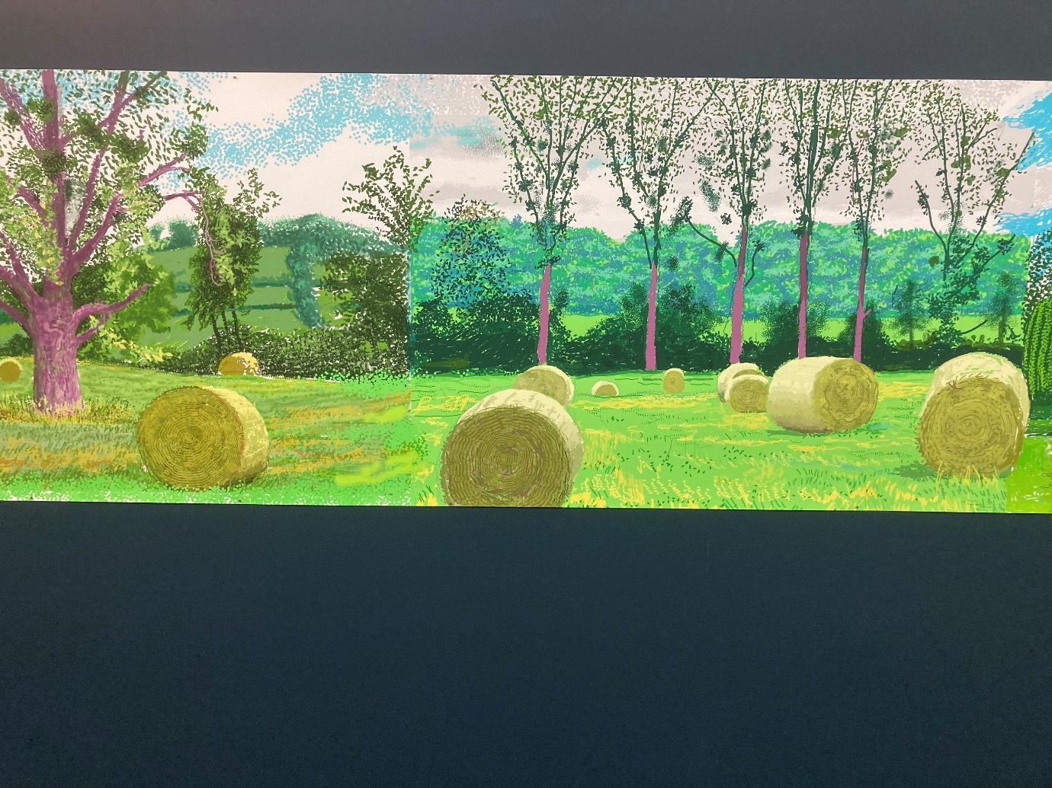
David Hockney from ‘A Year in Normandie 2020-2021’
Photograph by Kelvin Ravenscroft

From 4 May to 18 September 2022, Salt’s Mill, in Saltaire, England, are exhibiting David Hockney’s ‘A Year in Normandie 2020-2021’ work which is his largest ever painting. It measures 90,75 metres long and is a composite iPad painting which presents a joyful, vibrant, and energetic celebration of the changing seasons of Hockney’s home in Normandy.
Upon recently viewing this majestic work, I was overwhelmed by the sheer size of the project. It is, indeed, a major undertaking and it suggests how Hockney must have been deeply immersed in a detailed observation of the changing seasons. As I viewed the artwork, I had a very clear sense that Hockney’s creation is, in a sense, a deeply contemplative work; it takes us on a journey through the seasons and invites us to stop, to look closely, to pay attention, and to soak in, to immerse oneself, in the changing colours of the natural world as the seasons unfold.

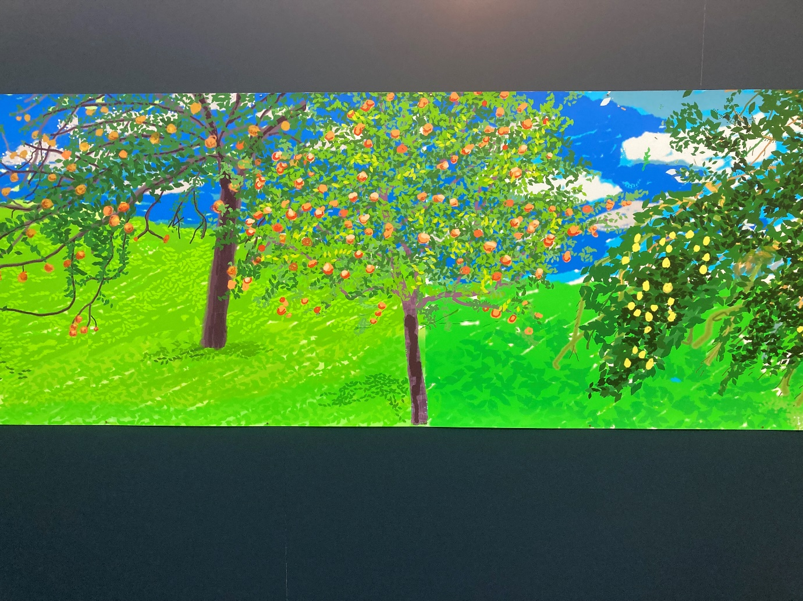
David Hockney from ‘A Year in Normandie 2020-2021’
Photograph by Kelvin Ravenscroft

The 2022 Earth Day declaration presented earlier in this document states that:
“In the Universe there are billions of galaxies.
In our galaxy are billions of planets.
But there is only one Earth.”
I suggest that in his ‘A Year In Normandie 2020-2021’ artwork, Hockney is testifying to the glorious gift, the privilege, of being human, having the miraculous experience of being born into a sacred universe in which each of us can play our part in manifesting love, compassion and beauty.
Reflection 2: Gaia
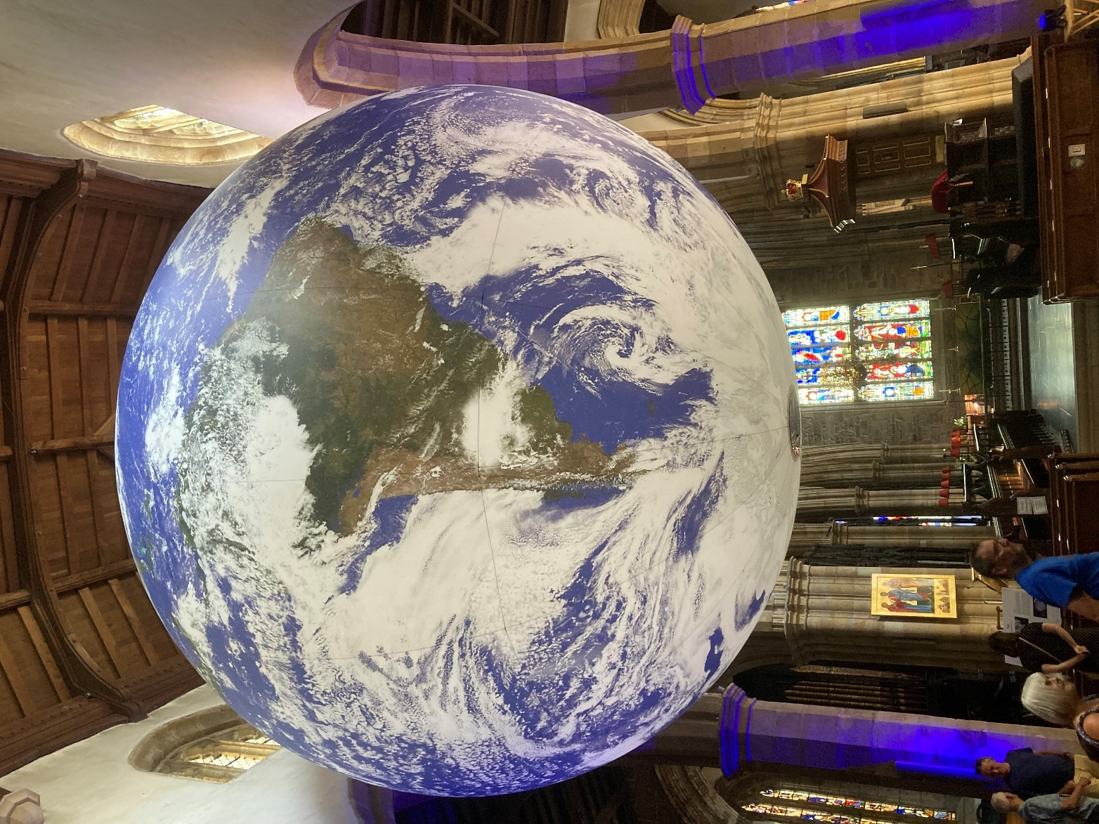
‘Gaia’ by Luke Jerram
Lancaster Priory, July 2022
Photograph by Kelvin Ravenscroft

From to July 2022 Lancaster Priory exhibited Luke Jerram’s installation ‘Gaia’. This work was hung above the nave of the Priory and, as one entered this place of worship, one could not help but be struck by its sheer size, seven metres in diameter.
There was a very real sense in which it did not seem to be incongruous to encounter such an installation in this place. Visitors were free to experience ‘Gaia’ in their own ways. Some walked around the Priory viewing it from different angles whilst, at times, some people sat quietly and looked carefully at the detail of ‘Gaia’. As I sat and contemplated this work, I inevitably began to reflect upon how this installation related to, and connected with, other features of the Priory.
I sat for some time in the pews in the right-hand side of the Nave, a vantage point from where I was able to observe an icon to the left of ‘Gaia’. This icon is presented below.
The word ‘icon’ means ‘image’ and, in the Christian tradition, it refers to representations of, for example, Jesus, Mary and the Saints. An icon is not, ultimately, an artwork and, indeed, icons are not ‘painted’ in the sense that an artist might usually paint, for example, a portrait, landscape or still life. Instead, icons are ‘written’ and they are created alongside the rhythms of prayer and worship. Icons, therefore, are grounded and rooted in the spiritual life of the icon writer.
Ultimately, icons are regarded as pointing beyond themselves, to the Divine, the Eternal, God. In effect, they are what I term ‘vehicles of Transcendence’.

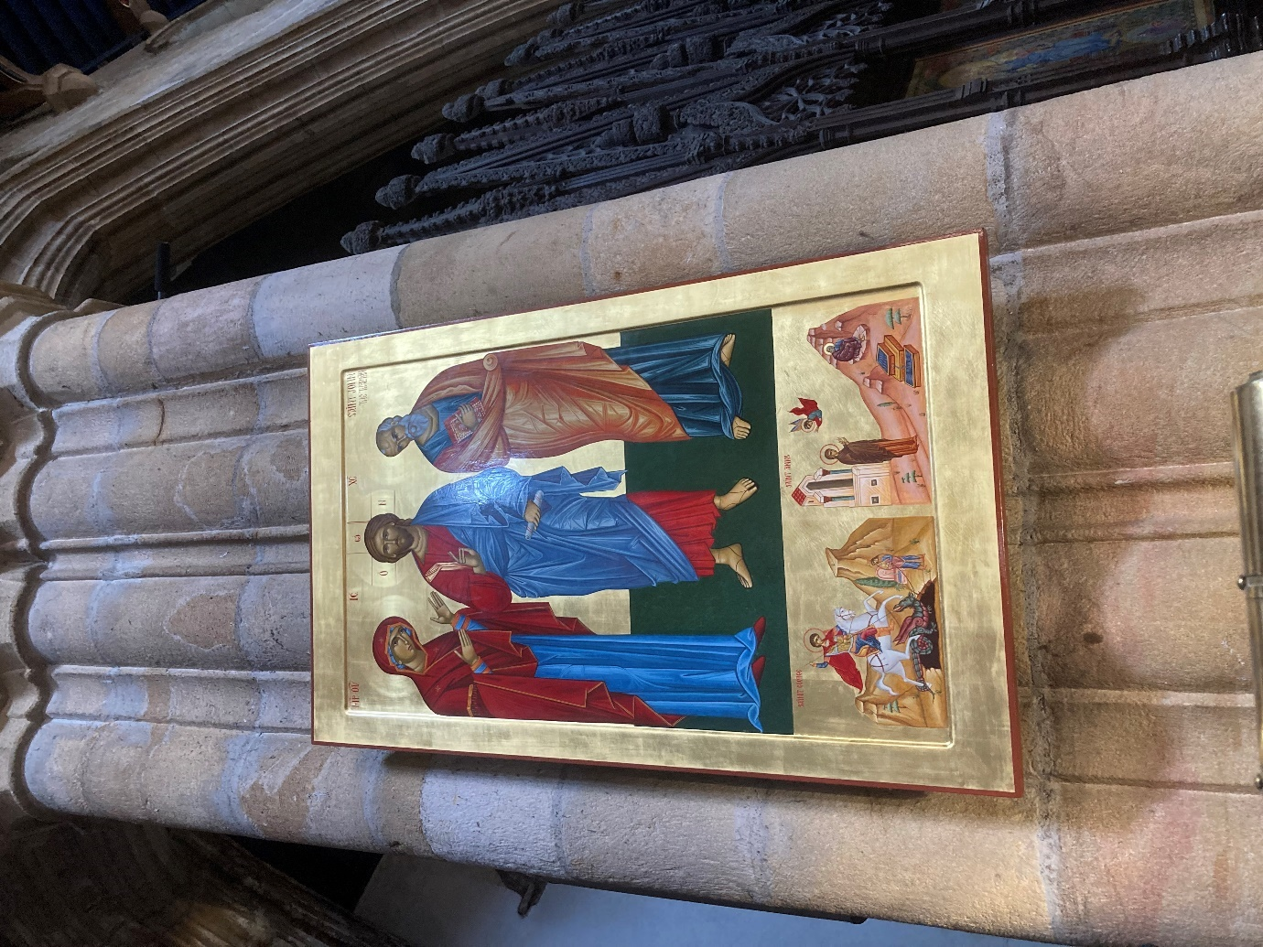

Icon, Lancaster Priory
Photograph by Kelvin Ravenscroft

There is a misconception that icons are worshipped particularly as those who approach them show deep reverence and respect, often accompanied by kneeling before the icon, kissing the icon, and saying prayers as one gazes upon the icon.
The icon, the image presented, points beyond itself; it can be thought of as being a door to the Infinite. Icons, therefore, inspire and encourage contemplation, reflection, meditation, and prayer and they can act as a focus for these spiritual disciplines.
As I sat in the Priory, I found myself making connections between the icon and the ‘Gaia’ installation. I have suggested above that icons point beyond themselves; they evoke the experience of a deeper reality. Through the icon writer’s creative activity, immersed in prayer, there is the potential and possibility to experience and encounter the Divine reality.
Luke Jerram’s ‘Gaia’ installation can, I suggest, be regarded as a creative work which also facilitates reflection upon deep issues such as, for example, how do we respond to the Earth? How can we live on this planet, our home, alongside billion other humans and countless billion forms of other than human life in such a way that this magnificent diversity is able to blossom and flourish? How is it possible to live in what Thomas Berry has termed an ‘Ecozoic’ way of being? The Ecozoic age can be thought of as being an emerging new way of seeing and being, an era in which humankind recognises the damage they have done to the Earth and its sensitive and interrelated ecosystems, which then leads to the development of a respectful and reverential approach to Nature alongside the cultivation of ways in which humankind can live in ecologically sustainable ways which promote harmony and mutual flourishing. Luke Jerram’s ‘Gaia’ encourages the viewer to be sensitive to the fragility of the Earth.
Whilst people viewed ‘Gaia’, in the background were audio recordings which explored the experience of astronauts as they gazed upon the Earth from space. Many astronauts have described their profound experience of viewing the Earth. For example, Edgar Mitchell (1930-2016) who, in 1971, was the Lunar Module Pilot of Apollo 14, spent nine hours walking upon the surface of the Moon. Mitchell experienced what he described as “an explosion of awareness and a profound sense of interconnectedness accompanied by ecstasy… an epiphany”.
For Mitchell, his experience of observing the Earth from space was truly life changing. It resulted in a significant change in his perception, his way of seeing, the world. This shift in his way of seeing, however, did not only refer to his visual experience of viewing the Earth, it also related to a change in his consciousness. Mitchell commented:
“You develop an instant global consciousness, a people orientation, an intense dissatisfaction with the state of the world, and a compulsion to do something about it. From out there on the moon, international politics look so petty.”
In effect, therefore, Mitchell’s observation of the Earth from space, put things into perspective. The everyday business of politics, for example, in his transformed view was relatively unimportant and insignificant in comparison to the altered perspective, which gave rise to a new vision, quite literally, a new world view, which arose from his ecstatic experience. ‘Ecstatic’ can be defined as ‘feeling or expressing overwhelming happiness or joyful excitement’ as well as ‘involving an experience of mystic self-transcendence’. The first definition illustrates that to experience ecstasy is a powerful emotional state characterised by highly positive feelings. The second definition incorporates language which can be termed broadly ‘spiritual’ in that it connotes an experience in which one’s sense of self is perceived as being part of, included and integrated into that which is greater than, and beyond, oneself. Such an experience can result in what William James, in his seminal work ‘The Varieties of Religious Experience’ has described as having a ‘noetic quality’ which he articulates as follows:
“Although so similar to states of feeling, mystical states seem to those who experience them to be also states of knowledge. They are states of insight into depths of truth unplumbed by the discursive intellect. They are illuminations, revelations, full of significance and importance, all inarticulate though they remain; and as a rule they carry with them a curious sense of authority for after—time.”
It can be suggested, therefore, that Edgar Mitchell’s experience of viewing the Earth from space can be regarded as having a significant noetic dimension as it profoundly transformed his understanding, his weltanshauung, his world view, his philosophy of life. Indeed, so profound was Mitchell’s experience in space that following his return to earth he founded the Institute of Noetic Sciences whose mission is to “reveal the interconnected nature of reality through scientific exploration and personal discovery.”
William James also explored what he termed the ‘ineffable’ quality of extraordinary, transformative experiences. ‘Ineffable’ can be defined as ‘too great or extreme to be expressed or described in words.” Ultimately, if an experience is regarded as being ‘ineffable’ it is, in a very deep sense, ‘beyond words’, in which we reach the limits of language to articulate what is seen, experienced or perceived.

Edgar Mitchell shared his experience of viewing the Earth from space:
“Suddenly from behind the rim of the moon, in long, slow-motion moments of intense majesty, there emerges a sparkling blue and white jewel, a light delicate sky-blue sphere laced with slowly swirling veils of white, rising gradually like a small pearl in a thick sea of black mystery.”
The astronaut James Irwin (1930-1991), who served as the Lunar Module Pilot for Apollo 15, described his space experience in these words:
“The Earth reminded us of a Christmas tree ornament hanging in the blackness of space. As we got farther and farther away it diminished in size. Finally, it shrank to the size of a marble, the most beautiful marble you can imagine. That beautiful, warm, living object looked so fragile, so delicate, that if you touched it with a finger, it would crumble and fall apart. Seeing this has to change a man, has to make a man appreciate the creation of God and the love of God.”
Irwin’s experience of seeing the Earth from space articulates a theological perspective, he interpreted his experience in space in the light of his Christian faith. Earlier in this reflection I have commented upon the concept of icons. From the perspective of Eastern Orthodox Christianity, John Chryssavgis has observed that for the spirituality of the Ecumenical Patriarch Bartholomew, often described as the ‘Green Patriarch’, “The environment is not only a political or technological issue: it is…primarily a religious and spiritual issue. Patriarch Bartholomew invariably relates the environment to a familiar aspect of Orthodox spirituality, namely to the icons that decorate Orthodox churches. Symbols are important in Orthodox thought, worship, and life. Creation is itself likened to an icon, just as the human person is created ‘in the image and likeness of God’ (Gen 1: 26 and Col 1:15). The Patriarch invites people to contemplate the Creator God through the icon of the created world (Col 1: 16-18).”
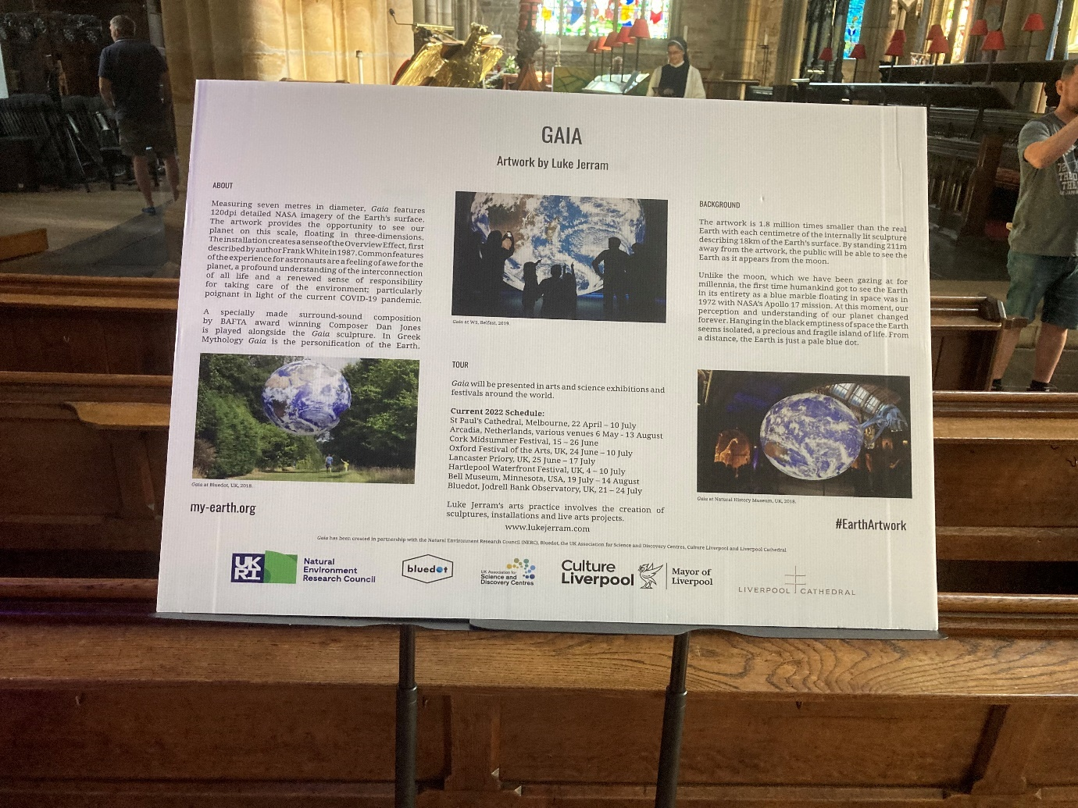
Lancaster Priory, ‘Gaia’ display board
Photograph by Kelvin Ravenscroft

Both Edgar Mitchell and James Irwin articulate, in their responses to seeing the earth from space, a sensitivity to the preciousness, the fragility, the beauty of the Earth and the mystery of space. They both express a deep appreciation of the Earth and its wonders. In effect, they present a respectful and reverential response complemented by personal humility. They are both thankful for what they have seen and experienced. Their responses are permeated with gratitude.

As I am writing this reflection, the news has been announced of the death of the scientist James Lovelock (1919-1922). He died on 26 July, his 103rd birthday. Amongst his many and varied achievements, Lovelock developed, together with the biologist Lynn Margulis, the Gaia hypothesis which maintained that the Earth is a self-regulating system which develops as a result of the interaction and the interrelationships between living organisms and their environments, their ecologies.
By naming his installation of the Earth ‘Gaia’, Luke Jerram can be regarded as testifying to Lovelock’s recognition of planet Earth as being a living being, in which a diverse multiplicity, a network of interactions, what Frijtof Capra has termed the ‘Web of Life’, is characteristic of all that exists. What takes place in one aspect of the Web of Life has consequences for what happens in other dimensions of the Web. Actions, particularly in relation to the ways in which humankind relates to, and engages with the Earth, have consequences. Climate scientists are, therefore, unequivocal in their recognition of the human impact on, for example, climate change, global heating, deforestation, and species destruction and loss.
In the light of this recognition, at this point in this reflection, I comment upon another feature which was on display in Lancaster Priory which is presented in the photograph below. The feature to which I refer I have given the name ‘Tree of Life’ for Ukraine. It presents a small tree, placed on a tablecloth which is in the colours of the flag of Ukraine. Those who stop before the tree were invited to attach prayers, wishes and reflections to it. This small prayer station installation, therefore, gently, and unobtrusively, brought to our attention that if there is hurt, suffering, conflict, loss, and grief in any part of the Earth, the whole network of the Earth’s relationships, is affected. Violence is not neutral; aggression has real consequences which can impact upon millions, even billions of people, together with the damage that war wreaks upon the Earth’s many and varied expressions of other than human life together with the Earth’s precious resources including water, plants, crops, and livestock. Indeed, the current conflict in Ukraine has clearly illustrated the reality of how the ruthless invasion of a sovereign country by an aggressor can potentially lead to the malnutrition and starvation of millions of people, many of whom live in what can be recognised as the world’s poorest countries. If any dimension of Gaia is hurt, damaged, or destroyed, there are, all too often, significant negative consequences which impact upon not only humankind but in the wider Web of Life.
As I spent time at Lancaster Priory to view Luke Jerram’s ‘Gaia’ installation, I reflected how it connected with, and related to, other aspects of this place of worship. I began to see that ‘Gaia’, ‘The Tree of Life’ prayer station for Ukraine, together with the icons on display are, in a very real sense, interconnected, interrelated, interlinked. The messages they each convey are, I suggest, congruent; they are in harmony.
Reflecting upon the passing of James Lovelock, I conclude this reflection with words from an interview presented in an article entitled ‘’I Speak for the Earth’ in the July/August 1988 issue of ‘Resurgence’ magazine in which James declared: “I sometimes wonder if this loss of soul from science could be the result of sensory deprivation. A consequence of the fact that 95% of us now live in cities. How can you love the living world if you can no longer hear birdsong through the noise of traffic, or smell the sweetness of fresh air? How can we wonder about God and the Universe if we never see the stars because of the city lights? … So let’s … keep a world that is healthy and beautiful, and that will remain fit for our grandchildren as well as those of our partners in Gaia.”

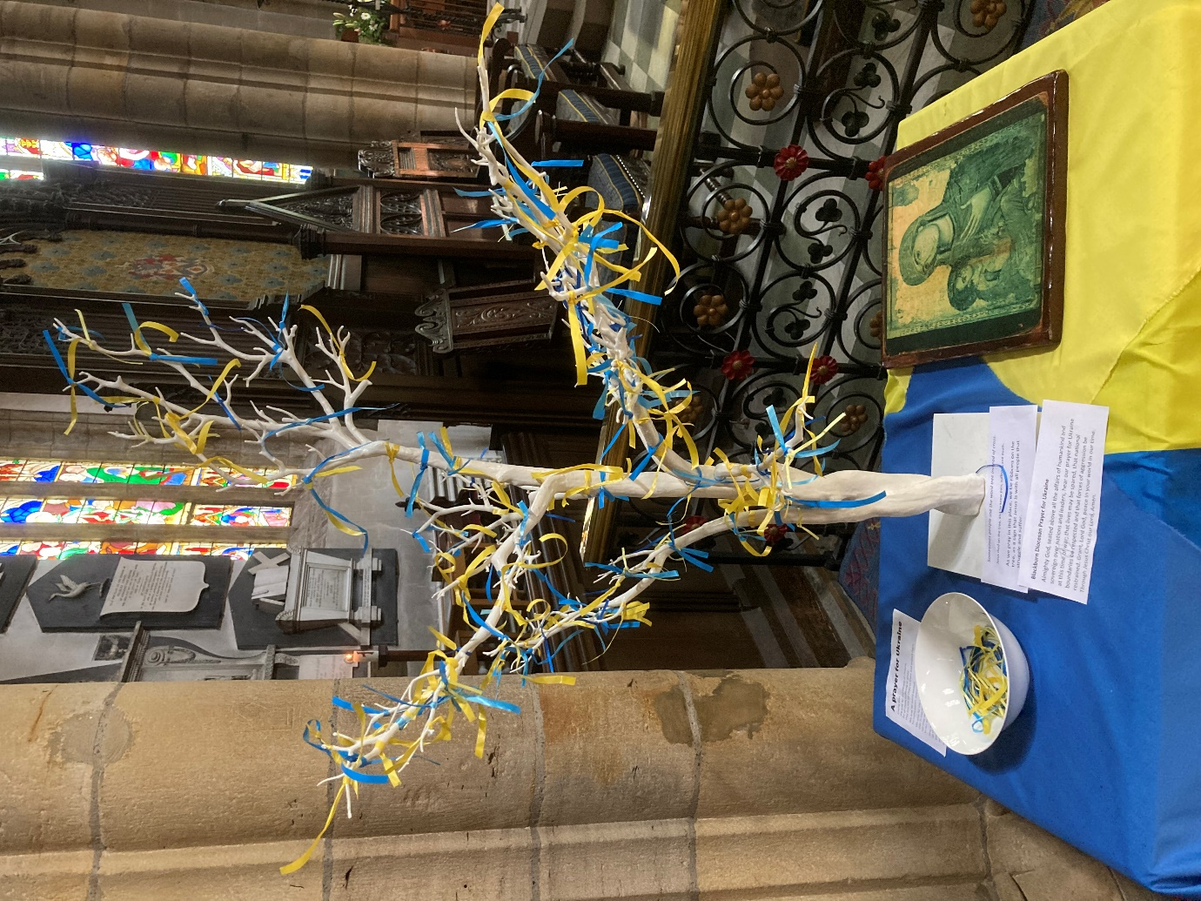

Tree of Life for Ukraine, Lancaster Priory, July 2022
Photograph by Kelvin Ravenscroft

Reflection 3: Odayaka-Ya

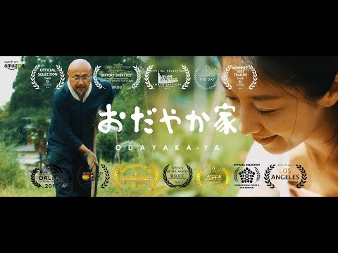

Reflection 3 explores a 2016 Japanese short film (15m 41sec) entitled Odayaka-Ya written and directed by Kazuhito Takazawa.
The film recognises that the Great East Japan Earthquake, tsunami and damage at the Fukushima nuclear plant of 11 March 2011has led, amongst many people, to a change in perspective, a re-evaluation of values and ways of living. These traumatic events which, understandably, have shaken society have raised questions about ways of living in contemporary society.
The film considers the experience of Kazu and Haru Shimazaki who move from Tokyo to Sagamiko to establish a way of living based upon growing their own food, teaching others how to grow vegetables, creating a sense of community and fostering harmony and peace.
I present below a transcript of the English translation of the dialogue which appears in the film. The transcript identifies when it is that Kazu and Haru are speaking.

Photograph by Polina Tankilevitch
www.pexels.com
KAZU:
The biggest reason would be The Great East Japan Earthquake and tsunami in Tohuku on March 11 2011.
HARU:
That’s when I started thinking that we have to act immediately. We can’t keep waiting for something to happen. We, well at least I, felt anxiety, especially towards food. What are we going to eat? Where can we find accurate information about the food we eat? It was truly frightening. It was truly frightening. This is why I spoke with Kazu and said ‘let’s move’.
KAZU:
I asked myself, ‘How are we going to eat vegetables that we can feel safe eating?’. My conclusion was that we have to grow our own vegetables. I also wanted to give these vegetables to my wife. I thought that we would never be able to escape the consumer lifestyle if we stayed in Tokyo.
HARU:
Initially, I was thinking of moving to Shikoku or Kyushu. Somewhere far. I even considered moving overseas. Then as talked together, we felt like there was something left for us to do closer to Tokyo. We considered Yamanashi, but ended up living here, in Sagamiko.

KAZU:
There’s something called ‘Team Goeman’ here. They are local farmers that share their traditional methods of making soy sauce and miso and growing vegetables. They share the traditional way of life, even with newcomers.
HARU:
Thanks to this community, we were able to find a place to live and to connect with people.
KAZU:
When we first started ‘ Odayaka-ya’ after we moved here, it was just Haru and myself. Then, people started to gather around us. Our wish was to have a small community, live peacefully, and to start something new.
HARU:
Well, the first thought I had was ‘It’s not as easy as it sounds’. Living in the countryside, in the midst of nature, and an old Japanese-style house sounded nice and easy but it takes a lot more work than I thought. But a year or two into it, we had a bit of experience. We now know how to endure the cold winter. I had never chopped wood before in my life. Now, I’m getting better each year. As a result our fields have expanded, and we are trying a lot of new things.

KAZU:
When we first started, the idea was to harvest enough vegetables to be self-sufficient. We hoped to eventually be able to share our produce with our friends and neighbours. Then, a friend told a friend, and the number of people who showed interest in what we’re doing ballooned. We had to become more active, so we expanded our fields.
So, today is ‘Daizu no inochi’ (‘Life of a soybean’) an open-farm day that we host once or twice a month. We do this at the end of June and July.
We first plant soybean seeds, grow the seedlings, and then plant the seedlings in mid-July. So right now they are blossoming, and the soybean shells are starting to form. These shells will turn into edamame around the end of September.
The point of ‘Daizu no inochi’ is to encourage all participants to have unique experiences. Please open yourselves up to the experience and have fun today.
We take the biggest and best ones and keep them to be used as seeds in next year’s batch. They will be removed and dried.
Today mainstream agriculture is industrial in nature, and they use seeds that have been bred for mass production. This way the plant grows faster, they are uniform in size, and so on. However, you have to keep buying seeds forever.

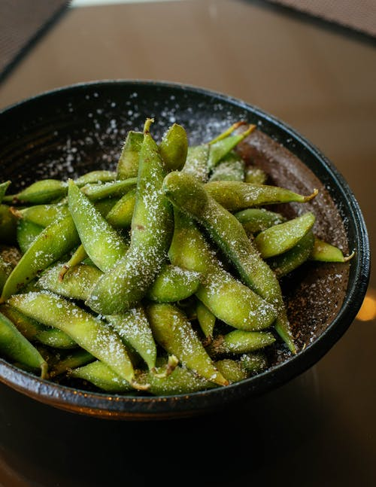
Photograph by Valeria Boltneva
www.pexels.com

{‘Edamame’ is the name given to immature soybeans in the pod which are steamed or boiled and are often served with salt or other condiments.}

KAZU:
What we do, instead, is to use traditional strains; the true breed or native species. Rather than the ‘artificial’ seeds. It’s best for the environment for us to collect seeds from our plants, re-plant these seeds, and repeat the cycle of growth.
The phrase ‘Daisu no inochi’ refers to one soybean plant but we want to plant seeds, grow seedlings, plant the seedlings, take care of them, harvest them, eat them, make miso and kinako with our friends, and so on. We aim to spread the cycle of growth throughout our activities.
HARU:
Those who have joined my cooking class would know, but the food I cook is very simple. If I had to explain why, it’s because the vegetables taste so good. It’s truly extraordinary to be able to eat vegetables that have been in the field since just a moment ago.
I have peace of mind going into the field, walking on my own two feet. Wondering how the soybean grows, touching them with my hands, smelling them, tasting them.
These experiences have made me reconsider what peace of mind and happiness are. I don’t think happiness is just a surplus of material things. It’s a great cycle.

Photograph by ‘makeafood’
www.pexels.com

{‘Miso’is soup made from soyabeans. The beans are the main ingredient in the soup and they are complemented by further ingredients such as salt, onions, tofu, seaweed, or dried kelp.}

HARU:
I feel happy that I am able to think about my existence, see the origin of our food, and experience all these things.
Kazu is just like a guide for our fields. He shows people around and I want people to eat some good food. That’s all we’re doing. Everybody around us seems to be having fun, though.
KAZU:
Slowly, but surely, I think that there are more people now who want to live a life of sharing and helping each other out. There is more harmony and I feel that we are on the right track.
Sometimes I find myself in the field, in the midst of nature, playing, relaxing, eating good food with friends, laughing, discussing … and I feel that the ‘true me’ comes out in those moments.
HARU:
When we chose the name ‘Odayaka-ya’my wish was to be more ‘odayaka’, or peaceful. I wanted my family to be peaceful. Then, and only then, would we be able to aim for a bigger peace, for world peace. These were my thoughts when choosing the name.
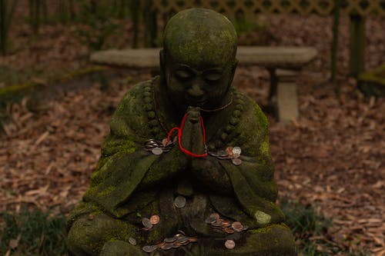
Photograph by Lefter D www.pexels.com

Kinako (Roasted soybean flour)
Photograph by Tiaa Monto
(Wikipedia Commons CCBY-SA 3.0)

{‘Kinako’ is roasted soybean flour. It is produced by finely grinding the roasted soybeans into powder. It is widely used in Japanese cuisine.}

In the film, ‘Odayaka-Ya’ (the transcript of which is presented above) Kazu and Haru share their journey from the major metropolis of Tokyo with its bustling and frantic pace of life to a rural environment, immersed in nature, where they, over time, develop a farm.
This project, although demanding, is, ultimately, rewarding because it cultivates both food and a sense of community, peace, and wellbeing. The soybeans that they nurture, in turn nurtures them through the sheer pleasure of sharing home-grown food, which comes direct from the farm to the kitchen table,
The film illustrates that the development of the farm and the growth of organic, wholesome, vegetables, is undertaken alongside activities such as yoga, chanting, making music, and sharing food with friends and neighbours.
Kazu declares: “Sometimes I find myself in the field, in the midst of nature, playing, relaxing, eating good food with friends, laughing, discussing … and I feel that the ‘true me’ comes out in those moments.”
Such a statement confirms that through his work with Haku on their food growing project, he is able to feel truly himself; he is not playing a role defined or determined by others. Instead, the work he undertakes is congruent with what, in Japanese, is known as his ‘Ikigai’.
In Japanese culture, ‘Ikigai’ is that which gives a person a sense of meaning, purpose, a reason for living. ‘Ikigai’ is made up of two words: ‘iki’ which means ‘life’ and ‘gai’ connoting ‘value’ or ‘worth’. The ‘Odayaka-Ya’ project, therefore, is a provider of meaning and purpose.
Haru comments that through the farming project she feels happy that she is able to think about her existence. The meaningful work that she undertakes with Kazu, therefore, encourages reflection and contemplation upon what is important in life.
The activities of yoga, chanting, making music, and sharing food which are undertaken alongside the farm project reflect a holistic approach to life in which peace, harmony, and wellbeing are the underlying principles.
In Reflection 1: ‘A Year in Normandie’, I explore how the artist David Hockney, through his paintings of the passing of the seasons, is responding to the coronavirus pandemic. His colourful, vibrant, and joyful artworks are a deeply inspiring example of how creativity can respond to adversity.
I suggest that the film ‘Odayaka-Ya’, gently, yet clearly, illustrates a further example of how creativity, in the work of Kazu and Hura on their farm, is a transformative manifestation of how people respond to challenging circumstances. Their transition from urban to rural living results in an enhanced sense of wellbeing, meaning and purpose.

Reflection 4: Etel Adnan-Colour as Language
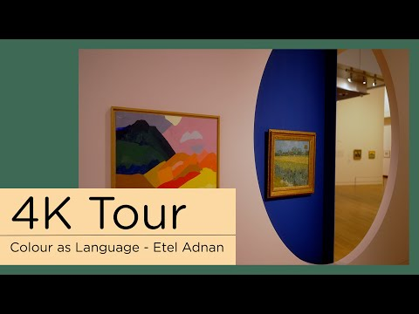

“I am very sensitive to beauty, we don’t speak of beauty anymore. We don’t mention beauty… is an inner sense, and it makes us happy. It’s not complicated. We need it.
You realise that we are in a constant change and turmoil. There is no total rest. Not only for us but for the world. Nature is also changing…like we do. The power of nature that comes to us through colour. What does colour do to us in relation to nature?
And I said ‘It is as if nature is alive and conscious and wants to affirm its presence, its power. It is colour that makes us realise the intensity of nature.”
-Etel Adnan (1925-2021

During 2022 the Van Gogh Museum in Amsterdam presented the exhibition ‘Etel Adnan-Vincent Van Gogh-Colour as Language’. The exhibition showed works by the Lebanese American artist, poet and writer alongside works by Vincent Van Gogh (1853-1890).
The short film above presents a preview of the exhibition and it includes recordings by Adnan in which she reflects upon nature and how colour “makes us realise the intensity of nature.” In effect, Adnan’s paintings draw our attention to the sheer vibrancy, the energy, the fecundity, of the natural world and how this is manifest in the myriad colours of, for example, trees, flours, mountains, and the sea and, in this, she finds inspiration in the oeuvre of Vincent Van Gogh.
Adnan has declared: “Van Gogh has a haunting presence in the world of art. He is an ultimate reference. When I went to the Van Gogh Museum in Amsterdam I felt there was a pilgrimage going on. There was a silence, a seriousness in the public, as though they were in a sanctuary”.
She is affirming that in the art of Vincent, she is encountering something that is, in some sense, ‘ultimate’. The word ‘ultimate’ can be defined as ‘the best achievable or imaginable of its kind’. To apply such a definition to Vincent’s work, therefore, is to regard it as being of the highest standard, of being art of such a profound quality to which other artists aspire to emulate in their work. When Adnan describes Vincent’s work as being ‘ultimate’, therefore, she is recognising that his art inspires, encourages, and nurtures her. Indeed, in her affirmation that her visit to the Van Gogh Museum was akin to being in a “sanctuary” and that “there was a pilgrimage going on” Adnan is articulating what I suggest is a quasi-religious or spiritual response to Vincent’s work.
This is a phenomenon to which I can relate. As the years pass, I find that art galleries and exhibition spaces increasingly have the quality of what I term ‘contemplative spaces and places’; environments in which one can take one’s time and slowly and attentively observe closely the works on display. However, this experience is not simply that of ‘looking’ but it is also an experience of ‘responding’.
As one looks carefully at the artworks before us, we can find that we respond in a range of ways. We can feel a powerful aesthetic sense of the artworks, their capacity to express beauty, indeed, at times, their power to evoke a sense of an encounter with the ‘sublime’ and/or ‘the divine’. Such artworks can leave us with a lasting, perhaps even, indelible, mark on our memory, our consciousness, our self-understanding, the way we see the world.
In my experience I have found that art galleries and exhibition spaces have, at times, a ‘respectful’, perhaps even ‘reverential’ aura to them as the viewers slowly and quietly contemplate the paintings, drawings, sculptures, or installations before them.
Adnan has commented that:
“Today, we are more afraid for nature than Van Gogh would have been. He had a more unquestioning relationship to nature. The fragility of nature makes our relationship to it more tragic. I think what he said is more important than ever: ‘Isn’t it the emotion, the sincerity of our feeling for nature that leads us ….’ We should fear positively and make some little sacrifices, not only for nature’s beauty, but for nature’s existence. And when we talk about nature’s existence, we mean our own existence.”
I interpret Adnan’s observations to mean that during his lifetime it may have been the case that Vincent was not aware of the danger, the precariousness, that the natural world is in as a result of humankind’s activity and the ways in which this negatively impacts upon the wellbeing of the planet. However, Adnan, in a life which straddled the 20th and 21st centuries, was clearly aware of the devastation of fragile eco-systems, climate change, global heating, drought, famine, deforestation, and biodiversity loss, and extinction of species.
The composer, musician, producer, artist and cultural theorist Brian Eno has recently declared:
“I’m more and more convinced that our only hope of saving our planet is if we begin to have different feelings about it: perhaps if we became re-enchanted by the amazing improbability of life; perhaps if we suffered regret and even shame at what we’ve already lost; perhaps if we felt exhilarated by the challenges we face and what might yet become possible. Briefly, we need to fall in love again, but this time with Nature, with Civilisation and with our hopes for the future. “
In early 1996 a major exhibition was held at the Whitechapel Gallery in London of the work of the painter Emil Nolde. Nolde can be regarded as a representative of the Expressionist movement in modern art which developed in the early 20th century and has become associated with the work of groups and artists in Berlin, Dresden, and Munich. The pioneering expressionists were a group of architectural students who believed that German society needed to undergo significant change. In their manifesto they declared:
“We believe in the development and in a generation of people who are both creative and appreciative … We want to acquire freedom for our hands and our lives, against the will of the established older forces.”
The group believed in the efficacy of art as an agent of change as a result of which they developed painting as a vehicle for bringing about spiritual transformation in society. They found inspiration in the life and work of Vincent Van Gogh whom they believed represented the ideals they stood for. Despite a life of emotional turmoil, which included the loss of the Christian faith of his early life, Van Gogh articulated deep spiritual feelings, emotions, and ideas in his drawings, paintings, and letters. With Vincent as their inspiration, the group of young Dresden artists adopted the name ‘Die Brucke’, a name which was to symbolise the building of a bridge between the past and the present, the old and the new.
I suggest that in the very challenging and unpredictable times in which we are living, the life and work of Vincent Van Gogh, together with David Hockney and Etal Adnan, for example, can provide a focus for contemplation, meditation, and reflection, which have the capacity to soothe the wounded soul and provide a source of inspiration, encouragement, and creative nurturing.
Adnan has commented:
“It is a sentiment of tremendous truth and simplicity, yet tremendously difficult for the mind to metabolize — we remain material creatures, spiritually sundered by the fact of our borrowed atoms, which we will each return to the universe, to the stardust that made us, despite our best earthly efforts.”
I suggest that such a declaration is congruent with the ways of seeing of Thomas Berry, an Ecozoic vision, which recognises that each and cell and atom of our body is integrally originates from, and is rooted in, the life of the Earth which, in turn, owes its very existence to the origins of life in the Big Bang, Echoing Carl Sagan, each of us is made of ‘star stuff’.

Reflection 5: Encountering Wonder-
The Child’s Response to Nature

This reflection takes the form of a paper I wrote which was published in the proceedings of a conference organised by the Ukranian Janusz Korczak Association. An abstract for the paper is presented below and the full text of the paper follows on from this.
For over thirty years I, together with Malgorzata Kmita, have overseen the activities of the Janusz Korczak Network UK. We have both presented papers internationally exploring the life, legacy, vision, and pedagogical philosophy of Janusz Korczak and have aimed to raise awareness of Korczak’s pioneering ideas for today’s world.
The paper makes connections between the ways of seeing and being of Janusz Korczak and Vasily Sukhomlinsky and the explorations of the Thomas Berry Manchester study group, particularly in terms of the concepts, themes, and ideas the group considered in its early meetings during 2015-2016.
In Reflection 4 above, I explore Etel Adnan’s affirmation of the transformative power of beauty. My ‘Encountering Wonder’ paper refers to Sukhomlinsky’s affirmation of the vital pedagogic importance of beauty:
“Working to create beauty enobles the young heart and prevents indifference. In creating beauty on the earth, the children become better, purer, and more beautiful. “
David Hockney’s ‘A Year in Normandie’ artwork, Luke Jerram’s ‘Gaia’, Kazu and Haru Shimazaki’s ‘Odayaka-Ya’ farm project and Etel Adnan’s ‘Colour as Language paintings (inspired by Vincent Van Gogh) can all be regarded as inspiring examples and illustrations of the transformative power and potential of creativity and beauty.

‘Moon Over Whalley Range, Manchester’
By Malgorzata Kmita

Encountering Wonder-
The Child’s Response to Nature
_{by Kelvin Ravenscroft}

_{Abstract:}
This paper explores perspectives upon nature with particular reference to the ways in which the educational philosophies of Janusz Korczak and Vasily Sukhomlinsky affirm the child’s encounter with the natural world and it relates their perspectives to the experience of a community study group which met during 2015-2016 in Manchester, United Kingdom to consider the cosmological concepts, themes and ideas of the philosopher and theologian Thomas Berry and how the film and book Journey of the Universe illustrate how an understanding of the evolution of life can impact upon our ways of seeing and being in the world. It suggests the development of approaches to teaching and learning which place the child’s encounter with, and response to, the natural world, and the experience of awe and wonder, at the heart of the school curriculum.

Key Words:
Nature; Janusz Korczak; Vasily Sukhomlinsky: Thomas Berry; Journey of the Universe; evolution; ways of seeing; teaching and learning; awe and wonder; curriculum; Fukushima: Joenji monks; spaces and places; Viktor Frankl; Henryk Skolimowski
Vincent Van Gogh declared: “I experience a period of frightening clarity in those moments when nature is so beautiful. I am no longer sure of myself, and the painting appears as in a dream.”
As I write this paper Spring has begun. The sun is shining, the flowers, trees and bushes are bursting into life and the birds are singing. There is a very real and positive sense in which things are now very different from the recent wet, windy, and cold weather of late winter. The arrival of Spring can have very positive effects upon our ways of seeing the world as each day brings more daylight and the glorious sunlight and Vincent Van Gogh yellows bring about a positive effect upon our mood and our general sense of well-being. Spring can bring about thoughts, feelings and ideas of new beginnings, a fresh start, and hope for the future and the anticipation of the eventual arrival of summer.
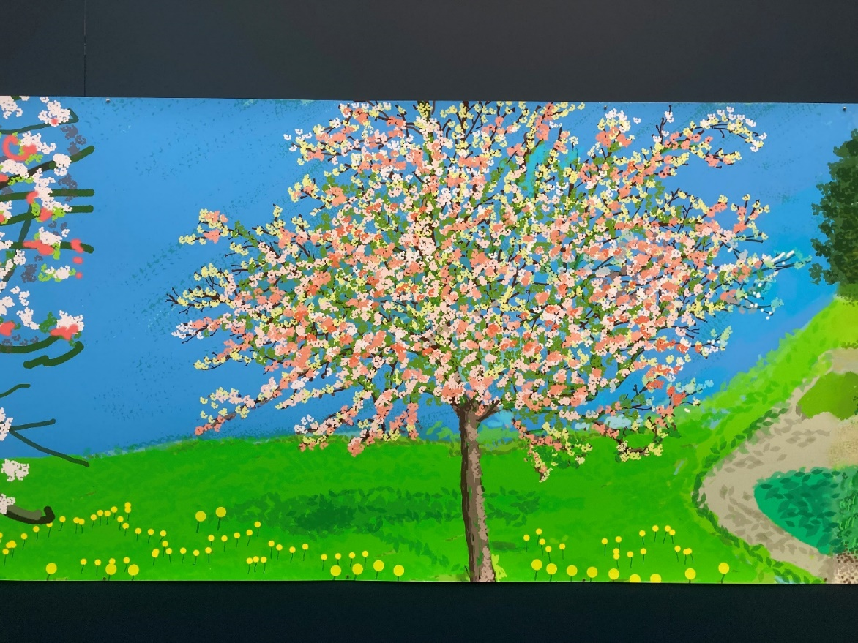
David Hockney from ‘A Year in Normandie 2020-2021’
Photograph by Kelvin Ravenscroft
“I went to the woods because I wished to live deliberately, to front only the essential facts of life, and see if I could not learn what it had to teach, and not, when I came to die, discover that I had not lived. I did not wish to live what was not life, living is so dear; nor did I wish to practise resignation, unless it was quite necessary. I wanted to live deep and suck out all the marrow out of life…”
These are the words of Henry David Thoreau in his classic 1854 work Walden. In Walden Thoreau chronicles his experience of living simply in solitude in a small cabin at Walden Pond in Concord, Massachusetts. His observations and reflections have inspired many to undertake their own journey to live deeply and to articulate ways of seeing and being which present radical and creative alternatives to much of what is often considered to be economic, political, educational, moral, and religious orthodoxy.
One small-scale initiative which explored the task of learning to live deeply was an informal Thomas Berry Manchester (TBM)/Journey of the Universe (JOTU) community study group which met regularly in Manchester, United Kingdom between September 2015 and December 2016 to explore together the key concepts, themes and ideas of the philosopher and theologian Thomas Berry. Berry’s ideas are significant because they relate spiritual perspectives on life to the insights of modern cosmology and evolutionary theory and they locate the development of human consciousness within the wider story of the universe and its origins in the Big Bang 13.7 billion years ago. There is sense in which, like Thoreau, Berry inspires us “to live deep”. Berry’s way of seeing and being in the world is characterised by a profound recognition and awareness of the interconnectedness of all that exists and the affirmation of the sacredness of the natural world.
The starting point for the development of Berry’s thought can be traced back to his experience as a twelve-year old when he encountered a field of lilies. He has described this moment as “A magic moment, this experience gave to my life something. I know not what, that seems to explain my life at a more profound level than almost any experience I can remember.” He recalls that:
“The field was covered with white lilies rising above the thick grass. A magic moment, this experience gave to my life something that seems to explain my thinking at a more profound level than almost any other experience I can remember. It was not only the lilies. It was the singing of the crickets and the woodlands in the distance and the clouds in a clear sky…. as the years pass this moment returns to me, and whenever I think about the basic life attitude and the whole trend and causes to which I have given my efforts, I seem to come back to this moment and the impact it has had upon my feeling for what is real and worthwhile in life.”
For Berry, his encounter with the field of lilies when he was young had a profound impact upon the overall orientation of his life. His experience of the flowers, insects, clouds, and woodlands was very significant for him. It was as if his senses were heightened, and he had a finely tuned awareness of the world around him so much so that it affected the overall direction and viewpoint of his life. He acknowledges that the experience impacted upon his “feeling for what is real and worthwhile in life.” Berry’s experience illustrates how an encounter with, and a receptivity to, the natural world can have far-reaching consequences. Such experiences can provide the inspiration and motivation to develop an outlook on life which affirms what is “real and worthwhile”.
It is likely that each one of us has experienced the sense of awe and wonder that is evoked by the beauty of the natural world. A wonderful sunrise or sunset, a starry night, a rainbow or the radiance of a field of sunflowers, for example, can move, inspire, and even overwhelm us. Such experiences capture our attention and elicit positive feelings and emotions. They can be described as ‘wonderful’ because they are beautiful, amazing, and even breath-taking. Such experiences are, indeed, of “inexplicable wonder” and “magic moment(s)”

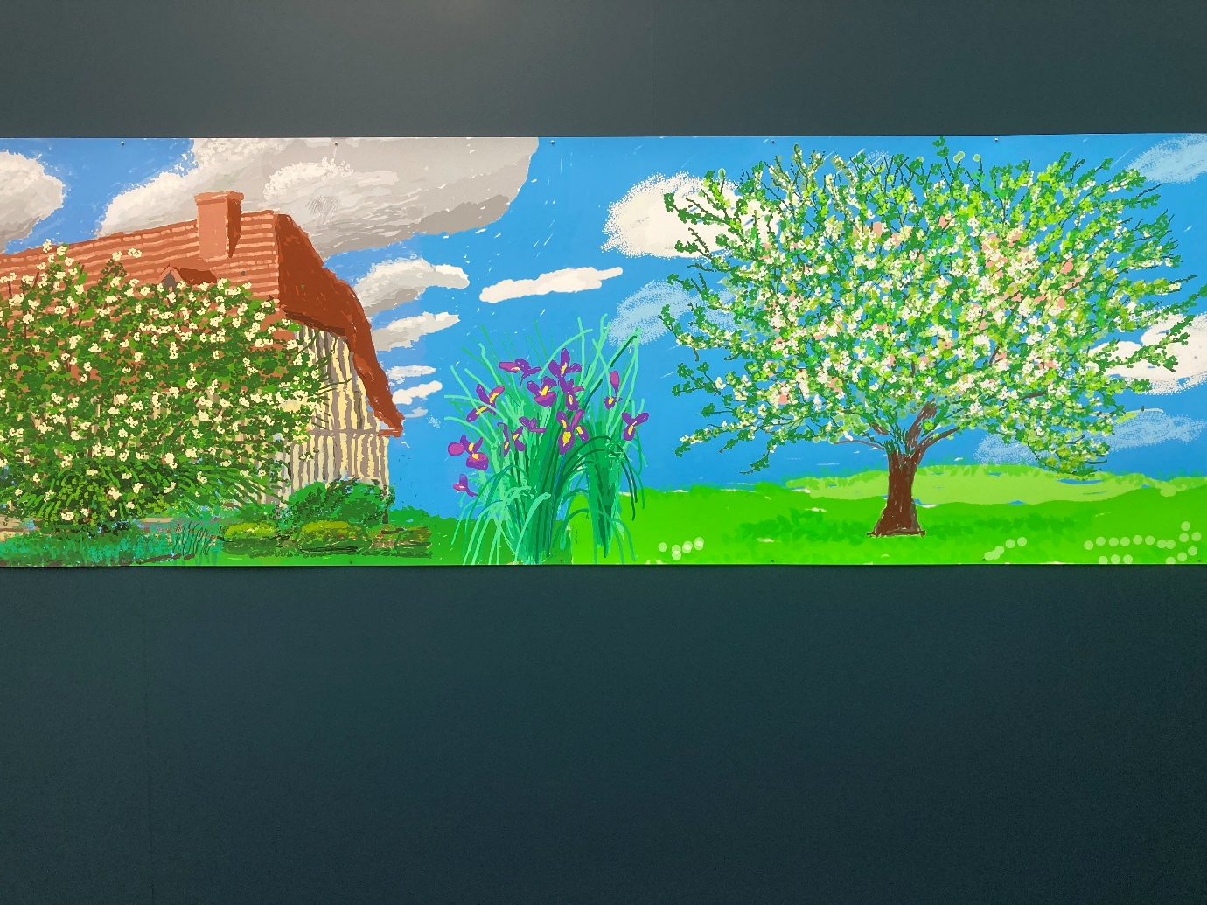

David Hockney from ‘A Year in Normandie 2020-2021’
Photograph by Kelvin Ravenscroft

Berry talks of “the realm of the sacred” and of “special sacred moments” and that “myth is our approach to the deepest realities of the universe”. He talks poetically and poignantly of the earth speaking to humankind and affirming that it has “interior riches to bestow upon (us).” For Thomas Berry the recognition and affirmation of the sacredness of all that is presents a call to change. He invites humankind to respond to what is fundamentally a radically new cultural story, a contemporary great cosmological narrative of the unfolding universe which he believes can present a rationale for hope and a catalyst for change.
It can be suggested that Berry has cogently and wondrously illustrated how an understanding of the origins, evolution and development of the universe can facilitate the experience of awe and wonder as human beings reverentially contemplate their place in the cosmos. Each person can begin to develop a sense that their existence is part of a much bigger picture, they are not separate from nature, they are part of the universe. Ultimately, therefore, each person belongs; they are at home in the cosmos.
It can be suggested that Berry’s evolutionary framework can be a significant resource for facilitating an elucidation of what I term the contemplative pedagogies of Janusz Korczak and Vasily Sukhomolinsky which can be closely related to dimensions of a curriculum for the world of the 21st century which are identified and outlined below. These dimensions are: encounter with nature, aesthetic and creative sensibility, contemplation, the power of story, service and an ecological and reverential perspective.
In his celebrated work To Children I Give My Heart, Sukhomolinsky declares:
In one of his letters, outstanding Polish educator Janusz Korczak ... reminds us of the necessity of gaining entrance to the spiritual world of the child, without condescending to it. This is a very subtle idea, the point of which we educators must understand thoroughly. The genuine educator must assimilate the child’s perceptions of the world, its emotional and moral reactions to the surrounding reality with all their distinctive clarity, sensitivity, and immediacy…
Sukhomolinsky is affirming the importance of the educator’s capacity to integrate into her ways of seeing the world the child’s perceptions, perspectives, and understandings of the world around them including their emotional and moral response to the environments with which they interact. He recognises, therefore, the vital importance of the educator being able to enter into the multi-dimensional world of the child. Sukhomlinsky follows this statement by affirming that:
I firmly believe that there are qualities without which a person cannot become a genuine educator, and foremost among them is the ability to penetrate into the spiritual world of the child.
For Sukhomolinsky, therefore, the child’s way of seeing and being in the world is, ultimately, a spiritual response. Korczak commented:
“I no longer wonder over the fact that God has no beginning and no end, for in him I see the harmony of an infinity of stars. It is creation which testifies to the existence of the creator, and not the priest. I have created a new religion for myself, it has no direction yet, but it is the manifestation of spirituality.”
Korczak appears to be articulating a perspective in which the existence of the cosmos, the infinity of stars, is a pointer to a transcendent reality, the ground of being of all that exists. However, he acknowledges that this ultimately spiritual perspective does not necessarily have to be rooted in a traditional theistic framework although he affirms that it is a new form of religion. Although Korczak’s perspective may be regarded as pantheistic in approach it can be viewed as the expression of an emerging view of the universe which has found its expression in Thomas Berry’s Universe Story and in the insights of the Polish-American Eco-Philosopher Henryk Skolimowski who has affirmed that
“To think reverentially is first of all to recognise human life as an intrinsic value; is to recognise love as an essential and indispensable force of human existence; is to recognise creative thinking as an inherent part of human nature; is to recognise joy as an integral part of our daily living; is to recognise the brotherhood of all beings as the basis of our new understanding of the Cosmos at large.”
It is possible to consider such perspectives in relation to Article 12 of the United Nations Convention on the Rights of the Child because they powerfully suggest that a significant vehicle for the development of the child’s capacity for articulating their voice, for affirming their right to be heard, is the teacher’s capacity to relate to, and engage with, the child’s ways of seeing and experiencing the world. Ultimately, therefore, it can be suggested that, echoing the Austrian psychiatrist Viktor Frankl’s affirmation of the primacy of meaning, the child’s right to be heard is grounded in a dialogic encounter between the child’s view of the world and the educator’s engagement with this.
Sukhomlinsky articulates an approach to education in which the child’s encounter with nature is affirmed:
We went to the meadow in the quiet of early evening. A pensive pussy-willow with tender foliage stood before us, and in the pond was the reflection of the endless firmament. A flock of swans flew across the clear azure sky. We listened attentively to the music of the beautiful evening. We heard a surprising sound from somewhere in the pond, as if someone were softly striking the keys of a clavicord. It seemed that the pond itself, the bank and the firmament were all ringing with the sound.

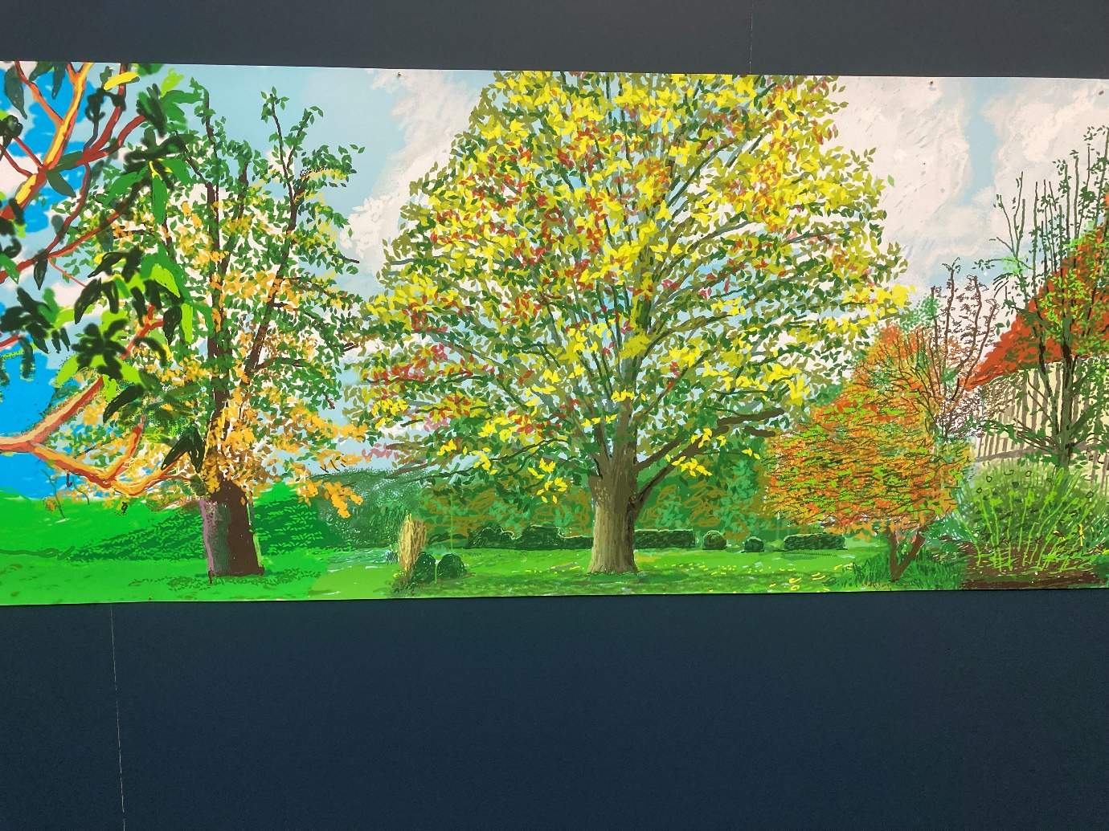
David Hockney from ‘A Year in Normandie 2020-2021’
Photograph by Kelvin Ravenscroft

It is possible to suggest that his evocation of the sights and sounds of nature echoes, and connects deeply with, the reverential respect for nature presented in the 1930 film Zemyla (Earth) by the Ukranian director Alexander Dovzhenko in its poetic and lyrical portrayal of the deep connection with, and to, the land.

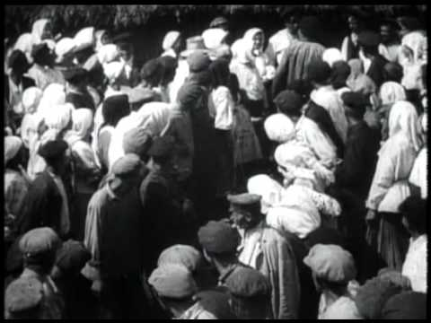
‘Zemyla’ (Earth)

Sukhomlinsky encouraged the children to engage with the sights and sounds of the natural world and to relate in depth to what they experienced. His declaration that “we listened attentively” illustrates that he was affirming a response to the beauties and joys of nature which required focus, concentration and an attitude of being fully present to, and with, the phenomena he and his children encountered. Such an approach echoes Korczak’s declaration in his Ghetto Diary:
Thank you, Merciful Lord, for the meadow and the bright sunsets, for the refreshing evening breeze after a hot day of toil and struggle. Thank you, Merciful Lord, for having arranged so wisely to provide flowers with fragrance, glow worms with the glow, and make the stars in the sky sparkle.
He is offering a prayer of thanksgiving for the beauties of the earth. His cosmic gratitude is rooted in an appreciation of the natural world which, despite the challenges he and his children faced, presented to him a vision of beauty and joy. Korczak’s pedagogical approach sensitised his children to the positive and the good which was present event in the midst of what often appeared to be the chaos which surrounded them in the wider world.
A curriculum which engages children with the natural world also encourages the development of the aesthetic, creative and contemplative dimensions. Sukhomlinsky illustrates the importance of the aesthetic dimension in his declaration that:
The chief aim for me was to teach (the children) the ability to relate emotionally to the beautiful and to give them a need for impressions of an aesthetic nature. Beauty must become an integral part of people’s lives, and this task is accomplished by education.
Indeed, he celebrates the transformative power of beauty in his affirmation that:
Working to create beauty enobles the young heart and prevents indifference. In creating beauty on the earth, the children become better, purer, and more beautiful.
Sukhomlinsky recognises, therefore, that beauty is not only to be perceived and discerned, it has also to be actively created. For example, he reflects upon the creation by the children of what he terms a Nook of Beauty:
Between the school plot and a thicket of bushes, the children found a clearing covered with thick grass by the slope of the ravine. There was a lot of moisture during showers. We weeded the clearing and began to transform it into a green lawn. ‘Our nook will be a Kingdom of green’, I told the children … This dream inspired the children.
It can be suggested that a key element of Korczak’s contemplative approach was his recognition that the telling of stories is a powerful vehicle for exploring the world and for making sense of our experience. In works such as King Matty, King Matty and the Desert Island, and Kajtek the Magician together with the stories he told as the Old Doctor on Polish Radio, Korczak introduced children of all ages to the experience of wonder, inspiration, of being spellbound by the power of an unfolding story. He recognised that we all need myths, narratives, dreams to live by; they provide meaning, hope and motivation in an all too uncertain world. Where can we look as a source of stories for the young people of today? Thomas Berry suggests that an understanding of the origins and unfolding of the Universe and our place within it provides an all-encompassing cosmic story for our times.
Sukhomlinsky echoes Korczak in his affirmation of the power of story. He wrote:
Why do children listen to stories so eagerly? Why do they love the twilight, when the very atmosphere supports flights of the imagination so? Why do stories develop the speech and strengthen the thought processes of the child? Because the images of stories are clearly emotionally coloured. The words of a story live in the child’s imagination. The child’s heart stops when it hears or pronounces the words painted by fantasy.
His recognition that stories ‘develop the speech and strengthen the thought processes of the child’ can be regarded as presenting a pedagogical foundation for the development of the child’s voice, their capacity for authentic self-expression, affirming their right to be heard. For the child to present their voice can involve them sharing their story, their experience, aspects of their personal narrative, their own perspectives, or ways of seeing things. Through listening to stories, enacting them and through writing their own stories children are encouraged and empowered to find their personal voice through which they are given the confidence to assert who they are and to share their memories, dreams and reflections, their concerns, hopes and aspirations.
It can be suggested that education for the world of the 21st century, therefore, should have as its heart the themes of personal, social, and ecological awareness, respect for others and the world in which we live and for the development of values such as respect, empathy, and compassion. The developing curricula of the future can creatively combine academic rigour, practical skills, and positive values, facilitating a contemplative appreciation of the sheer gift of being alive. Such a pedagogical approach can be regarded as being truly faithful to the radical, deeply spiritual, contemplative humanism of Janusz Korczak and Vasily Sukhomlinsky.
Through this creative activity the children are being socialized into the dimension of service as a significant feature of life. Through articulating their creative voices they are being inspired, encouraged and motivated to act not only with regard to self-interest but they are also being nurtured into an altruistic understanding of the world. Indeed, Viktor Frankl affirms that:
… being human always points, and is directed, to something, or someone, other than oneself – be it a meaning to fulfill or another human being to encounter. The more one forgets himself – by giving himself to a cause to serve or another person to love the more human he is and the more he actualizes himself.
Korczak and Sukhomlinsky both recognized and affirmed in their work with children that meaning, value, significance and purpose is located in encounter with, and service to and for, others. Their pedagogies, therefore, are infused with a profound moral dimension. This moral dimension and the capacity for the child to be heard and express their voice are also located in the storytelling dimension..
The interplay of the aesthetic, service and storytelling dimensions of the curriculum is consolidated by what can be termed the contemplative dimension which is characterised by, for example, attention, focus, mindfulness, reflection, meditation and prayer. A contemplative curriculum recognises that both teachers and pupils require opportunities for silence and stillness so that they are liberated from the all too pervasive barrage of concepts, themes and ideas which the curriculum can overwhelm and overload us with.
For Korczak trust is at the heart of the pedagogical enterprise. The essence of trust is located in providing the child with the opportunity, and environment, a safe space, in which her views can be articulated. The child should be able to share her perceptions, thoughts, concerns, anxieties, hopes, aspirations and dreams in an atmosphere where she will be truly heard by the adults who listen to her. The relationship between educator and child is that of a dialogue in which the child learns to trust the adult as a result of genuinely being given a voice. As a result of being heard the adult gains respect. Respect, therefore, is mutual and grows from trust.
Mary Rose O’Reilly has explored the concept of what she terms Radical Presence and she draws upon Parker Palmer’s idea that “To teach is to create space...” In To Know As We Are Known Parker identifies three key features of a learning space: openness, boundaries and an atmosphere of hospitality. For Parker, hospitality denotes “...receiving each other, our struggles, our newborn ideas, with openness and care.” It can be suggested that the “space” to which Palmer refers includes both the physical space, the material environment, which is the location for teaching and learning, and also the nature and quality of the relationships and interactions within the classroom. “Space”, therefore, can be regarded as having both inner and outer, subjective and objective, dimensions in which the existential encounter, the learning dialectical space, between teacher and students is located in a physical space, the classroom environment. Indeed, recent years have seen the emergence of an interest in educational circles in the relationship between physical spaces and children’s wellbeing with particular reference to the ways in which experience of the natural world promotes flourishing of both children and teachers. Point (e) of Article 29 of the United Nations Convention on the Rights of the Child states that “Parties agree that the education of the child shall be directed to …the development of respect for the natural environment.” Indeed, it can be suggested that ‘respect for the natural environment’ underpins all aspects of Article 29 because, ultimately, the ‘environment’ is not restricted to the physical, material, natural world but also refers to the dynamic network of relationships and interactions, the ‘web of life’ which characterises the whole of creation. Ultimately, therefore, “to create a space”, in an educational context, can be regarded as creating sanctuaries, places of safety, security, meaning and value.
Reflecting upon the explorations undertaken in the Journey of the Universe community study group, amongst the diversity of perspectives discussed, there are five dimensions in particular which can be considered.
Firstly, the experience of Wonder, Re-enchantment, and Transformation. Common to the spiritual traditions of the world is the experience of transformation. Sacred scriptures tell of individuals and communities who have undergone a turning around, a leaving behind of the old self and the emergence, at times involving significant loss and pain, of a new identity. Using Biblical language, it is possible to talk of metanoia, conversion, a reorientation of the self to the Divine. For Thomas Berry, rooted in the Roman Catholic Christian tradition, and, in many ways echoing the spiritual vision of Francis of Assisi, he articulated a spirituality which encompassed the whole of creation, affirming the importance of awe, wonder, reverence and a sense of the unity of all things at the heart of which is cosmic creativity. In essence, Berry invites us to undergo the task of rediscovering the enchantment at the heart of life. He calls us to abandon any sense of despair, cynicism and nihilism and to (re)discover the glorious gift of life in all its fullness.
Secondly, related to the experience of Wonder, Re-enchantment, and Transformation is the relationship between Worship and Value. We worship that which is of worth. Echoing the theologian Paul Tillich, it can be said that Berry calls us to reappraise and re-evaluate that which, in our individual and collective lives, is our Ultimate Concern. At the heart of Berry’s way of seeing is a profound reverence for life.
In The Dream of the Earth Berry declares that:
“If the earth does grow inhospitable towards human presence, it is primarily because we have lost our sense of courtesy towards the earth and its inhabitants, our sense of gratitude, our willingness to recognise the sacred character of habitat, our capacity for the awesome, for the numinous quality of every earthly reality.”

This sense of the “numinous quality of every earthly reality” suggests a third significant dimension of Berry’s way of seeing, namely, what can be termed Contemplative Awareness.

It can be suggested that Berry’s vision has significant implications for the experience of teaching and learning in all its diverse contexts. The development and introduction of a Journey of the Universe curriculum into schools, colleges and universities, and also within community groups and faith communities, has the potential to nurture the contemplative capacity, the capacity of what Simone Weil termed “attention” which she said is “the rarest and purest form of generosity.”
Experiencing things in a new way and being transformed connects with what can be regarded as the fourth dimension arising from Berry’s Universe Story which is the concept of Sacred Activism. Berry calls us to love the Earth and each other.
Jenny Grut, in her book The Healing Fields: Psychotherapy and Nature to Rebuild Shattered Lives has commented:
“If we do not consider ourselves connected with nature we are in a state of disconnection and this is what shattered lives are about. If we cannot make a link with what is outside ourselves, we cannot get to know ourselves.”
The link with “what is outside ourselves” is powerfully and beautifully articulated by the poet Wendell Berry:
“When despair for the world grows in me
and I wake in the night at the least sound
in fear of what my life and my children’s lives may be.
I go down and lie where the wood drake
rests in his beauty on the water, and the great heron feeds.
I come into the peace of wild things….
I rest in the grace of the world and I am free.”
Berry’s poem illustrates that it is possible for nature to provide a sanctuary from despair and fear. He suggests that the natural world can provide a space for rest, peace, grace and freedom. It can be an oasis offering physical and spiritual refreshment when faced with existential challenges. Fifthly, however, it is important not to romanticise nature and to view it as a panacea for curing all of the ills of contemporary society. Indeed, in his cosmological narrative, Thomas Berry acknowledges and recognises that the origin, process and evolution of the universe is characterised by change which is, all too often forceful and destructive in its power and energy. Nature can, indeed, be restorative, but it can also, as evidenced by regular news bulletins from around the world, be a cause of great suffering to both humankind and the animal kingdom.
Reflecting upon the experience of the 2011 Fukushima nuclear disaster in Japan, Koyu Abbe, the Chief Monk of the Joenji Temple community has declared: “To put Buddhist belief in one word: life doesn’t go as you wish. Everyone runs into obstacles; therefore, in order to overcome this disaster we should accept that this disaster had happened and need to face the reality squarely.” He is recognising the reality that existence is characterised by contingency, finitude, and impermanence. As the experience of the Buddha in his encounter with old age, sickness and death confirms, life presents challenges, which are all too often unexpected, which can shake the very foundations of our being. Suffering in its many and varied forms can have the effect of destabilising and subverting what we consider to be the reassuring predictable reliability of the positive routines and experiences of daily living. When suffering breaks into our lives it is understandable why individuals and communities ask “Why has this happened?”, “What does this all mean?”, “Why do people suffer?” “Is there any purpose to what has happened?”, “What can we do?” and “How should we respond?”. The irruption of dukkha, suffering, into our lives can present a profound existential challenge because it powerfully and painfully illustrates that our understandable and laudable aim to construct individual and social lives characterised by order, routine, predictability, and some degree of certainty can, often violently, be sabotaged by forces beyond our control.
Indeed, the experience of Janusz Korczak and his orphans in the Warsaw Ghetto of Nazi-occupied Poland was located in the context of an apocalyptic vision of a world which appeared to have gone mad. The old order had been subverted and a chilling ideology was systematically and clinically defining millions of people as undesirable, as being less than human, for whom the only fate was certain death. The early years of the 21st century have also seen many challenging examples of war, conflict and injustice which, at times, can be perceived as overwhelming and rendering individuals, communities and nations powerless to restore order, security and peace.
The significance of transformation, both personally and socially, and the primacy of what Viktor Frankl has termed the “will to meaning” has been demonstrated in the action undertaken by the Zen Buddhist monks of the Joenji Temple in Japan following the Fukushima nuclear disaster in 2011. Koyu Abbe, declared: “I contemplated what I could do. I decided to receive the radiated dirt at my Temple. The Temple ground is vast.” Together with his community, Koyu Abbe made the decision to undertake transformative action in order to try to alleviate the radioactivity emanating from the Fukushima nuclear power plant. The Temple took large quantities of the radiated soil and stored it in the Temple grounds and established a project entitled “Hana ni Negaiwo”, “Make A Wish Upon Flowers” which encouraged the local population to plant sunflower seeds and mustard seeds together with other plants in order for them to absorb and transform the radiation. In effect, the Joenji monks have taken their practices of meditation, mindfulness, contemplation, and reflection and made connections between their individual and collective spiritual disciplines and the wider ecology of their Temple grounds and the surrounding towns and villages. The spiritual disciplines, therefore, engage with the environmental, social and economic challenges presented by the Fukushima nuclear disaster. The deep inner contemplative spirituality of the monks makes profound and practical connections with the outer transformative challenges and opportunities of the wider environment. In his 14 Principles of Engaged Buddhism Thich Nhat Hanh indicates: “Do not avoid suffering or close your eyes before suffering. Do not lose awareness of the existence of suffering in the life of the world. Find ways to be with those who are suffering, including personal contact, visits, images and sounds. By such means, awaken yourself and others to the reality of suffering in the world.” Through their sunflower project the monks of Joenjai Temple are, indeed, awakening themselves and others to the reality of suffering in the world and are undertaking action aimed at alleviating some of this suffering motivated by “metta”, loving kindness.
The Joenji monks and the Make A Wish Upon Flowers project in their planting of sunflowers to transform the radiated soil can be regarded as saying a joyous Yes! to life and are presenting a simple, yet profound illustration of the capacity of spiritual traditions to engage with the challenges and opportunities of life. Their transformative action affirms and embodies Frankl’s declaration that man’s struggle for self-identity is rooted and located in “... dedication and devotion to something beyond his self, to something above his self.”
Koyu Abbe has declared: “My hope is, as we wish upon flowers, the seeds of sunflowers and many other flowers we have distributed will bloom in Fukushima and become everyone’s flower of hope and happiness for the future. I wish this from the bottom of my heart.” In this perspective the act of growing sunflowers is a practical meaningful act of transformation. As the sunflower plants absorb the radiation from the surrounding area they act as a profound symbol of transformation in the personal, social, and ecological dimensions of existence. What can be regarded as a simple act of planting and nurturing seeds illustrates that simple actions have the potential to have significant, even far-reaching, consequences. Confirming the understanding of the Buddhist law of karma, actions do have consequences. How we live, what we do and say, how we relate to, and connect with, others and with our wider ecologies, all have significance. It is like the pebble tossed into the lake. Once the pebble is thrown into the water we are no longer in control of what happens. We are actively involved in the casting of the stone into the water but we are not in control of, and we cannot ultimately predict, the extent and the force of the ripples on the lake which arise from the act of casting the stone. There is a profound sense, therefore, in which in a world in which we can easily become overwhelmed by the sheer scale of suffering, in its many and varied forms, the inspiring and ennobling example of the monks of the Joenji Temple present us with a contemporary role model illustrating how small acts can have very significant consequences. Indeed, from a small seed a mighty oak can grow. It can be suggested that in his declaration that “The Kingdom of God is like a mustard seed” Jesus, in harmony with the Buddha, draws our attention to the importance of “planting seeds”, preparing the ground for, and nurturing actions, activities, initiatives and projects which can transform lives and transform, in the process, darkness into light, hopelessness into hope and despair into meaning and purpose. The Kingdom of God, therefore, is present wherever and whenever positive transformation is manifested.

In The Boarding School Janusz Korczak wrote:
“Is it not enough that I experience a feeling of joyful gratitude? As I see them grow and toughen? Is this in itself not a sufficient reward for the work done? Haven’t I the right to be a disinterested worshipper of nature, to watch the shrub become green?
In this metaphor Korczak is affirming that as a pedagogue, a sculptor of childrens’ souls, he experiences a sense of joyful gratitude when he sees the children in his care blossom and flourish and reach maturity. Every pedagogue, therefore, can be regarded as being a “sower of seeds” which she nurtures and cherishes so that the fruits can be made manifest in the lives of the children in their care.
In 2017 during the season of Lent, the community of St Margaret’s Church in Whalley Range in Manchester hung on the branches of an acer tree labels on which were written their names together with details of what they considered to be their personal “roots”, the places, spaces, people and experiences which have grounded them and provided a sense of purpose and direction in their lives. The labels became the “roots” and “fruits” of the tree. To be a pedagogue, therefore, can be regarded as acknowledging a calling, a vocation, to embark upon the life-long journey of being a sower of seeds of wisdom, knowledge, understanding and inspiration who, in dialogue and encounter with the child creates and nurtures teaching and learning environments in which the children can blossom and flourish.

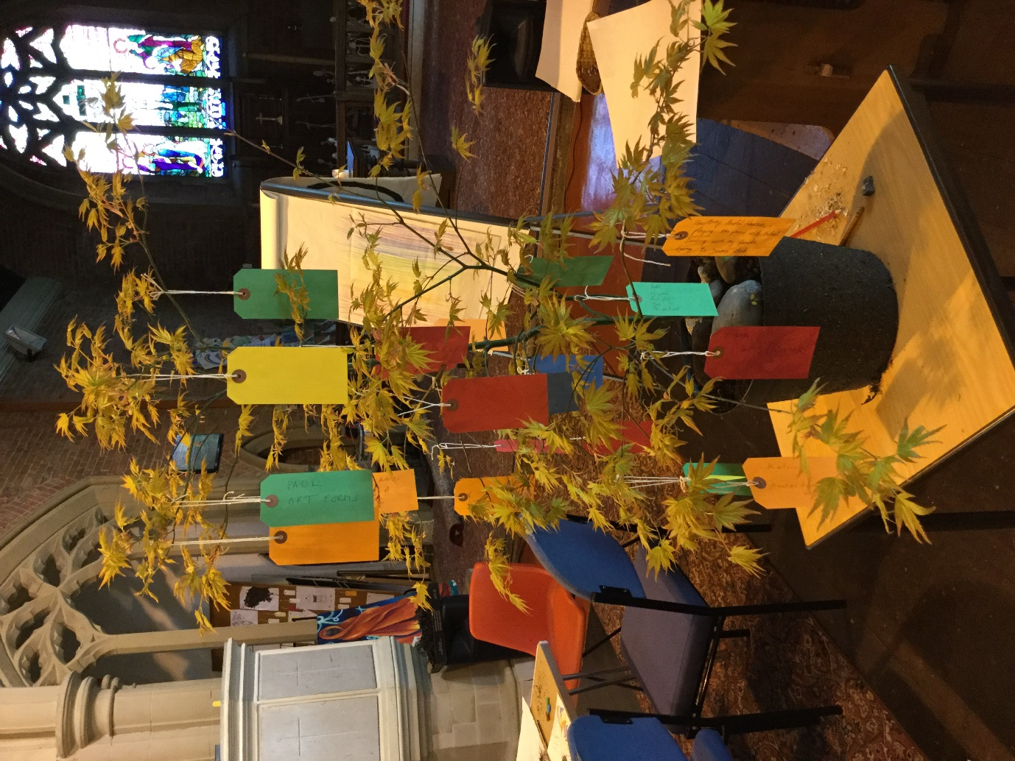

St Margaret’s Church Whalley Range
Photograph by Malgorzata Kmita

In his ‘Ghetto Diary’ Korczak declared:
“Thank you, Merciful Lord, for the meadow and the bright sunsets, for the refreshing evening breeze after a hot day of toil and struggle.
Thank you, Merciful Lord, for having arranged so wisely to provide flowers with fragrance, glow worms with the glow, and make the stars in the sky sparkle.”
He is offering a prayer of thanksgiving for the beauties of the earth. His cosmic gratitude is rooted in an appreciation of the natural world which, despite the sufferings of life, presented to him a vision of beauty and joy. Korczak’s contemplation, reflection and meditation were undertaken in the midst of the challenging life of the orphanage in the Warsaw Ghetto at a time when the lives of he and his children hung in the balance. The future was most uncertain. Despite this Korczak took the time to mindfully and attentively focus not solely on the challenges, stresses and strains of running the orphanage but, instead, he took the time to be grateful for each positive aspect of the children’s existence. He said a glorious Yes! to life when it would have been understandable for him to have been ground down by the daily challenges he and his children faced.
The Monks of the Joenji Temple gently, humbly, yet powerfully, illustrate that significant transformation can arise from relatively small acts of “metta”, loving kindness, in which individually and collectively persons can create and leave a legacy. Each human being, responding to the precious gift of life in all of its fragile glory, can create the ripples on the pond confirming that, ultimately, all things exist in a dynamic, creative and interconnected web of life. Each person begins where they are, in their own context and situation. From this context they exercise their freedom to choose and act and, in this process they can actualise transformation. Inspired by the teaching and way of the Buddha, the “Dharma”, the Joenji monks affirm the Four Noble Truths and the Noble Eightfold Path and mindfully, creatively and with compassion for all beings bring about, at times almost imperceptibly, profound personal, social and ecological change. The Joenji monks and the Make A Wish Upon Flowers project articulates clearly and unambiguously the philosopher Jean Paul Sartre’s perspective that “Man is nothing else but that which he makes of himself.” To be a person is to be embodied and engaged; we do not exist as disembodied minds engaging purely in rational thought. Thinking and reflection is translated into engagement with the world. We are what we do. Who we are is how we act.

The concluding section of this paper reviews the key concepts, themes and ideas explored in the concluding meeting of the Journey of the Universe community study group meetings held in Manchester, United Kingdom, in December 2016 and includes examples of approaches to teaching and learning which can be regarded as being in harmony with the pedagogical philosophies of Janusz Korczak and Vasily Sukhomlinsky.

The meeting included a visualisation exercise in which each member of the group was invited to imagine in their mind’s eye a place or space, either real or imagined, which they regard as being a positive, meaningful, and safe space. They were invited to visualise the details of this place or space, being aware of the sights, sounds and smells, for example, of the environment which they visualised. The group was also invited to become aware of the thoughts, feelings, and emotions they experienced in relation to the space or place of which they found themselves immersed.
Each member of the group shared their experience of the visualisation exercise all of which were of significant memorable experiences of the natural world. The experiences gave rise to responses of awe and wonder, a sense of an awareness of, and a connection with, a power or reality beyond oneself, together with a profound sense of gratitude, appreciation, and thankfulness. The responses from the group members testified to the restorative power of nature and their relationship to meaningful life-enhancing memories and their capacity to transform our perspectives, our ways of looking at the world.
This visualisation exercise was then followed by a viewing of the short film Crows which is one of eight films which together make up the feature Dreams directed in 1990 by the late Japanese film director Akira Kurosawa. Crows begins with a Japanese man in an art gallery viewing paintings, in silence, by Vincent Van Gogh. He passes from one artwork to another looking briefly at each one. When looking at one of the paintings he suddenly finds himself transported to, and located within, the painting which has come alive. He has become a character in the drama which is unfolding in the painting. He asks a group of women, who are washing their laundry in the river, if they have seen Vincent Van Gogh. They point him in the direction where Vincent can be found but they warn him that Vincent has been in what they describe as a lunatic asylum.
The Japanese man walks through the landscape looking for Vincent, but the landscape is made up of changing scenes from Vincent’s paintings. It is as if Vincent’s artworks have come alive and the boundary between the observer in the art gallery and the paintings he is viewing have been dissolved. The Japanese man, in effect, has become a living part of Van Gogh’s visual world.
The man sees Vincent (played by the acclaimed auteur Martin Scorsese) in a wheat field painting and as they meet there is a short exchange of questions and responses. Vincent appears to be in a hurry, determined to capture on his canvas the scene he sees before him. He is impatient with the Japanese man, asking him why he is not painting. Vincent expresses the view that the beauty of nature should be captured in creative activity and he declares “The sun, it compels me to paint.” Vincent declares that there is so little time in which to paint and he declares that he feels driven like a locomotive. Vincent walks away from the man and he appears to disappear from the scene. The Japanese man continues to search for Vincent and, as the figure of Vincent slowly disappears over the horizon, a flurry of crows burst into the foreground filling the wheat field. In the final scene of the film we find the Japanese man back in the art gallery gazing at Vincent Van Gogh’s painting Wheat Field with Crows. He looks at it carefully and attentively and, respectfully and reverentially, takes off his hat.
The viewing of the film was followed by a discussion responding to the question “What do we make of this?” A variety of perspectives were presented regarding responses to the film. In summary, it can be said that the film raised the question of how humankind responds to nature, is nature something that we simply pass through without giving it attention and really observing what is before us? Are we observers who do not fully experience and participate in the world? What is the relationship between beauty and creativity? How can each of us respond positively, meaningfully, and creatively to the environments we experience? In what ways can we respond to the world around us, and our relationships within it, in an existence which is finite in which each human being is a traveller on the earth. The Crows film presents Vincent and the Japanese man both located within a specific place, space and time in which, in a very powerful sense, they are both challenged to be transformed.
This sense of a call to personal, social, and ecological transformation led into the conclusion of the Journey of the Universe meetings in which we revisited the experience of Thomas Berry (which was explored in the first JOTU meeting in September 2015) as a twelve-year-old experiencing a field of lilies, an event which he recounted in his book The Great Work. Thomas Berry’s recounting of this transformative experience of nature points to the capacity for the natural world to act as a catalyst for providing meaning, purpose, and value to life and for its potential to frame our basic life orientation. Berry concludes The Great Work with the declaration that:
“The distorted dream of an industrial technological paradise is being replaced by the more viable dream of a mutually enhancing human presence with in ever-renewing organic-based Earth community. The dream drives the action.”
May our dreams, inspired by the transformative visions of Janusz Korczak, Vasily Sukhomlinsky and Thomas Berry, drive our vision and our actions.

Reflection 6: Seeing the World Anew
This reflection takes the form of an expanded version of a paper I presented at a conference in Kazan, Russia, in July 2011, entitled ‘Seeing the World Anew- Towards A Philosophy of Contemplative Education’.

Photograph by Pixabay
www.pexels.com

Seeing The World Anew-
Towards A Philosophy of Contemplative Education
by Kelvin Ravenscroft

An expanded version of a paper presented at the
International Janusz Korczak Conference
“Humanisation Of Childhood Area’, Kazan, Russia, July 2011

Today is a beautiful day. As we gather for this conference, we are able to experience and appreciate the warmth and light of a summer’s day and as the conference speakers share their perspectives on the life and legacy of Janusz Korczak and its relationship to the United Nations Convention on the Rights of the Child, we can hear the sound of birdsong in the garden outside. The French composer Olivier Messiaen incorporated birdsong into his compositions, of which his 1953 Catalogue of the Birds is perhaps his most celebrated example. As a composer Messiaen was entering into a dialogue with the natural world; he took the musical notation of modern western classical music and developed a creative synthesis with the sounds, the music, of nature.

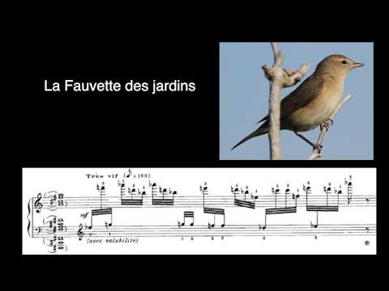

I suggest that the concept of creative dialogue is central to the work and activities of the International Janusz Korczak Association in two ways. Firstly, through scholarly study of Korczak’s life, legacy, and writings and in the task of exploring his pedagogical approach, we enter into a dialogue with his ideas, philosophy, moral example, and his capacity to inspire. This dialogue is a process of relating Korczak to the world of today; Korczak is liberated from historical particularity and is made available to the world of the 21st century. To be a Korczakian, therefore, is to be engaged in the enterprise of making Korczak a living reality so that his vision can be practically and meaningfully related to areas as diverse as, for example, teaching and learning, childcare, youth work, social work, counselling and psychotherapy, human rights, and the creative arts. This dialogue is ongoing and is at the heart of the work of a conference such as this.
The dialogue with Korczak also takes place when each of the delegates attending this conference returns to, for example, their home, family, local community, and place of work and, following reflection upon the inspiring presentations and debates which are taking place today, makes decisions about what Korczak means to them and commits themselves to applying Korczak’s principles, values, and vision to their personal and professional situation.
Janusz Korczak wrote:
“An educator who does not enforce but sets free, does not drag but uplifts, does not crush but shapes, does not dictate but instructs, does not demand but requests, will experience inspired moments with the child.”
In this declaration from his work “How to Love a Child”, Korczak acknowledges that at the heart of the process of teaching and learning is the capacity for students and teachers to be inspired. Inspiration can be defined as “being stimulated to creative thought or action”. To be inspired means to be motivated, energised and animated to engage positively and creatively with something which has meaning and significance. We are inspired by that which has the capacity to connect with us deeply. We can be inspired by, for example, a work of art, a piece of music, a film, by the beauty and wonder of the natural world, by someone or something we love or by the example of great effort, achievement, and acts of compassion. Korczak is affirming that education, the art of teaching and learning, pedagogy, is ultimately about relationship, encounter and engagement with others and the world in which we live.
The experience of Janusz Korczak and his orphans in the Warsaw Ghetto of Nazi-occupied Poland was located in the context of an apocalyptic vision of a world which appeared to have gone mad. The old order had been subverted and a chilling ideology was systematically and clinically defining millions of people as undesirable, as being less than human, for whom the only fate was certain death.
In his ‘Ghetto Diary’ Korczak declared:
“Thank you, Merciful Lord, for the meadow and the bright sunsets, for the refreshing evening breeze after a hot day of toil and struggle.
Thank you, Merciful Lord, for having arranged so wisely to provide flowers with fragrance, glow worms with the glow, and make the stars in the sky sparkle.”
Photograph by Sindre Strom
www.pexels.com
Korczak is offering a prayer of thanksgiving for the beauties of the earth. His cosmic gratitude is rooted in an appreciation of the natural world which, despite the sufferings of life, presents to him the possibility of a hopeful vision of beauty and joy. Korczak’s contemplation, reflection and meditation were undertaken in the midst of the challenging life of the orphanage in the Warsaw Ghetto at a time when the lives of he and his children hung in the balance. The future was most uncertain. Despite this Korczak took the time to mindfully and attentively focus not solely on the challenges, stresses, and strains of running the orphanage but, instead, he took the time to be grateful for each positive aspect of the children’s existence. He said a glorious Yes! to life when it would have been understandable for him to have been ground down by the daily challenges he and his children faced.
Grigory Pomerants, the Russian dissident, essayist, and philosopher has affirmed what he calls ‘the still small voice from the great silence’ and he has declared that the ‘Old Adam turns away from the kind of contemplation and silence in which the deeper interior whisper can be heard’. Like Korczak, Pomerants affirms the power of being attentive, mindful, and fully aware in the present moment even (perhaps especially) when all around you the world appears to be falling apart. Indeed, Pomerants has indicated that what kept him going, what gave him hope, a reason for living, during his time spent in the labour camps of the Gulag was the midnight sun in the far-North of the Soviet Union and of the beauties of nature. Despite the Gulag’s challenges Pomerants’ life affirms that a contemplative vision can enable people to ‘discern the footprint of God, the essential thread in all things.’
Central to Korczak’s vision, and at the heart of his legacy is the recognition that in a world of unpredictability, uncertainty, and even chaos, it is imperative to attempt to create inspirational oases of calm, order and structure which provide a foundation for the possibility of facilitating meaning and hope for the future. Even in the darkest situation there is the possibility of discerning meaning and hope, however imperceptible this might appear to be. In the world of the 21st century, with its significant challenges and opportunities, Korczak’s recognition of the requirement to create order out of chaos, meaning out of meaninglessness, to create a sanctuary, is to be taken seriously.
Amidst the trials and tribulations of the Ghetto experience with the possibility of death an ever-present reality, Korczak recognised and affirmed the requirement to create and maintain an atmosphere and an ethos of structure, order, discipline, calm and beauty, and he recognised that a response to, and relationship with, the natural world can act as an inspiration and as a catalyst for hope. Although Korczak could easily have become overwhelmed by the enormity of the challenges he faced he was resolutely determined to give the children in his care a meaningful experience of life rooted in a wider connection with the natural world, however limited this may understandably have been.
The ‘Ghetto Diary’ presents Janusz Korczak’s powerful and poignant observations, meditations, and reflections upon the experience of life with his orphans in the Warsaw Ghetto. It contains wide ranging reflections upon the joy and pain, the challenges, and opportunities, presented by existence. In his ‘Ghetto Diary’ Korczak poignantly looks back upon his life and he reflects upon significant experiences, including those of his childhood, which have impacted upon his development, and he is mindful of the detail of the joys and pains, the challenges and opportunities, the despair and the hopes, which the children in his care experience.
In a profound sense the ‘Ghetto Diary’ is a book of memory in which Korczak attempts to make sense of his life in relation to his vocation as a children’s advocate. In Polish, a diary, a book of memory, is known as a pamietnik. There is a very real sense in which a pamietnik, however, is not simply a factual timeline recording of events but is also a reflection and commentary upon event, upon memory. As a literary genre, therefore, it is a creative synthesis of historical and existential reflection. The past and the present are inextricably interwoven and interrelated. In addition, through their capacity to challenge, illuminate and inspire, pamietniks are not only the reflections of a specific individual or community, but they can also assume a universal aspect. The memories, dreams. and reflections of one person can become the story of every woman and man. There is a profound sense, therefore, in which the experience of Janusz Korczak and his orphans can be regarded as a powerful illustration of the contradictions and paradoxes of the human condition and the capacity of human beings to embrace political, economic, and religious extremism. The fate of Korczak and his orphans reminds us, in the early years of the 21st century, of the imperative to take steps to avoid entering a new Dark Ages in which prejudice and discrimination, stereotyping and scapegoating, injustice, extremism and conflict reassert themselves.
Throughout history humankind has engaged with questions of meaning, purpose, and value, particularly with reference to the dark nights of the soul which can arise in response to the existence of evil and suffering. Indeed, in the ancient Biblical Book of Ecclesiastes the writer declares: “I have seen everything that is under the sun, and behold, all is vanity and a striving after wind” (1:14)
The spiritual traditions of the world can be regarded as living, dynamic, organic networks of relationships in which the past, present and future are understood with reference to an Ultimate concern, a Transcendent framework, a Divine reality, which, in some sense, provides a reconciliation of the tensions which exist between the real and the ideal, between life as it is and life as it could be, between the life shattering experience of evil and suffering and the life-affirming experience of joy, love, beauty, truth, justice and peace. Spiritual traditions are, therefore, in a very real sense, living pamietniks; they engage the individual and the communities to which they belong in a process of relating their traditions to contemporary experience. Spiritual traditions have, ultimately, to be living traditions; they have to engage the real lives and experiences of real people in the real world with the insights and wisdoms of the past. In this way, the past, present and future are inextricably linked; the “modern”, therefore, does not exist in isolation because it is rooted in what has gone before it. Indeed, both the “modern” and the “post-modern” can only exist on the foundations of what has preceded them. Modern spiritualities, therefore, must take seriously the roots of their traditions. To be a radical means to be a person of roots, who can creatively engage with the challenges of contemporary society through being immersed in a tradition which has preceded them. To be a radical provides the freedom to embrace both tradition and the modern and hold them in a creative tension. The twentieth century provided us with many examples of spiritual radicals such as, for example, Martin Luther King, Thich Nhat Hahn, the Dalai Lama, Daisetz Suzuki, Dietrich Bonhoeffer, Mahatma Gandhi, Martin Buber, Thomas Merton, Henri Nouwen, Simone Weil, Dorothy Day, and Dag Hammarskjold who all illustrated that dark periods in human history elicit in us the capacity to actualise an alternative way characterised by peace, justice and ecological responsibility.
The insights of spiritual traditions are also powerfully complemented by the creative insights into existence elucidated by, for example, poets, novelists, painters, sculptors, musicians and filmmakers and it can be suggested that the power of great art resides, ultimately, in its capacity to empower and inspire us to begin to make sense of our place in the world and to locate us in a meaningful network of relationships and in an authentic connection with the physical space, the environment, in which we live. Spiritual traditions and the creative impulse, complemented by the powerful and majestic insights of scientific and technological discovery, can provide the resources to engage with the philosopher Jean Paul Sartre’s view that existence is characterised by anxiety, despair, abandonment, and forlornness.
There is a sense in which dialogue with the life and legacy of Janusz Korczak creates many new and varied pamietniks as all those who find themselves inspired by Korczak’s pedagogical philosophy to engage meaningfully and authentically with the world and experience of the child find that they are engaged in a process of reflection in which they relate their experience to that of Korczak and his children. This presentation is also a pamietnik because it attempts to discern the significance of Korczak’s approach for education in the modern world in which its primary theme is an exploration of what can be termed Korczak’s contemplative pedagogy in which the concepts of presence, attention and mindfulness can be regarded as key features which, together, suggest a profoundly spiritual, albeit humanistic, approach to the educational enterprise.
In order to begin to discern and explore the contemplative dimension of Korczak’s pedagogical philosophy it can be regarded as appropriate to consider several key ideas which can be regarded as being foundational to any lexicon of Korczakian pedagogical terminology. These ideas were clearly actualised in his life and are deeply embedded in his writings and include, for example, trust, faith, confidence, learning, curiosity, acceptance, and approval.
In The Child in The Family in How to Love A Child Korczak declared:
“It has not yet crystallised within me, nor has it been confirmed by reasoning that the child’s primary and irrefutable right is the right to voice his own thoughts, to active participation in our considerations and verdicts concerning him. When we will have gained his respect and trust, once he confides in us of his own free will and tells us what he has the right to do – there will be less puzzling moments, less mistakes.”
For Korczak trust is at the heart of the pedagogical enterprise. The essence of trust is located in providing the child with the opportunity, and environment, a safe space, in which her views can be articulated. The child should be able to share her perceptions, thoughts, concerns, anxieties, hopes, aspirations, and dreams in an atmosphere where she will be truly heard by the adults who listen to her. The relationship between educator and child is that of a dialogue in which the child learns to trust the adult as a result of genuinely being given a voice. As a result of being heard the adult gains respect. Respect, therefore, is mutual and grows from trust. Mary Rose O’Reilly has explored the concept of what she terms Radical Presence, and she draws upon Parker Palmer’s idea that “To teach is to create space...” In To Know as We Are Known Parker identifies three key features of a learning space: openness, boundaries, and an atmosphere of hospitality. For Parker, hospitality denotes “...receiving each other, our struggles, our newborn ideas, with openness and care.” It can be suggested that the “space” to which Palmer refers includes both the physical space, the material environment, which is the location for teaching and learning, and also the nature and quality of the relationships and interactions within the classroom. “Space”, therefore, can be regarded as having both inner and outer, subjective and objective, dimensions in which the existential encounter, the learning dialectical space, between teacher and students is located in a physical space, the classroom environment. Indeed, recent years have seen the emergence of an interest in educational circles in the relationship between physical spaces and children’s wellbeing with particular reference to the ways in which experience of the natural world promotes flourishing of both children and teachers. Point (e) of Article 29 of the United Nations Convention on the Rights of the Child states that “Parties agree that the education of the child shall be directed to …the development of respect for the natural environment.” Indeed, it can be suggested that ‘respect for the natural environment’ underpins all aspects of Article 29 because, ultimately, the ‘environment’ is not restricted to the physical, material, natural world but also refers to the dynamic network of relationships and interactions, the ‘web of life’ which characterises the whole of creation.
Ultimately, therefore, “to create a space”, in an educational context, can be regarded as creating sanctuaries, places of safety, security, meaning and value. I have previously explored the importance of places of sanctuary and their relationship to the natural world in two of the five Janusz Korczak Projects I developed during the summer of 2009 which were introduced at the International Korczak Association meeting in Warsaw in September 2009, and which were subsequently distributed by e-mail to Korczakians throughout the world.
The Space for Reflection and Sanctuary Projects explore the concept of respect for the natural environment through the planning, development, creation and maintenance of natural spaces which embody the values of peace, tolerance, equality, friendship, understanding and responsibility which characterised Korczak’s life and are affirmed in the United Nations Convention. The Projects aim to explore Korczak’s affirmation of the primacy of oases of calm through the creation of Spaces for Reflection, Sanctuaries, what the Polish philosopher Henryk Skolimowski has called Oikos, a Sacred Enclosure.
The Projects have two distinct, yet related aspects to them. Firstly, they aim to create physical spaces in which, for example, pupils, students, teachers, therapeutic groups, and faith communities can create what can be termed a sanctuary, a space apart, a place of quiet and calm. Secondly, the creation of these physical spaces is complemented by the establishment of reflective, contemplative, meditative and mindfulness-based programmes, teaching and learning activities, which aim to actively foster the positive peaceful values articulated both in Korczak’s vision and in Article 29 of the United Nations Convention on the Rights of the Child.
Unused or underutilised spaces in schools, colleges, or universities, for example, are identified with a view to transforming them into Quiet Spaces and Places. Alternatively, land adjacent to museums, galleries or public parks or land belonging to faith communities could be identified and selected as spaces for transformation into Sanctuaries. The Spaces should aim to be inclusive and be suitable for use by people from religious and secular traditions.
The Spaces should aim to incorporate a range of media and materials which utilise the range of skills and talents of the project group members. Consideration should be given to the impact of the appearance and layout of the Spaces in order to facilitate reflection and contemplation and they should aim to create aesthetically pleasing and environmentally sustainable quiet places which facilitate reflection upon positive values and principles such as those embodied in the life and work of Janusz Korczak.
The Spaces should aim to incorporate a range of natural media and materials such as trees, plants, shrubs and wood and stone sculptures and artefacts which utilises the range of skills and talents of the project group members. Consideration should be given to the effects of the changing seasons on the appearance and ‘feel’ of the Sanctuaries.
The Spaces and Sanctuaries should, therefore, aim to facilitate reflection upon how the values and principles advocated by Janusz Korczak can be regarded as being meaningful and relevant in the world of today. This process of reflection can be assisted through the recording of the transformation and evolution of the selected Spaces and Sanctuaries through a range of media such as, for example, photography, film, a dvd, cd-rom, or a website. The process of planning, developing, and creating such Spaces for Reflection can be regarded as cultivating the capacities for Presence and Mindfulness.
In The Boarding School Korczak utilises metaphors from nature in his declaration:
“Is it not enough that I experience a feeling of joyful gratitude as I see them grow and toughen? Is this in itself not a sufficient reward for the work done? Haven’t I the right to be a disinterested worshipper of nature, to watch the shrub become green?”
He is affirming that for the “shrub to become green”, for the child to develop and mature, there has to be an encounter with the teacher characterised by “a feeling of joyful gratitude.” For Korczak, “to be a disinterested worshipper of nature” is to approach the life of the child with respect and reverence, to be fully present to the unique individuals before us. Indeed, it can be suggested that “Presence” is at the very heart of Korczak’s pedagogical philosophy. From the perspective of Sufi philosophy, Kabir Helminski has commented that:
“Presence is the state of transcendent awareness, which embraces and comprehends all other functions, including thought, feeling, action and intuition. Unless we develop in presence we are not wholly here. We exist in our thoughts, in our desires, but not in our Being, and therefore we cannot really love because we are not fully here. Without presence our dialogue is primarily mental or emotional but not fully spiritual. Without presence we cannot develop in love.”
Such a perspective articulates a holistic understanding of the nature of being with oneself, others and the world. Korczak affirmed the primacy of being available for, and present with, the child and in his approach to teaching and learning he expressed a profound understanding of the role that positive nurturing environments, therapeutic spaces, have in the child’s development.
Korczak commented that:
“There are one hundred more days left till spring. There is, as yet, not a blade of grass, not one single bud is showing. But inside the soil, among the roots, the dictate of spring is already there, secretly persisting, throbbing, lurking, waiting and gathering strength - under the snow, inside the bare branches, in the icy gale - to suddenly burst into blossom.”
He is affirming that even when things look bleak, when life’s challenges appear to overwhelm us and when we find it difficult to discern any possibility of hope or optimism there is, at the heart of things, the potential for positive change, transformation, and development. This can also be regarded as a metaphor for understanding and relating to children. Instead of adults focusing on the negative in the child’s behaviour, actions, and attitudes they should, instead, aim to affirm the positive and from these small acorns mighty oaks might grow. The entire pastoral system in schools, for example, should be geared towards transforming negativity in all its forms through the transformational power of positive life-affirmation. Educational and therapeutic organisations should, therefore, have at the heart of their aims, objectives, philosophy, and mission-statements the central question of ’In what ways do we promote the positive in, and for, our children?’ Addressing this question honestly and realistically, but with a sense of an achievable positive vision, can encourage and empower schools and related educational and therapeutic enterprises to create an ethos which celebrates positive transformation in all its many and varied forms. Such an ethos, however, must radically address profound questions of meaning, significance and purpose.
In The Special School Korczak suggests that:
“To teach morality is simultaneously to nurture the good, to obtain a good which exists in spite of faults, vices, and innate vicious instincts. And confidence, faith in man, is this not in itself a good that can be perpetuated, developed as a counterweight to the evil which occasionally cannot be eradicated, and which can be controlled only with difficulty?”
For Korczak, faith includes the willingness to have trust in humankind’s capacity for goodness. Having this trust, faith, does involve the honest recognition of the difficulties that exist in the world, including the moral challenges that the values, attitudes and behaviour of people present to us, but such things do not, ultimately, define the human condition nor do they negate the primacy of goodness. Faith involves the development of a confidence, a sense of hope, in the capacity for people to transcend negativity in its many and varied forms and to create and nurture alternative ways of being characterised by virtues such as love, compassion, empathy, honesty, generosity and creativity.
In The Boarding School Korczak writes of a teacher who:
“... is losing faith in himself. Formerly, not a single day went by without his noticing something new in the children or in himself. The children used to be fond of him, now they keep their distance. Is he still fond of them? He is rough, brutal at times.”
Korczak recognises that it is possible for people, including educators, to become dispirited, to lose faith in their capacity to engage with the children in their care. He recognises that in this process of alienation the educator loses sight of that which initially inspired and empowered him to become a pedagogist, the outcome of which can be that the children tune into and sense what is happening and, as a result, they can become alienated from each other. Indeed, Korczak recognises that the educator’s lack of faith in both himself and his children can lead to extremes of behaviour in which harshness and brutality, both in attitudes and actions, can be expressed. For genuine encounter between educators and children to be actualised there has, therefore, to be the (re)establishment of faith, trust, and confidence.
In The Child in The Family in How To love A Child Korczak observed that:
“Every child passes through periods of aged weariness and periods of exhilarating vitality, but this does not in any way mean that we should give in to him and shield him nor that we should resist and toughen him. The child’s heart does not keep pace with his growth, so he ought to be allowed to rest, or on the other hand, perhaps he should be stirred to more lively activity to give him strength and develop better? The issue can be resolved only for a given case and for a given time, but it is essential to win the child’s confidence, and to place confidence in the child.” Korczak recognises that confidence of the child in the educator is not automatic; it must be actively developed. He is also aware that an attitude and an atmosphere of confidence must recognise the individuality of each child. To develop an ethos of confidence requires paying attention to, and being mindful of, the specifics of what he terms “a given case and for a given time.” Confidence, therefore, should be at the heart of the relationship of faith and trust which can exist between educators and children; in effect, confidence is simultaneously an attitude, an outlook, a perspective, a way of seeing and a way of being, an approach to life, an ethic of hope.
In The Ghetto Diary, July 18, 1942, Korczak comments:
“Victory for the children’s confidence in the leadership. They believed that as long as the doctor was calm there was no danger.”
Korczak recognises that if educators actively work to develop and nurture oases of calm in the midst of what can, at times, be very challenging circumstances and issues, this will impact positively upon the attitudes and behaviour of the children. Children respond with faith and trust when they perceive that the adults who are caring for them are calm, balanced, and level-headed. The calm educator elicits confidence from her children.
In Summer Camps in How to Love A Child Korczak reflects that:
“And again life taught me that something good comes from what looked like disaster, that a violent crisis is frequently the herald of recovery. Not only did I not lose the children’s friendship but on the contrary, mutual confidence increased. For the children the whole thing was a minor episode, for me a momentous event.” Korczak recognises that challenging situations and circumstances can enable teachers and pupils to engage together in responding positively to create recovery, new beginnings characterised by hope which transcend the challenges, hurts and disappointments which are features of the human condition. He is aware that the capacity of the educator to enable both he and his children to transcend adversity can create a positive, vibrant and dynamic bond of mutual confidence.
Korczak affirms the importance of self-knowledge gained through experience and reflection upon it. He declared:
“You yourself are the child you must learn to know, rear and above all enlighten. To demand that others should provide you with textbook answers is like asking a strange woman to give birth to your baby. There are insights that can only be born of your own pain, and they are the most precious. Seek in your child the undiscovered part of you.”
Korczak affirms that at the heart of pedagogy, the process of teaching and learning, is self-knowledge. To become aware, at a profound level, of who one truly is and to integrate into one’s experience and identity the pain and suffering of existence, can empower one to begin to truly know children. Self-knowledge and self-awareness facilitate knowledge of the child. This is, ultimately, a prerequisite for meaningful and genuine education.
Korczak declared:
“When I approach a child, I have two feelings; affection for what he is today and respect for what he can become.”
He recognises the creative dialectic between the present and the future, between potential and actuality and the interplay of the positive emotions of affection and respect. For Korczak the starting point for both education and therapy is the experience of the child in the present moment. This present, however, is rooted in an existential context. Each child has a personal history and this impacts upon their development and the unfolding of their future. For the pedagogist, therefore, to facilitate meaningful teaching and learning requires that in addition to being self-aware the teaching and therapeutic enterprise requires knowledge of the child. There are, however, no short cuts to this knowledge. The role of the teacher requires that she pays attention to, for example, what each child says, how each child acts, what each child writes and how each child expresses themselves in, for example, art, music, languages, drama, mathematics, and the sciences. This task requires time, effort and energy and is an ongoing process in which new and, at times, unexpected insights into the child and their way of seeing the world are articulated. The teacher and therapist, therefore, share the experience of entering into a dialogue with each child.
The dialogue between teacher and child can significantly complement the positive nurturing provided by the child’s family. However, there will inevitably be cases where the teacher and therapist are the primary source of an affirmative dialogical encounter. It can be suggested, therefore, that the foundation for the development of a civic and humane society is the establishment of relationships characterised by openness, spontaneity, warmth, genuineness, and compassion. Indeed, what can be termed Dialogic Encounter or Moral Personalism, the ‘I-Thou’ philosophy articulated by Martin Buber, can be viewed as being an ethic of human relationships which should underpin the entire ethos of all organizations and institutions entrusted with the care and nurture of children.
Korczak wrote:
“What a powerful effect on the sad life of a child, would be the memory of that person - perhaps the only one - who showed kindness, understanding and respect in a world where cruelty had become the norm. The child’s future life and sense of himself could take a different course, knowing there was one person who would not fail him.”
He is recognising that parents, relatives, friends, teachers, carers, and therapists, for example, all have the capacity to engage with children in a way which affirms their value, worth and uniqueness. In terms of schools, therefore, the teacher is not primarily a teacher of mathematics, technology, science, history, or art, for example, but is first and foremost a teacher of children. However, the teacher is also a learner from children. At the heart of the process of teaching and learning is the nature of the positive relationship between the teacher and her children. For many children, particularly for those who are from emotionally disadvantaged backgrounds, their only positive interaction with adults is those they experience with their teachers at school. Central to the role of the teacher, therefore, is the pastoral work in which she is engaged daily. Everything a teacher does or says is a learning opportunity for the child and presents them with an example, either positive or negative, of what it means to grow and mature. Indeed, Korczak declared:
“Be yourself and seek your own path. Know yourself before you attempt to get to know children. Become aware of what you yourself are capable of before you attempt to outline the rights and responsibilities of children. First and foremost you must realise that you too are a child, whom you must first get to know, to bring up and to educate.”
Central to this perspective, therefore, is the Socratic injunction to ‘Know thyself’. The teacher or therapist must aim to become aware of her identity, her personality, her strengths and weaknesses and the ways in which she can promote or inhibit the child’s spiritual, moral, social and cultural development. The philosophy of pedagogy articulated by Korczak, therefore, is rooted in the experience of authentic dialogue between the child and those responsible for their care.
In The Child’s Religion Korczak notes:
“We ourselves are trying, always searching, never satisfied with what is, looking with curiosity at tomorrow. The question is much more important than the answer. It is a guide for thoughts on the way towards goals...Whether in a dream or in awakened state, in the everyday matters these are moments when a question is born and there are hours when it matures. Now I will await not for the answers but the question.”
Korczak affirms that at the heart of the pedagogical process is the capacity to ask questions, to be curious, to want to discover, learn and understand more fully and deeply. To ask questions is to engage in a process of critical exploration in which thinking is not constrained by the possible outcome or by predetermined answers. Instead, asking questions is open ended, philosophical in nature, concerned with the multiplicity of possible meanings.
In The Ghetto Diary Korczak observed:
“I have an investigative mind, not an inventive one. Investigating in order to know? No. To inquire in order to ascertain, to probe to the very bottom? Not that either. Investigating, rather, in order to ask further and further questions.”
Korczak is aware that it is in the process of asking questions that one can extend the boundaries of what is possible and of what can be known. Asking questions is, therefore, at the very heart of the process of teaching and learning. The freedom to ask questions is closely related to the trust, faith and confidence that are developed between educators and children. The relationship between educator and child is affirmed in Korczak’s encouragement to:
“Do allow children to make mistakes and to joyfully strive for improvement. Children love laughter, running about and playing tricks. If your own life is like a graveyard to you – leave children free to see it as a pasture. How often do we feel disappointment, when children fail to live up to our expectations? And how often do we feel disappointment at every stage of their development? We are their harsh judges, rather than their counsellors and consolers.” Korczak is all too aware of the capacity for educators to judge children, to grind them down through being harshly critical. He affirms that education requires acceptance and approval of the unique personal worth of the child and that this is not conditional upon the ways in which the children act. To be an educator, therefore, has at its heart a significant pastoral role in which one is both a “counsellor and a consoler.”
The Boarding School forms the second section of Korczak’s How To Love A Child. In the opening paragraph of the work Korczak states:
“I want to write a book about the city boarding school where a hundred orphans, boys and girls of school age, are brought up under the care of a small staff, in its own building, with a limited attendant personnel.”
The term Korczak uses for Boarding School is Internat, a residential institution for children. Korcak presents a critique of the often harsh and inhumane regimes which can exist in such establishments, and he powerfully illustrates the negative impact, the grinding down of the spirit, such institutions can have both upon teachers and children. Ultimately, Korczak’s The Boarding School is a call to actively create new forms of education in which the well-being of the child is at the centre. When children flourish educators also flourish.
The capacity for human flourishing and its relationship to presence, attention and mindfulness is profoundly articulated by Brian Keenan in his reflections upon his experience following his liberation from captivity in Lebanon:
“I have not the language nor the conceptual philosophy to designate the elements of the spirit and spirituality. But my experience suggests that an encounter with the spiritual is, first, a celebration of the joy and fullness of life and then an overwhelming sense of contentment. But the road is difficult.”
This reflection upon the nature and meaning of “the spiritual” presents a life-affirming perspective in which it is possible to identify three significant elements of the spiritual life.
Because Keenan undoubtedly endured great suffering during his years in captivity which he has poignantly documented in his book An Evil Cradling, it may at first appear somewhat surprising to see that he identifies celebration as an element of the spiritual dimension of life. Celebration suggests a way of looking at the world in which glory, honour, rejoicing and praise are at the core of one’s being. For Keenan celebration relates to joy and the fullness of life. Joy connotes bliss, delight, ecstasy, elation, exaltation, gladness, pleasure, satisfaction and rapture. A joyful perspective on life, therefore, is a perspective which affirms aliveness; it is in tune with the rhythms of life. It says a resounding Yes! to life. Indeed, Keenan talks of “an encounter with the spiritual”. The word “encounter” does not suggest superficiality, triviality, or lack of substance. Rather it suggests that the spiritual dimension of life is that to which one relates in depth. It leads one to relate to oneself, others and the world authentically with an attitude of trust and affirmation.
When consideration is given to the nature of Keenan’s experience of captivity it may appear at first to be somewhat incongruous that his perspective on the spiritual is characterised by hope and optimism. The French philosopher Gabriel Marcel has described what he terms creative fidelity which affirms Being in the face of despair and denial. Creative fidelity would appear to be suggested by Keenan’s perspective and involves an attitude of faithfulness which
“.... is the spontaneous and unimposed presence of an I to a Thou.... it is a call to which I answer “present”. In saying “here” I create my own self in the presence of a thou.... fidelity is the active perpetuation of presence. “
William Blair Gould acknowledges that in French the term presence has dimensions that are absent in the English perception, understanding and usage of the word. He suggests that:
“Marcel’s term presence involves a bond of feeling between one person and another. He points out that when two people become aware that they have shared an experience - they have visited the same place, they have shared the same risks, they have read and enjoyed the same book, or they share a friendship with the same person - a unity is established in which the I and the Thou become the we. These beginnings of being present to the other can develop into being for the other.
Encounter in Keenan’s perspective, therefore, can contribute to an understanding of the spiritual dimension of life because it affirms the primacy of relationship and moral personalism which is central to both religious and humanistic traditions.
Keenan is aware, however, that “the road is difficult”. This can suggest that life is like a journey in which challenges, hardships and hurdles are encountered. Keenan’s experience of captivity followed by liberation powerfully illustrates how the catalyst for personal growth and development in self-understanding can often be found in one’s world being unexpectedly turned upside down as a result of which all the so-called certainties of everyday life disappear. This perspective recognises that a significant element of the spiritual dimension of life is what can be called the shadow side of life. The shadow side of life is often expressed in terms of a contrast between positives and negatives such as, for example, darkness and light, good and evil, love and hate, peace and violence and beauty and ugliness. It has been suggested earlier that the tenor of Keenan’s view of the spiritual dimension of life is ultimately optimistic, but it is possible to interpret it as a powerful example of what Emmanuel Mounier has termed tragic optimism. Keenan’s personal experience of the shadow side of life can poignantly illustrate that an awareness of the reality of the darker side of human nature is an integral component of an understanding of the spiritual dimension of life.
However, in An Evil Cradling Keenan recounts the experience, following a long period of deprivation, of being presented with a bowl of fruit:
“There’s a bowl in front of me that wasn’t there before. A brown bowl and in it some apricots, some small oranges, some nuts, cherries, a banana. The fruits, the colours, mesmerize me in a quiet rapture that spins through my head. I am entranced by colour. I lift an orange into the flat filthy palm of my hand and feel and smell and lick it. The colour orange, the colour, the colour, my God, the colour orange. Before me is a feast of colour. I feel myself begin to dance, slowly, I am intoxicated by colour. I feel the colour in a quiet somnambulant rage. Such wonder, such absolute wonder in such an insignificant fruit.
I cannot, I will not eat this fruit. I sit in quiet joy, so complete, beyond the meaning of joy. My soul finds its own completeness in that bowl of colour. The forms of each fruit. The shape and curl and bend all so rich, so perfect. I want to bow before it, loving that blazing, roaring, orange colour . . . Everything meeting in a moment of colour and of form, my rapture no longer an abstract euphoria. It is there in that tiny bowl, the world recreated in that broken bowl. I feel the smell of each fruit leaping into me and lifting me and carrying me away. I am drunk with something that I understand but cannot explain. I am filled with a sense of low. I am filled and satiated by it. What I have waited and longed for has without my knowing come to me, and taken all of me.”
In this powerful reflection, Keenan appears almost overwhelmed by the experience of being unexpectedly presented with a variety of fruits which appeal to his senses. It is understandable how, after a long period of being deprived of even the simplest of the pleasures of life, he is faced with the prospect of a delicious and satisfy treat. However, it can also be suggested that what Keenan articulates is akin to a very intense expression of what can be termed an experience of Mindfulness. Jon Kabat-Zinn has indicted that “Mindfulness can be thought of as a moment-to-moment, non-judgemental awareness, cultivated by paying attention in a specific way, that is, in the present moment, and as non-reactively, as nonjudgmentally, and as openheartedly as possible.”
This analysis of Keenan’s perspectives, therefore, suggests that there are three dimensions to an understanding of the spiritual. Firstly, there is the affirmation that the foundation of the spiritual is the concept of encounter in which life is experienced in terms of depth and relationship. Secondly, life is valued, affirmed, and celebrated. This ‘feeling of being alive’ can be regarded as an apposite phrase to encapsulate Keenan’s view of the celebratory dimension of the spiritual. Celebration is related to the third dimension of Keenan’s perspective which is his recognition, arising from his own personal experience, that an understanding of the spiritual should acknowledge the realities of the darkness, the shadow side of life. Keenan’s reflections upon the bowl of fruit also illustrate the significance of a mindful, attentive presence.
This discussion of Keenan’s understanding of the spiritual dimension of life has been undertaken in order to illustrate that Korczak’s capacity to engage with the challenges of life and transform them can also be identified in recent literature and it also introduces the contemporary educational debate about the aims of education, particularly in terms of, in England and Wales, the impact of the 1988 Education Reform Act which locates the educational enterprise in a frame of reference in which the spiritual, moral, cultural, mental and physical development of pupils is at the heart of the curriculum and the ethos of the school.
Although undoubtedly many schools have always affirmed the importance of the spiritual and moral dimensions of the curriculum the 1988 Act has provided the catalyst for a stimulating and vigorous debate about the purpose and nature of education and has particularly focussed dialogue about the meaning of the spiritual dimension of life and the nature of spiritual development together with creative exploration of the strategies by which schools can actively promote the spiritual development of their students. Opportunities for spiritual development can regarded as being the entitlement of every student irrespective of their religious affiliation. From the National Curriculum Council’s identification of beliefs, a sense of awe, wonder and mystery; experiencing feelings of transcendence; search for meaning and purpose; self-knowledge; relationships; creativity, and feelings and emotions as dimensions of spiritual development, it is clearly possible to recognise areas with which Spiritual Education can engage in a healthy and blossoming cross-fertilisation with
For John Bradford
“Spirituality ... describes a healthy attitude towards and a positive engagement (i) with ourselves and our family; (ii) with our God and our faith community; and (iii) with our day to-day activities and our involvement with others in the wider world.”
The three elements of this model of spirituality, therefore, can be called human spirituality, devotional spirituality, and practical spirituality. Human spirituality relates to the holistic interrelatedness of the emotional, cognitive, and intuitive self which develops as a result of affirmation, receiving love and affection together with praise and recognition which facilitates growth in confidence and self-esteem as a result of which openness to new experiences and opportunities is fostered. This dimension of spirituality, therefore, is concerned with the basic human needs and rights of love and affection; security and serenity; new experiences and wonder; encouragement and support and responsibility and participation. These needs relate to the humanistic psychologist Abraham Maslow’s hierarchy of needs which recognises that the demands of lower needs have to be met before those of the higher levels, including self-actualisation, can emerge. Indeed, developmental psychology has long recognised that in order for the child to fulfil his or her potential, particularly in terms of emotional development, a secure, caring, loving and stimulating environment is highly desirable.
In tune with Bradford’s understanding of the human dimension of spirituality is the perspective articulated by Kevin McCarthy who, in his exploration of the role of emotional education in raising school achievement, comments that
“If education is concerned with the development of the whole person, it must now involve the historically neglected area of the emotional education of young people, by which we mean education which engages the emotions and education about the emotions.”
The importance of education for the emotions has been cogently presented by Daniel Goleman who suggests that our understanding of human intelligence is far too restrictive. He believes that emotions have a significant role in thought, decision making, and individual achievement and he articulates a theory of Emotional Intelligence and emotional literacy. His thesis advocates the further development of a Self-Science curriculum the main components of which include teaching and learning strategies which facilitate development of self-awareness, personal decision-making, managing feelings, handling stress, empathy, authentic communications, self-disclosure, insight, self-acceptance, personal responsibility, assertiveness, group dynamics and conflict resolution. The recognition of the value of emotional intelligence can also be considered in relation to Dan Baines’ testimony to the importance of what he terms Spiritual Intelligence.
Bradford’s delineation of the human dimension of spirituality can be regarded as presenting insights which can be usefully incorporated into plurality of ways of seeing the world, including both religious and non-religious perspectives. However, it is in his discussion of the second dimension of spirituality that Bradford would appear to be moving into an area which closely relates to the language of religious belief, faith, and practice. This second dimension of spirituality is termed Devotional Spirituality and relates to the formation of a personal and corporate religious life in which the child is enabled to develop her identity as a member of a community of faith and is therefore nurtured in the beliefs, values and norms of their community’s traditions which provide a framework for worship and a focal point for contemplation. This empowers the child to affirm others and to create, share and celebrate peace. A devotional spirituality is ultimately a spirituality of worship, both personal and communal, in which, the child is provided with the opportunity to engage their everyday experience of the world with the transcendent ideals presented in the rituals and observances of their faith community. This encounter of the real and the ideal provides opportunities for growth and the reordering of life, in terms of the creative definition and expression of one’s beliefs, values and ideals. Opportunities for contemplation and reflection have the potential to facilitate changes in perception which may lead to increased acceptance of self together with an awareness of the responsibility for making authentic moral and ethical choices.
This responsibility can be regarded as relating to the third dimension of Bradford’s model of spirituality which he terms Practical Spirituality. This refers to a spirituality which is actively engaged in personal and public everyday living. This is Human and Devotional spirituality translated into action on behalf of all those who need physical, mental, emotional or spiritual support. Empathy, the potential for understanding and imaginatively entering into another person’s feelings is encouraged together with the capacity for friendship, affection, authentic communication, and interaction characterised by an increasing confidence in one’s openness to growth and personal development as well as advancement of the wellbeing of others.
Many perspectives on spirituality and spiritual development affirm that living is a creative act. Each individual is an artist who out of the raw materials of their existence strives to fashion something which has meaning. Life presents opportunities for the affirmation of self and others as a result of which each individual has the potential to become what the Humanistic Psychologist Ted Landsman has described as the Beautiful and Noble Person. In Landsman’s perspective there are three stages in the development of the Beautiful and Noble Person. The first stage is described as the Passionate Self which is characterised by self-respect and self-acceptance. Such an individual perceives themselves as being a worthwhile person. This acceptance of self facilitates development of the second stage in the growth of nobility and beauty which is characterised by the Environment Loving Person. In this stage there is a passionate concern for the physical environment. The world is perceived and experienced from a perspective of joy and celebration. This encounter between the person and the world promotes the development of the third, social, dimension of the Beautiful and Noble Person which is described as the Compassionate Self. This person deeply cares about and loves others, including those who are in need. This empathy, however, is translated into action on behalf of those who suffer.
Although not developed as a model for understanding the nature of spirituality and the spiritual development of students Landsman’s model of healthy personality presented in his concept of the Beautiful and Noble Person does appear to anticipate many of the themes articulated in Bradford’s tri-partite understanding of spirituality and in Korczak’s pedagogical philosophy. For example, the Passionate Self characterised by self-acceptance and self-respect would appear to be closely related to Bradford’s Human Spirituality. Development of self-acceptance and self-respect provides the foundation for a healthy personality as a result of which the individual is able to explore life with increasing self-confidence and can actively participate in life’s tasks and challenges from a position of a willingness to accept responsibility.
Elements of Landsman’s view of the Compassionate Self can be discerned in Bradford’s Practical Spirituality. The individual translates her beliefs and values into active participation in the world. Just as the Compassionate Self is deeply concerned about the well-being of others Practical Spirituality is ultimately a transformative spirituality; it aims to initiate change in the world. Landsman’s Environment Loving Person who displays a passionate concern for the physical environment is echoed in the Forum for Values’ Environment dimension which testifies to the
“.... value (of) the natural world as a source of wonder and inspiration and accept(s) our duty to maintain a sustainable environment for the future.”
Although Bradford’s model of spirituality does not explicitly refer to an Environmental Spirituality his discussion of Practical Spirituality does clearly indicate that he regards a capacity for reverence and reflection as being an integral aspect of one’s engagement in everyday living. The Forum for Values’ recognition that nature can be a source of value and wonder can, therefore, clearly be linked to Bradford’s affirmation of reverence and reflection because, as poets, artists, and musicians, for example, have testified throughout the ages, the natural world can be a powerful medium of Transcendence. Indeed, the Polish philosopher Henryk Skolimowski has cogently articulated an Eco-philosophy in which humankind’s relationship with nature is explored in terms of its spiritual significance.
In addition to Landsman’s model of the Beautiful and Noble Person it can be suggested that there are other significant perspectives which can be incorporated into a framework for understanding the spiritual dimension of life, whether Humanistic or Religious. For example, in his acclaimed work To Have or To Be? the Humanistic psychologist Erich Fromm presents an analysis of human values in terms of the distinction between the modes of Having and Being. He suggests that:
“In the having mode of existence my relationship to the world is one of possessing and owning, one in which I want to make everybody and everything, including myself, my property”
In the Being mode of existence, however,
“...we must identity two forms of being. One is in contrast to having, ... and means aliveness and authentic relatedness to the world.
The other form of being is in contrast to appearing and refers to the true nature, the true reality of a person or thing in contrast to deceptive appearances...”
Martin Buber, in his seminal work I and Thou, outlined the two significant perspectives from which humankind can relate to the world. These perspectives, or ways of relating, are described as I-Thou and I-It. Clements summarises the nature of, and relationship between, the I-Thou and I-It perspectives in his observation that
“In I-Thou, man addresses his world and neighbour as Thou, and allows himself to be addressed as Thou in turn. This is the relation of mutual personal encounter, dialogue, communion.
In I-It, he regards his world as an It - the attitude of observation, description, usage, seen at its most detached in scientific analysis.
Both attitudes are necessary, but it is in I-Thou that man is genuinely human. “All real living is meeting.”
Buber articulated the I-Thou/I-It distinction/polarity in the context of a theological framework in which the deepest and most profound I-Thou relation is with God, the eternal Thou who can never become an It. It can be suggested that a synthesis of Fromm’s concept of Being and Buber’s I-Thou relationship can be creatively incorporated into an exploration of models of human spirituality. Indeed, what Fromm and Buber appear to articulate is what can be termed a philosophy and/or spirituality of Moral Personalism in which the primacy of authentic modes or ways of relating is affirmed.
It can be suggested, therefore, Korczak’s contemplative pedagogy and Landsman’s model of the Beautiful and Noble Person share an approach to understanding human existence and personality which affirms the interaction between the self, others and the world. The contribution that the life and legacy of Janusz Korczak can make to understanding spirituality, spiritual development and spiritual education is to be primarily found in his recognition that self-awareness, self-understanding, self-actualisation, and self-transcendence is rooted in interaction with others and one’s environment. This perspective echoes Buber in its affirmation of the primacy of relationship and encounter.
Janusz Korczak affirmed the importance of storytelling. In books such as King Matty the First, King Matty and the Desert Island and Kajtek the Magician, together with his radio broadcasts from Warsaw as the Old Doctor, he has inspired many to recognise in story telling the capacity for tales, myths, legends, and fables to engage us at a deep level. I wish to continue this exploration of Korczak’s contemplative spirituality and pedagogy through consideration of a story, a modern legend, by a writer who was a contemporary of Korczak, Joseph Roth’s short story The Legend of the Holy Drinker was written a few months before his death, at the age of forty-four, in May 1939. In 1988 the film of the book was released to critical acclaim. The film, directed by Ermanno Olmi, won a Golden Lion award at the Venice Film Festival in that year and four Italian Oscars during 1988-89. It stars Rutger Hauer as Andreas, an ex-miner jailed for an accidental murder, now released from prison, and living homeless in Paris.
A mysterious old man offers Andreas two hundred francs on the condition that he repay it the following Sunday to the church of Sainte Marie des Batignolles. The film chronicles Andreas’ encounters with faces from the past and present and presents a scenario in which each time he spends the money he wakes up, usually from a drunken stupor, to find that the bank notes have miraculously reappeared in his wallet.
There is a sense in which Joseph Roth’s own life echoed that of Andreas. Alcoholism had destroyed his health and in 1938 he suffered a heart attack which left him severely incapacitated. In what can be regarded as being perhaps the most powerful and painful scene in the film, Andreas escapes from the torrential rain by spending the night drinking alone in a bar. Throughout the night his solitary drinking contrasts with the experience of deep respect, caring and love displayed in the interaction of others in the bar. Andreas, in his isolation, reflects upon his life and appears to experience despair, meaninglessness and a sense of loss. Through his promise to repay the money to the Church Andreas has the possibility of finding a purpose, goal or mission to his life. When Andreas’ money runs out it is always unexpectedly replaced. Is this chance, coincidence or providence? He encounters friends and loved ones from the past who have a significant effect on his present life; how is this to be explained? The task of returning the money to the Church allows him to transform his apparently aimless life into a life lived from a transcendent perspective.
In his experiences, both joyful and despairing, Andreas appears to be searching for meaning to his life. The psychiatrist Viktor Frankl has suggested that “man is characterised by his “search for meaning” rather than his “search for himself’. Indeed, Andreas appears to be engaged in a profound existential quest, attempting to make sense of his situation. Ultimately, the film poses the question “Is death the premature and tragic end to Andreas’ life or is it the fulfilment of his mission?”
Through such themes and concepts, the film can be recognised as being an inspiring, and deeply contemplative, exploration of the nature of existence, including the joy and the pain of life, together with examination of the relationship between meaning and well-being. However, it can be suggested that The Legend of the Holy Drinker is actually a parable about the human condition. Perhaps what it powerfully illustrates is that human beings have available to them all the resources they need to live well. Indeed, even though Andreas appears to squander the money which he receives from others, it is regularly replenished. The gifts which Andreas receives can be viewed as being a metaphor for the gifts, the resources, the natural world provides to us in abundance which are, all too often, shared inequitably or are wasted on a vast scale leading to the creation of a world which is ravaged by greed and the quest for power and dominance. In succumbing to his personal addictions, Andreas all too often finds himself to be alone, alienated from others, cut off from those around him, even those who try to reach out and help him. Whatever the messages of the film may be, it does appear to suggest that, echoing Janusz Korczak, meaning is found in encounter with others, through a reverential, loving engagement with our fellow human beings and through a response to, and relationship with, the Divine. Korczak declared:
“I no longer wonder over the fact that God has no beginning and no end, for in him I see the harmony of an infinity of stars. It is creation which testifies to the existence of the creator, and not the priest. I have created a new religion for myself, it has no direction yet, but it is the manifestation of spirituality.”
In such a perspective, the world in which we live, therefore, has personal, social, ecological, and cosmic dimensions and meaning and well-being is to be found in a holistic interaction of these dimensions.
In her 2005 novel “Gilead”, which won the Pulitzer Prize for fiction, Marilynne Robinson explores the experience of the Rev John Ames, who, in 1956, towards the end of his life, writes a letter to his young son. The idea is that the son will open the letter after John’s death and as he grows up he will be able to revisit the letter and begin to learn and reflect upon the life of John and his ancestors. In an evocative scene, John recalls how, when he was a child, he visited with his father the grave of his grandfather. He describes his father kneeling deep in prayer at his grandfather’s grave:
“Every prayer seemed long to me at that age, and I was truly bone tired. I tried to keep my eyes closed, but after a while I had to look around a little. And this is something I remember very well. At first I thought I saw the sun setting in the east; I knew where east was, because the sun was just over the horizon when we got there that morning. Then I realised that what I saw was a full moon rising just as the sun was going down. Each of them was standing on its edge, with the most wonderful light between them. It seemed as if you could touch it, as if there were palpable currents of light passing back and forth, or as if there were great taught skeins of light suspended between them. I wanted my father to see it, but I knew I’d have to startle him out of his prayer, and I wanted to do it the best way, so I took his hand and kissed it. And then I said, ‘Look at the moon.’ And he did. We just stood there until the sun was down and the moon was up. They seemed to float on the horizon for quite a long time, I suppose because they were both so bright you couldn’t get a clear look at them. And that grave, and my father and I, were exactly between them, which seemed amazing to me at the time, since I hadn’t given much thought to the nature of the horizon. My father said, ‘I would never have thought that this place could be beautiful. I’m glad to know that.’
It can be suggested that this extract from Gilead encapsulates four key elements of a contemplative spirituality and pedagogy. Firstly, the experience of John and his father takes place in a context of prayer and thanksgiving. The experience has a profoundly contemplative, reverential, and meditative quality to it. Secondly, at the heart of their experience is a deep response to, and appreciation of, the beauty of the world and their place within it. Ultimately, their lives are located in a cosmic context. Thirdly, this awe and wonder in response to the world as it its centre the image of the sun and moon. Gilead’s lunar and solar motifs, evoking Vincent van Gogh’s “Starry Night” panoramas, can be thought of as reminding us of our connection to the web of life and to our place within the cycle and rhythms of creation. Fourthly, John Ames’ loving non-verbal interaction with his prayerful father is a reminder that at the heart of the spiritual traditions of the world (both religious and humanistic) is the imperative to relate to others and to our world authentically and compassionately, in what Martin Buber has termed “I-Thou” encounters. It is my view that the imagery and experiences presented in the Gilead extract are deeply Korczakian in their affirmation and celebration of the mysteries of existence.
Through exploration of, and dialogue with, the life of Janusz Korczak it is possible, therefore, to embark on a process of the development of an appreciation of his transformative way of seeing and experiencing the world. The development of our sensitivity to Korczak’s approach to the child can facilitate the capacity to acknowledge the primacy of existential questions, questions of ultimate concern, of meaning, purpose, and value. Korczak’s life can act as a model, an illustration, of a life which is authentic and empowered because it undertakes to relate all aspects of existence to a dimension of experience which is both experienced within the human soul and is also understood as being a Presence, a ‘Thou’ beyond the self. In such a relational dialogical approach each one of us is an ‘I’ who encounters the ‘Thou’ of Korczak because of which we can be challenged, inspired, and empowered to live authentically and to develop spiritually as a Passionate Self.
Spring 1999 saw the first major exhibition in Britain, at the Royal Academy, of the paintings of the Russian artist Wassily Kandinsky (1866-1944) who is often regarded as being the first abstract painter. Although the exhibition undoubtedly provides the opportunity to view rarely seen works the exhibition may also provide the catalyst for what can be regarded as a long overdue rediscovery and reappraisal of Kandinsky’s pioneering book Concerning the Spiritual In Modern Art. In this text Kandinsky commented that
“The nightmare of materialism, which has turned the life of the universe into an evil, useless game, is not yet past; it holds the awakening soul still in its grip. Only a feeble light glimmers like a tiny star in a vast gulf of darkness. This feeble light is but a presentiment, and the soul, when it sees it, trembles in doubt whether the light is not a dream, and the gulf of darkness reality.”
If one relates Kandinsky’s declaration to the radical pedagogical perspectives of Janusz Korczak, it is perhaps apposite to suggest that what all models of spirituality and spiritual development can share, including philosophies of spiritual and contemplative education in schools, is their affirmation of the necessity to actualise light in the darkness through their capacity to creatively nurture and develop the capacity to practice and experience presence, attention, and mindfulness.
I dedicate this presentation to the memory and continuing inspirational legacy of Janusz Korczak.
© Kelvin Ravenscroft 2013-2022

Reflection 7: Contemplation in a World of Action

“When we are alone on a starlit night, when by chance we see the migrating birds in autumn descending on a grove of junipers to rest and eat; when we see children in a moment when they are really children, when we know love in our own hearts; or when, like the Japanese poet, Basho, we hear an old frog land in a quiet pond with a solitary splash - at such times the awakening, the turning inside out of all values, the "newness," the emptiness and the purity of vision that make themselves evident, all these provide a glimpse of the cosmic dance.”

-Thomas Merton

Photograph by Hristo Fidanov

www.pexels.com

Reflection 7 consists of the text of a lecture I presented at Bradford Cathedral, West Yorkshire, on 19 September 2008 entitled ‘Contemplation in a World of Action’.
The statement which begins this reflection above is by the Roman Catholic Christian monk, mystic, contemplative, poet, and writer Thomas Merton (1915-1968). Merton is drawing our attention to examples of life experiences which have the capacity to change us, to transform us, to bring about new ways of seeing and being, different perspectives on life. He affirms that such experiences are moments of ‘awakening’ which bring ‘a purity of vision’. In effect, such experiences can be termed ‘enlightenment’ moments, which, from the perspective of Christian faith, we can think of as being moments of ‘grace’; those times in our lives when we discern God’s love, freely and unconditionally, given; a gift which comes to us, often unexpectedly, and changes the way we see things.
Many of the examples Merton gives are examples of grace found in creation, the natural world. From 26 July to 8 August 2022 Bishops from the international Anglican Communion gathered in Canterbury for the Lambeth Conference which included a day at Lambeth Palace, London, for the launch of what is called the ‘Communion Forest’ which is a global initiative to plant trees, protect forests, and restore eco-systems throughout the provinces, dioceses, and parishes of the Anglican Communion. Such an initiative can be regarded as a significant expression of the Anglican Communion’s fifth mark of mission: “To strive to safeguard the integrity of creation and sustain and renew the life of the earth”.
1n recent times, the period from 1 September to 4 October in the Church’s calendar marks what is known as ‘the Season of Creation’ or ‘Creation Time’ which is a time to renew our commitment to our Creator and our relationship with, and care and compassion for, creation. It can be thought of as a time of what I term ‘Ecological Conversion’, when we recognise and affirm that to be a follower of the Way of Jesus is not only concerned with personal salvation, but also, ultimately, concerns the transformation of the whole of creation. Colossians 1:15-16 reminds us that: “The Son is the image of the invisible God, the firstborn over all creation. For in him all things were created: things in heaven and on earth, visible and invisible, whether thrones or powers or rulers or authorities; all things have been created through him and for him.”
To care for, to be a steward of, creation, therefore, can be thought of as being a radical act of serving Jesus. May we, particularly during the Season of creation, glimpse something of that which Merton calls the ‘cosmic dance’, the transforming and life-giving dance of the Risen Christ whose loving presence permeates the whole of the created order.
Contemplation in a World of Action
by Kelvin Ravenscroft
“Where are the placid landscapes of my childhood?
Where are the forests full of birds?
Where is the silence of my homeland?
Are we the last romantics who yearn for the beauty
Of the changing seasons?
Where are the flowers we gathered near stream waters when
We were children?
Where is the whiteness of the snow?
Does it only live in on in paintings?
Remember!
The face of the earth is similar to that of a human being.
Don’t forget that you are but a traveller
On this planet and nothing belongs to you.”
In this poem the Croatian artist Ivan Lackovic Croata looks back upon his childhood and reflects upon what appears to be a way of life that is rapidly disappearing. Ivan’s homeland was torn apart by the civil war between Bosnia, Croatia and Serbia, former-Yugoslavia, in the early 1990’s. For most people in his homeland it was very difficult during this time to find any cause for optimism, hope or celebration.

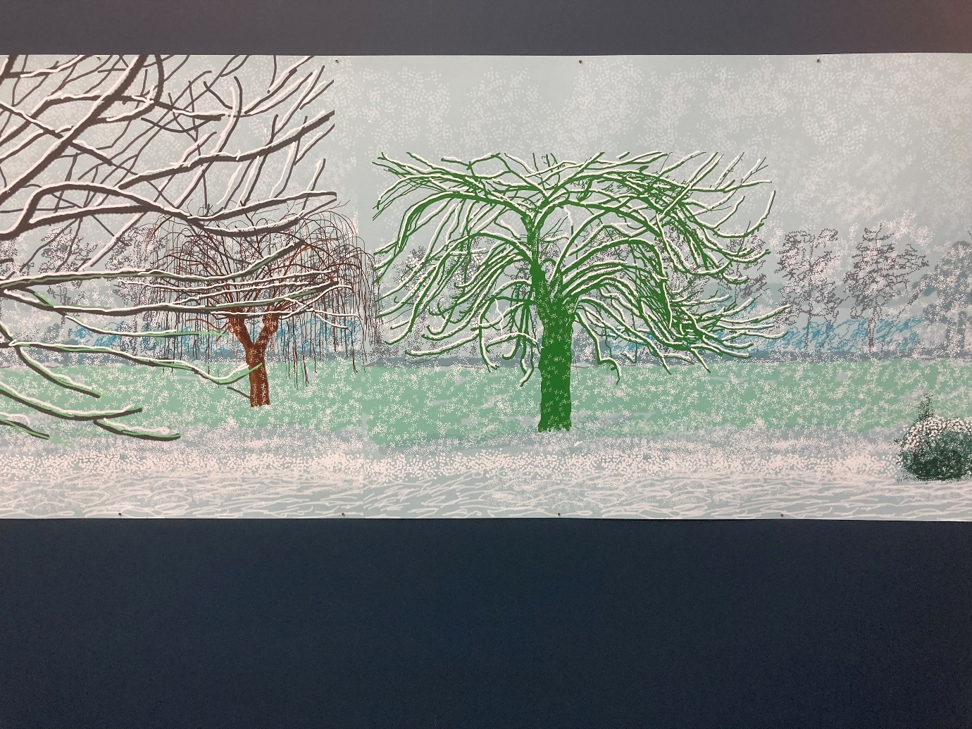
David Hockney from ‘A Year in Normandie 2020-2021’
Photograph by Kelvin Ravenscroft
However, throughout the conflict Christians in Yugoslavia, Eastern Orthodox and Roman Catholic, continued to celebrate Easter and Christmas as festivals of hope. The message of Christianity with its gospel, good news, of God’s love for humankind gave people cause for joy and thanksgiving. Muslims continued steadfastly to maintain their spiritual practices; they fasted during the month of Ramadan demonstrating their submission to Allah and, despite great hardship, celebrated the festival of Eid as part of the ummah, the worldwide community of Islam. However, despite the power of faith to nurture and sustain individuals and communities Ivan draws our attention to a world in which the past rapidly disappears over the horizon and the future which dawns requires humankind to be presented with a reminder that, ultimately, they are temporary residents, travellers passing through the world. Ivan’s view suggests that each and every human being is a person on the move, in transit, a wanderer on the face of the earth in which, ultimately, they possess nothing.
Indeed, the world of the twenty-first century can be regarded as a world in which the only constant is change. Nothing stays the same. All things are in a constant state of flux and development. Philosophers talk of a ‘post-modern’ world in which there are no fixed, unchanging, eternal and absolute truths but instead there is a world of a multiplicity of perspectives, ideas, beliefs, practices, world views and lifestyles. There are those who see this relativist approach to life as being a liberation from the dominant political, religious, moral and economic systems of the past. They see the high-technology virtual world of the internet as presenting creative opportunities for human beings to become the persons they truly wish to be unfettered by geographical and national boundaries. This can be seen as opening up a new world of freedom and creativity in which each individual has available to them economic, educational and technological resources which promote a higher quality of life.
However, there is a contrary view which suggests that in a world of widening inequalities between the developed world and the developing world, where environmental degradation is rampant and where violence, conflict and war affect millions of people the post-modern vision can be regarded with some suspicion. Even in affluent societies drug addiction, for example, is widespread and many people experience high levels of stress, insecurity, depression and suicide. In such a scenario the challenge with which people are presented concerns the question of how is it possible to find the motivation, energy and resources to adapt to unpredictable and rapidly changing circumstances
In such a world how is it possible to develop and maintain, for example, any degree of political, economic and religious consensus? Is it actually possible to formulate a vision of society to which most people would voluntarily subscribe? Or are we actually heading inevitably and irreversibly to a world of nihilism, breakdown and anarchy?
Although since the end of the Second World War in 1945 Europe enjoyed many years of peace the conflict in former-Yugoslavia and the ethnic cleansing associated with it brought back to many the harrowing images of former times. The recent experiences of Beslan, Rwanda, and Darfur, for example, raise profound questions about the nature and direction of the contemporary world.
Speaking of the modern condition the psychiatrist Viktor Frankl declared:
Today we live in an age of crumbling and vanishing traditions. Thus, instead of new values being created by finding unique new meanings, the reverse happens. Universal values are on the wane. That is why ever more people are caught in a feeling of aimlessness and emptiness or, as I am used to calling it, an existential vacuum….
Armenia was the first country to recognise Christianity as the official state religion in 301 AD. In the Armenian Church, the night from Maundy Thursday to Good Friday is kept as a vigil and a profound and solemn period of devotional prayer, contemplation, meditation, and reflection. This is known as the night of the Tenebrae, during which sin, evil and death are predominant.
At this point the world, which appears to prefer darkness to light, has its way. Choosing to remain in darkness, men choose to destroy the light. At midnight, the lights of the Church are extinguished one by one until the congregation kneels in total darkness. This is a time of sorrow, destitution, forlornness, anguish, and abandonment and is expressed in the singing of an ancient melody which symbolises the words of Jesus upon the cross to his mother Mary: ‘Dear woman, here is your Son’.
The composer Mychael Danna has conveyed the spirit of Tenebrae in the track ‘Oor Es Mayr Eem’ from his soundtrack to Atom Egayan’s 2002 film ‘Ararat’ which is presented below.

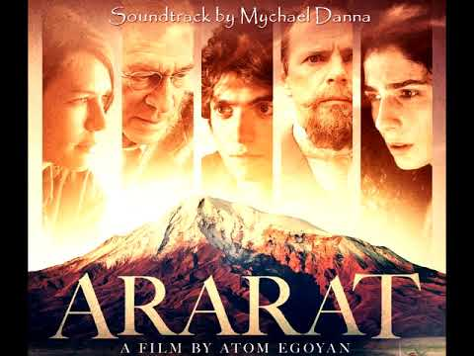
Such pain and sorrow has also been expressed by the composer Jonathan Elias in his acclaimed work ‘The Prayer Cycle’. Reflecting upon the creative process he has stated:
“As I worked, my personal views inspired dark visions of where I think we, globally are heading. And I found prayer is what we turn to when the only thing we have left is hope. For whatever reason, providence, or chance, we take paths that lead us somewhere we never imagined….
The world we live in is both joyous and cruel. The divide between love and hate has never been as wide as it is in our world today. I pray that we can move forward and that the next generations rise where we have fallen.
Movement III of The Prayer Cycle: Hope, presents a poignant reflection upon the human condition and anticipates a time at which the ‘… soul will surrender and give in to Grace.”
MUSIC: ‘The Prayer Cycle’ cd Track 3: Movement III; Hope
(6 minutes & 38 seconds)
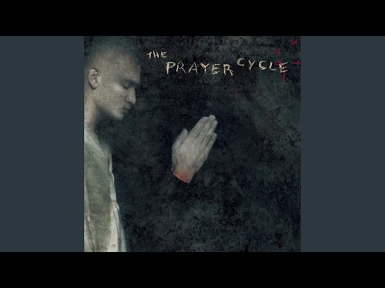

In a world in which joy and pain co-exist in what can seem, at times, to be a powerful yet irrational and meaningless combination, it is understandable why people ask what is to be done about the real challenges which face not just the human race but the entire planet. This evening I wish to suggest that within the Christian faith there exists spiritual traditions which can be (re)discovered, reflected and acted upon all of which have the potential to provide the inspiration for us to be empowered to live meaningful lives in an increasingly unpredictable and uncertain world. It is the contemplative tradition which will be the focus of tonight’s exploration and this tradition will be considered with particular reference to the spirituality of the Roman Catholic Christian monk, priest and mystic Thomas Merton.
Our exploration of Merton’s spirituality and its relationship to the contemplative tradition, however, will not take the form of a traditional biographical approach such as those presented by Merton scholars in which detailed time-line narrative accounts of his life are presented. Rather, the approach adopted tonight involves a different strategy. Inevitably, some biographical input is necessary, but the primary focus is upon identifying what can be regarded as being the significant features of Merton’s spirituality and reflecting upon the meaning his spirituality can have for the world of today. There is a sense in which this reflection upon Merton’s spiritual legacy is, indeed, a personal response to his life. There are very different ways of understanding and relating to Merton and our exploration this evening is one amongst many possible ways of seeing his life. For those interested in exploring the detail of Merton’s life story there is a wide range of published material available. Monica Furlong’s 1980 biography of Merton is a good place to start alongside Merton’s autobiography The Seven Story Mountain.
Thomas Merton was born in Prades, France on 31 January 1915. His parents were both artists, his father Owen was from New Zealand and his mother Ruth was a Quaker from America. In 1916, because of the difficulties created by the First World War, the family moved to the United States. In 1917 Thomas’ brother, John Paul, was born.
On 21 October 1921 Ruth Merton died from stomach cancer. Thomas was not permitted to see his mother during her time in hospital and Ruth’s farewell to Thomas was in the form of a letter which was delivered to him by his father. Following the death of his mother, Thomas spent time in Bermuda and France with his father and in New York with his grandparents and at Oakham School in England. These early years of Thomas’ life were deeply significant for him because it was difficult for him to develop close relationships with people and places. There was a very real sense in which he was on the move, not having the opportunity to establish roots. As a student at Clare College, Cambridge it has been noted that he appears to have led a somewhat hedonistic and perhaps aimless life. One outcome of this period of youthful experimentation was that he fathered an illegitimate child.
Following Cambridge Thomas returned to the United States and he enrolled at New York’s Columbia University. In November 1938 Thomas was baptised a Roman Catholic Christian and in December 1941 following a long period of internal struggle about the direction of his life and discerning his vocation he joined the Trappist Abbey of Gethsemani in Kentucky.
The twenty-seven years which Thomas spent in Gethsemani were a period of significant political, economic, cultural and religious change throughout many parts of the world, including the United States and he was to profoundly and creatively engage with these changes from his life as a contemplative in the monastery. Within the Roman Catholic Church, the Second Vatican Council ushered in a period of transformation and renewal at a time when the world was faced with an ever intensifying Cold War in which two political and economic ideologies competed for dominance to such an extent that they appeared to be willing and able to resort to the use of weapons of mass destruction in order to assert what they believed to be their superiority. In the United States Martin Luther King was engaged in the Civil Rights struggle at a time when the country was immersed in a war in Vietnam. Resistance to the Cold War and the Vietnam conflict coincided with the growth of a counter-cultural movement, particularly amongst the young, and what had been seen as the ‘old certainties’ of politics, religion and ethics appeared to be rapidly fading away. In religion, theologians such as William Hamilton, Gabriel Vahanian, and Paul Van Buren, following Nietzsche, declared the Death of God. Particularly in Protestant Christian circles what became known as the New Theology in which the insights of, for example, Rudolf Bultmann, Dietrich Bonhoeffer and Paul Tillich were presented to a public eager to engage with spiritual and moral issues.
The life of Thomas Merton confirms how the seismic shifts taking place in the wider world profoundly affected individuals and groups. Upon joining Gethsemani he could be regarded as an ‘ordinary’ or ‘typical’ monk; however, by the time of his death in 1968 he had an international profile and in his engagement with the challenges and opportunities facing the world what can be called his true self gradually emerged. Merton’s monastic life can be regarded as being ultimately a process of discovering his true identity, the authentic self who was defined in relation to his ever-deepening experience of God.
Merton wrote: “Lord, it is nearly midnight and I am waiting for you in the darkness and in the great silence. I am sorry for all my sins. Do not let me ask any more than to sit in the darkness and light and no thoughts of my own, and be crowded with no crowds of my own thoughts to fill the emptiness of the night in which I await you.” He is emptying himself of the ego and being fully present to the still small voice of a God who comes not in the whirlwind, not in the thunder, but in the silence. For Merton prayer was central to the contemplative life and he recognized and affirmed that it is in solitude, in the real depths of one’s aloneness, that God is found. However, from this experience he was able to affirm that transformation at the personal and social levels and engagement with the world could materialize.
Merton wrote that:
“The silence of the forest, the peace of the early morning wind moving the branches of the trees, the solitude and isolation of the house of God, these are good because it is in silence, and not in commotion, in solitude and not in crowds, that God best likes to reveal Himself most intimately to men.”
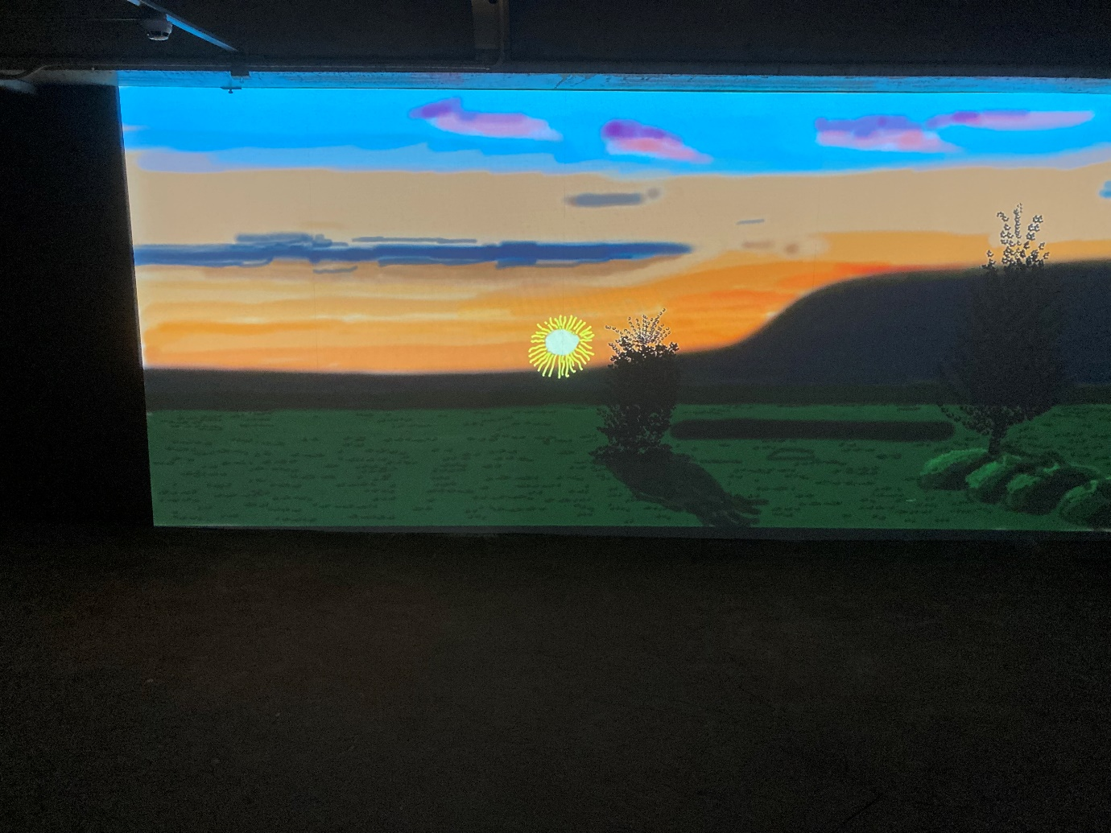
David Hockney from ‘A Year in Normandie 2020-2021’
Still from short film to accompany the exhibition
Photograph by Kelvin Ravenscroft

In the United States of America of the 1960’s Merton articulated a theology of resistance. His engaged spirituality can be regarded as presenting a Christianity which is counter-cultural, presenting a vision of the Kingdom of God in contrast to the dominant values of society. The contemplative spirituality which Merton devoted his life to was for many a catalyst for opposition to the Vietnam war, to racism and to the threat of nuclear annihilation.
His alternative vision of society, however, is rooted in the contemplative life. For Merton, to be a monk does not mean retreating to the monastery to escape from the realities of life; rather, it is in the monastery, in a spiritual community which affirms the interrelatedness of a life of prayer, study and work that true engagement with the world can begin to take place. Merton’s engagement with the world included dialogue with other faiths including Buddhism and Islam. He met His Holiness the Dalai Lama and Thich Nhat Hanh and he explored deeply the mystical tradition of Sufi Islam. He was inspired to dialogue with other ways of seeing the world because of his rootedness in his own spiritual tradition. His life of prayer and contemplation within the Christian tradition inspired and empowered him to confidently engage with other faiths in a spirit of genuine openness.
When Merton’s life ended prematurely in December 1968, he left the world with a spiritual vision and legacy which continues to inspire people from both within the Christian faith and beyond it to explore what it means to be a faithful person in the modern world. What can we take from Merton’s experience and relate it to our lives in 21st century Bradford and beyond?
The experience of grace, being unreservedly and unconditionally accepted and loved by God is a key element of Merton’s spiritual vision. The song ‘Grace’ from Jonathan Elias’ Prayer Cycle explores the nature of grace in its affirmation that all, ultimately, are carried by God.
MUSIC: ‘The Prayer Cycle’ cd Track 5: Movement V: Grace
(5 minutes & 54 seconds)
It can be suggested that a lesson which can be learned from Merton’s vocation is that he recognised and affirmed the importance of periods of quiet reflection in which one could spend time focusing on that which has value. Edmund O’Sullivan has commented in his exploration of the nature of transformative learning that
“As much as humans need to be in relation, there is also a very deep need for silence. We all find it necessary to be alone and in silence. We need sanctuaries where we can be in silence …. Silence does in some essential way enhance the quality of our lives …. Silence enables us to sanctify our lives. We are enabled in silence to come to a sense of the sacredness of our existence.
Alongside places of worship, educational and therapeutic institutions and business and commercial enterprises for example, can aim to incorporate into their work structures opportunities for silence, contemplation, reflection, meditation, and prayer so that each person can have the opportunity to experience periods of retreat from the all-pervasive and debilitating noise, tensions, and stresses of organisational and institutional life. Indeed, if teachers and therapists, priests and pastors, leaders and innovators are not in a position to have the opportunity to be alone, to be fully present to their experience, the world and God and to engage in reflection upon their own existence, how can they truly be present to those in their care?
In addition, it can be suggested that within the Christian tradition what should be seriously considered is how patterns of worship are often very much based upon words, whether in the form of saying prayers, singing hymns, reading from the Bible and preaching. However, where are the opportunities for deep stillness, profound silence to be found in much contemporary Christian life and ministry? Perhaps it is only through inner stillness and silence and the dissolution of the ego that we can truly be empowered and energized to engage meaningfully with the challenges of life today.
Symphony No.3, the Symphony of Sorrowful Songs, can be regarded as the Polish Roman Catholic Christian composer Henryk Gorecki’s most powerful work. It engages the listener with the horrors of the twentieth century, particularly the Second World War and the Holocaust for which the Nazis used Poland as a base from which to exterminate millions of people including six million Jews. Gorecki’s symphony utilises the imagery of a mother addressing her son who she fears is being taken away from her. The symphony, therefore, utilises Christian imagery, but it has, ultimately, a universal message.
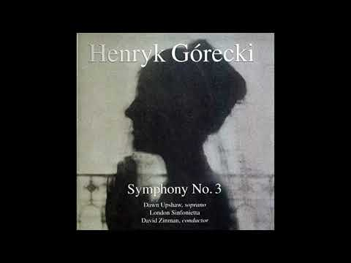
Through his message Gorecki has facilitated reflection upon the horrors of the world, a world in which humankind has often attempted to become God-like. The rise of Nazism presented a profound challenge to people of faith because they were required to consider who, or what, was really their God: what was really their ‘Ultimate Concern’. What actually was at the heart of their worship? This is a challenge for Christians today. What is the church’s mission all about? What are its roots? What does it aim to achieve? Is it rooted in waiting upon God to discern His will?
Gorecki has stated: “music is one of the domains that people really need, and its importance only depends on whether one knows how to receive it.” Christians believe that the Gospel, the Good News, is available through God’s grace, to all those who wish to receive it. The message of Jesus, therefore, like Gorecki’s music, acts as a witness and a warning. Authentic faith, deep spirituality, is not cosy and comfortable. Instead, it challenges us to explore at a profound level of our existence, at the very core of our being, who God is, what is His nature, how does God act, what does God require of us and how are people to live lives faithful to the life, death and resurrection of Jesus of Nazareth? Like Gorecki’s reflections upon the Second World War, Merton, in his critique of the war in Vietnam and in the challenges he presented to institutionalised racism, was drawing attention to the prophetic nature of the Christian faith. To be a contemplative is to speak out, from the depths of one’s being, to a world in which individuals and communities can appear to have lost their roots.
The Biblical account of Jacob’s encounter with the angel at Jabbok (Genesis 32: 22-32) can be regarded as presenting profound insights into the human condition and Thomas Merton’s spiritual journey can be thought of as profoundly and powerfully illustrating the existential power of Jacob’s experience.
One approach to the Jacob story is to suggest that it is the story not only of Jacob but of each one of us. Like Jacob who sets out on a journey to make peace with his brother Esau, we make plans which are clear, well thought out and aim to achieve a specific objective. The plans are implemented and things, initially, go smoothly.
However, something happens unexpectedly to disturb, challenge and overthrow our plans. We are thrown into chaos, confusion, and uncertainty. Yet, despite the surprise and shock which results from our plans going awry, we begin to face the challenges head on. We struggle and wrestle with that which appears to overwhelm us, and we attempt with difficulty to understand it; we try to categorise and ‘name’ it until, eventually, we reach a point where we can begin to move ahead and make progress with our life plans and projects.
However, we begin to realise that facing our challenges has not been without cost. We have been changed, perhaps even forever, by our experience and we may even have suffered hurt and loss. Despite this what might well be at the heart of the Biblical story is that, like Jacob who receives a new name, we find that we too, albeit slowly yet noticeably, have begun to undergo a subtle, yet significant transformation.
Indeed, perhaps unawares we have begun to become aware of a new reality, a different perspective on life opens up to us. Just maybe, like Jacob, we have caught a glimpse of what the ancient writers of the book of Genesis called the ‘face of God’.
Like Jacob, Thomas Merton wrestled with God. His life clearly suggests that although he was a person of deep faith, this trust in God did not come easily. It evolved and deepened. The wild young man at Cambridge, exploring the pleasures of the world and coming to terms with the loss of those he loved, was transformed over time into the contemplative and mystic who affirmed that personal and social transformation is at the heart of the Gospel.
The hope that Christians believe the message of Jesus of Nazareth offers, therefore, is not a panacea for life’s difficulties. It requires people of faith to engage with the world and to express faith in loving and compassionate action on behalf of those in need. Central to a contemplative spirituality, therefore, is personal and social transformation, a metanoia, a turning-around, a conversion, of individuals and communities. For Merton, this transformation was rooted in a life of prayer and waiting upon God, being available to, and present with, the Transcendent mystery, the Ground of our Being.
Echoing the spirituality of Liberation Theology, it is possible to declare that faith is expressed in praxis, engagement with the world. As Jesus indicates unambiguously in His Parable of the Good Samaritan, love of God is expressed in love of neighbour, in love of all those in need. Love, however, is not primarily a feeling; it is engagement with the many and varied challenges which the world of the 21st century faces including, for example, climate change, global warming, inequalities in the distribution of wealth and resources and the apocalyptic possibility of global economic collapse and, closer to home, the challenges and opportunities the city of Bradford faces.
This understanding of love was echoed by Martin Luther King Jr, in his declaration that: ‘When I speak of love I am not speaking of some sentimental and weak response. I am speaking of that force which all the great religions have seen as the supreme unifying principle of life. Love is somehow the key that unlocks the door which leads to ultimate reality.’ For Thomas Merton, this love is rooted in prayer, contemplation, meditation, and reflection.
Each individual is an artist who out of the raw materials of their existence strives to fashion something which has meaning. Faith traditions are for many a profound vehicle for exploring and expressing their self-understanding and their relationships to, and with, others, the world and God. Reflection upon significant features of Thomas Merton’s spiritual vision can suggest that within communities of faith it is possible to be introduced to an activity and a process which can be called Narrative Spirituality. This approach suggests that through a sensitive and empathic exploration of an individual’s life it is possible to discern the perspective, the way of seeing, philosophy of life, the spirituality they articulate. This can be explored in terms of its relationship to, and meaning for, the world today. The approach of Narrative Spirituality would acknowledge that in exploring the life, legacy and vision of Thomas Merton there are three interrelated dimensions which can be investigated in order to appreciate the depth and breadth of his significance for the world of the twenty first century.
The first dimension would aim to explore what can be called the Historical Merton. This would involve a detailed study of Merton’s life and work which would aim to facilitate an accurate reconstruction of the events of his life in the context of the world in which he lived.
The second dimension to be explored can be termed the Post-Historical Merton. This dimension would explore responses to Merton’s life as expressed, for example, by biographers, theologians, musicians, and poets in which the creative imagination engages in a dialogue with his spiritual vision.
These responses to Merton can be called post-historical because they release Merton from his specific historical, social, political, and cultural context and facilitate the rediscovery and reinterpretation of his life and work by contemporary and future generations. Through the responses of artistic and literary creativity the story of Thomas Merton is told anew and he therefore transcends his particular historical context and his spiritual vision is made available to be (re)discovered in each new generation.
Exploration of the post-Historical Merton can facilitate exploration of a third dimension which can be called the Expressionist Merton. In this dimension we can begin to explore what meaning and significance the life and legacy of Merton may have for our own lives. In this approach we are encouraged to explore our self-understanding, our ways of seeing, our spiritualities, both as individuals and as communities. This approach recognises that the self and the groups and communities to which we belong are in a process of change and development. A self is not fixed and static but is dynamic, creative, open to experience and able to change, grow and develop. All of life, the spiritual life, necessitates growth and development. As Merton confirms life is, ultimately, movement towards a deeper experience of God.
It can be suggested that within our places of worship, our schools, colleges, universities, hospitals, businesses and places of leisure it is essential to have opportunities to be nourished not only physically but spiritually, morally, emotionally, aesthetically, intellectually and psychically. Exploration of the Expressionist Merton, therefore, aims to enable us to recognise that, echoing Martin Buber, we are the ’I’ who encounters the ’Thou’, the spirituality and vision, of Thomas Merton; we engage in a creative dialogue with his life and legacy.
Exploration of the life and legacy of Thomas Merton can, therefore, facilitate exploration of the links between existential questions and spiritual perspectives about people, the world and the cosmos and reflection upon the meaning and significance of his vision can provide us with the opportunity to consider, reflect upon and share our own experiences of the search for meaning and identity. A Narrative approach to spiritual development, therefore, celebrates the importance of, for example, Bible study, prayer, worship and spiritual direction which engages with each individual’s personal narrative, their journey of faith and encourages the sharing of these stories in community in which the narratives of the Bible and Christian tradition creatively interact with each other.
There is a real potential for the development of a programme of Christian education which explores of the spirituality of Thomas Merton in terms of the framework for human potential presented in the psychologist Ted Landsman’s concept of the Beautiful and Noble Person.
In Landsman’s perspective there are three aspects to the development of the Beautiful and Noble person. The first aspect is termed the Passionate Self which is characterised by self-respect and self-acceptance. Such an individual perceives themselves as being a worthwhile person. This acceptance of self facilitates development of the second aspect of the growth of nobility and beauty which is termed the Environment Loving Person for whom there is a passionate concern for the physical environment and the natural world. The world is perceived and experienced from a perspective of joy and celebration. This encounter between the person and the world facilitates the development of the third, social, dimension of the Beautiful and Noble Person which is described as the Compassionate Self. This person deeply cares about others about and loves others, including those who are in need. This empathy is translated into action on behalf of those who suffer.
It can be suggested that Thomas Merton was truly a Beautiful and Noble Person. He was a person who valued himself, others and the world in which he lived. He was a Passionate Self; a person who said a resounding Yes! to life and is an inspiring example of what a life rooted prayer, contemplation, meditation and reflection can be.
In October 2007 I had the privilege to attend at Durham Cathedral the world premiere of Jon Lord’s Durham Concerto. We conclude this exploration of Thomas Merton’s spiritual vision with a track from the Concerto entitled The Road to Lindisfarne.
Merton wrote: “This is what it means to be a Christian: not simply one who believes certain reports about Christ, but one who lives in a conscious confrontation with Christ in himself and in other men. This means, therefore, the choice to become empty of one’s self, the illusory self fabricated by our desires and fears, the self that is here now and will cease being here if this or that happens.”
I dedicate this music and this evening to the memory of Thomas Merton.
MUSIC: ‘Durham Concerto’ cd Track 3: The Road to Lindisfarne
(7 minutes & 18 seconds)

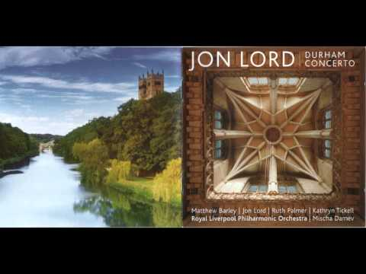

Reflection 8: International Janusz Korczak Association Projects 2009-2010
In Reflection 1 above, I explored the artist David Hockney’s exhibition ‘A Year in Normandie 2020-2021’. For many people, Hockney’s paintings depicting the Spring of 2020, which coincided with the onset of the coronavirus pandemic, provided a glorious, joyful, and vibrant response to the new life, the renewal of nature, which Spring heralds.
In effect, being rooted in Normandy, Hockney found a place and a space in which he could testify to the arrival of Spring. This environment has resulted in a prolific output of work, particularly in recent years, which has broadened to include not only an affirmation of the coming of the Spring but also records sensitively the changing of the seasons.
In Reflection 2, I explored Luke Jerram’s ‘Gaia’ installation which I viewed at Lancaster Priory which testifies to the fragile beauty of the Earth.
In Reflection 3, I explored the experience of Kazu and Haru Shimazaki as they began a new life in rural Japan creating an oasis of calm, peace, and tranquility in creating a farm. It is in their immersion in nature that provides them, in effect, with what can be regarded as a place of healing and restoration, a place in which they discover their true selves. My late Father, Derek, told me as a boy that the greatest gift in life is to have peace of mind and I find that as the years pass, and as I have entered old age, I continue to firmly agree with his view.
In Reflection 4, I explored the perspectives of the artist Edel Adnan and the ways in which she has been inspired by the life and work of Vincent Van Gogh. Both Etel and Vincent affirm and celebrate the intensity, vibrancy and the sheer ‘aliveness’ of nature.
In Reflection 5, I present ‘Encountering Wonder-The Child’s response to Nature’ with a focus on the pedagogical philosophies of Janusz Korczak and Vasily Sukhomlinsky and Refection 6, ‘Seeing the World Anew’, builds upon and develops the key concepts, themes and ideas presented here.
In Reflection 7, I explored ‘Contemplation in a World of Action, the spiritual vision of Thomas Merton in which an affirmation of the nurturing of the contemplative life is presented.
In Reflection 8, I look back to a project I initiated during the autumn of 2009. I put forward a proposal to the International Janusz Korczak Association for a series of five projects which could be put into practice in a range of educational contexts, Projects 4, ‘Space for Reflection’ and Project 5, ‘Sanctuary’, affirm the importance of spaces and places which facilitate contemplation and wellbeing.
The process of creating this portfolio of five projects was undertaken as a therapeutic activity during a time of significant ill health, a period in my life of profound change in which creativity, and the recognition and affirmation of beauty, in its many and diverse forms, played a healing role.
This time in my life confirmed the vital importance of spaces and places for contemplation, reflection, meditation and prayer in, for example, schools, colleges and universities, in places of worship, in community settings and also the cultivation of personal, private spaces and places in which one can experience renewal and restoration.
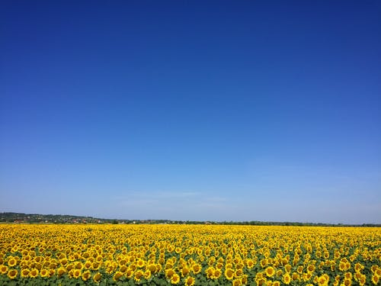
Photograph by K Zoltan www.pexels.com

International Janusz Korczak Association

Project Proposal
2009-2010

by
Kelvin Ravenscroft

Warsaw, September 2009

Introduction

1979 was designated by the United Nations as the International Year of the Child. The year was inspired by the life and work, the values and vision of Janusz Korczak, an advocate of children’s rights and a pioneer of child-centred education.
During this 30th anniversary of the International Year of the Child it is appropriate to reflect upon both the life and work of Janusz Korczak and to consider how the values and principles enshrined in the United Nations Convention on the Rights of the Child need to continue to be affirmed throughout the world today.
This paper outlines proposals which illustrate how Janusz Korczak Associations, Networks and Groups throughout the world can actively and creatively participate in a project during 2009-2010. The projects outlined aim to provide opportunities to combine creativity with scholarly rigour and to promote critical thinking and the development of transferable skills.
There are five projects outlined from which Korczakians should select one project to work upon. The aim would be to plan and actualise the project, as far as possible, during the period October 2009 to July 2010. The outcomes of the projects would then be presented at the International Janusz Korczak Association Conference in Tokyo in August 2010.
The Tokyo Conference programme would include sessions which would present the projects undertaken by Korczak groups from around the world. These presentations could be incorporated into the proceedings of the Conference which would be multi-media in format.
The aim is to make reflection upon the life, work and legacy of Janusz Korczak and the values and vision he articulated a living experience in which his passionate advocacy for the welfare and well-being of the child is recognised as being at the heart of the ethos and philosophy of educational, therapeutic, and cultural organisations, groups and initiatives and programmes.
Feedback upon the proposals is welcome. Your thoughts, comments and observations about the projects can please be e-mailed to Kelvin Ravenscroft at krikona@aol.com

Janusz Korczak

Janusz Korczak was born on 22 July 1878 as Henryk Goldszmidt in Warsaw. His parents were Cecylia and Josef Goldszmidt. The name Janusz Korczak was originally adopted by Henryk as a literary pseudonym. This pseudonym was adapted from J I Krazewski’s nineteenth century novel ‘Janasz Korczak and the Pretty Sword Sweeper Lady’. Although Josef Goldszmidt was actively involved in Jewish causes, particularly education, Henryk grew up in an assimilated Polish speaking middle class Jewish family which appeared to have little affinity for Jewish tradition. Following the death of his father at a psychiatric clinic in 1896 Janusz had to support himself while graduating from secondary school and then studying at Warsaw University’s Institute of Medicine. In addition to his medical career, however, Korczak developed a successful literary career, particularly as a writer of stories for children, together with a significant profile in radio broadcasting for which he hosted a children’s programme which he called ‘Gadaninki Starego Doktora’ (‘The Old Doctor’s Little Wisdoms’) Although it appeared that Korczak would be destined for a prolific academic career he chose instead to utilise his skills for the benefit of the poor and orphans in Warsaw’s slums.
In his novels ‘Dzieci Ulicy’ (‘Children of the Street’) (1901) and ‘Dziecko Salonu’ (‘Children Of The Parlour’) (1904) Korczak emerged as an advocate of the rights of children which he believed were all too often denied by adults. Korczak’s later books including ‘Krol Macius I’ (‘King Matty the First’) and ‘Kroll Macius na Bezludnej Wyspie’ (‘King Matty on a Desert Island’) explore the theme of how children can gain dignity and affirmation and a place in which they can articulate their dreams. In addition to his medical, literary and radio careers Korczak was also one of the founders and head from 1912-1942 of the Jewish Dom Sierot (The Orphans’ Home) and the orphanage Nasz Dom (Our Home) for Polish children from 1916- 1936. In these children’s’ homes Korczak put into practice the principle that children should be treated as equal partners with adults with rights including the right to be loved. Following the Nazi invasion of Poland Korczak and two hundred of his charges, together with about 400,000 other Jews were forced into a walled Ghetto in Warsaw. Despite the inhumane conditions of the Ghetto Korczak aimed to maintain a civilised regime in order that the children could still thrive as far as possible. On the 5th of August 1942 the Nazis ordered the children to leave the orphanage from which they were transported to their deaths at the concentration camp at Treblinka. Friends from outside the Ghetto made arrangements for Korczak to escape but he chose to remain with his children. Korczak felt that it was not necessary to inform the children of their destination. Instead, he and his staff said that they were going on a visit to the country for which they could take along a few toys. They marched out of the building holding their heads high carrying the flag that Korczak had designed, green with white blossoms together with the blue Star of David. Two weeks after the evacuation of the orphanage the Warsaw resistance movement commenced.

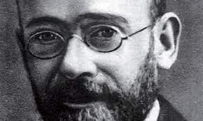
Janusz Korczak

Janusz Korczak and Article 29
of the United Nations
Convention on the Rights of the Child

Point 1 of Article 29 of the United Nations Convention on the Rights of the Child declares that:
“States Parties agree that the education of the child shall be directed to:
(a) The development of the child's personality, talents and mental and physical abilities to their fullest potential;
(b) The development of respect for human rights and fundamental freedoms, and for the principles enshrined in the Charter of the United Nations;
(c) The development of respect for the child's parents, his or her own cultural identity, language and values, for the national values of the country in which the child is living, the country from which he or she may originate, and for civilizations different from his or her own;
(d) The preparation of the child for responsible life in a free society, in the spirit of understanding, peace, tolerance, equality of sexes, and friendship among all peoples, ethnic, national and religious groups and persons of indigenous origin;
(e) The development of respect for the natural environment.”
It can be suggested that this Article has at its core the values and principles, the vision for the welfare and well-being of children embodied in the life and work of Janusz Korczak. Indeed, the Article affirms that the personality, talents, and abilities of children have to be actively nurtured and developed.
The Project Proposals outlined below incorporate opportunities for consideration of the links between Janusz Korczak’s life and legacy and the values and principles which he articulated and embodied and the philosophy of the United Nations Convention on the Rights of the Child.

Project Rationale

The International Janusz Korczak Project Proposal for 2009-2010 presents five distinct, yet related, projects which aim to explore Janusz Korczak’s life, work, vision and legacy through their relationship to the values and ethical principles embodied in the United Nations Declaration on the Rights of the Child.
The focus of this year’s Project Proposal is Article 29 of the United Nations Convention. The five projects outlined below facilitate exploration of Korczak’s vision through a range of media including a combination of practical projects and scholarly study which present a range of media through which Korczak’s pedagogical philosophy is related to the lives, experiences, hopes and aspirations of people in the modern world.
At the heart of all five of the projects outlined below are the following: the primacy of meaning, the centrality of values, dialogic encounter, the ethical dimension and a philosophy of pedagogy. The projects allow pupils, students, teachers, youth and community groups and those who are engaged in work in, for example, therapeutic and faith community settings to creatively and meaningfully engage with Korczak’s vision, to make everything he stood for come alive and be actualised in contemporary society.
- The Primacy of Meaning
Korczak commented that:
“There are one hundred more days left till spring. There is, as yet, not a blade of grass, not one single bud is showing. But inside the soil, among the roots, the dictate of spring is already there, secretly persisting, throbbing, lurking, waiting and gathering strength - under the snow, inside the bare branches, in the icy gale - to suddenly burst into blossom.”
He is affirming that even when things look bleak, when life’s challenges appear to overwhelm us and when we find it difficult to discern any possibility of hope or optimism there is, at the heart of things, the potential for positive change, transformation and development. This can also be regarded as a metaphor for understanding and relating to children. Instead of adults focusing on the negative in the child’s behaviour, actions and attitudes they should, instead, aim to affirm the positive and from these small acorns mighty oaks might grow. The entire pastoral system in schools, for example, should be geared towards transforming negativity in all its forms through the transformational power of positive life-affirmation. Educational and therapeutic organisations should, therefore, have at the heart of their aims, objectives, philosophy and mission-statements the central question of ’In what ways do we promote the positive in, and for, our children?’ Addressing this question honestly and realistically, but with a sense of an achievable positive vision, can encourage and empower schools and related educational and therapeutic enterprises to create an ethos which celebrates positive transformation in all its many and varied forms. Such an ethos, however, has to radically address profound questions of meaning, significance and purpose.
- The Centrality of Values
Exploration of Article 29 of the United Nations Convention on the Rights of the Child suggests that at the heart of the approach to the welfare and well-being of children articulated is the centrality of values such as, respect, peace, tolerance, equality, friendship, understanding and responsibility.
The five projects outlined below aim to explore and actualise such values through their promotion in the project communities and in the process of project realization.
- Dialogic Encounter
Korczak declared:
“When I approach a child, I have two feelings; affection for what he is today and respect for what he can become.”
He recognises the creative dialectic between the present and the future, between potential and actuality and the interplay of the positive emotions of affection and respect. For Korczak the starting point for both education and therapy is the experience of the child in the present moment. This present, however, is rooted in an existential context. Each child has a personal history and this impacts upon their development and the unfolding of their future. For the pedagogist, therefore, to facilitate meaningful teaching and learning requires that in addition to being self-aware the teaching and therapeutic enterprise requires knowledge of the child. There are, however, no short cuts to this knowledge. The role of the teacher requires that she pays attention to, for example, what each child says, how each child acts, what each child writes and how each child expresses themselves in, for example, art and music. This task requires time, effort and energy and is an ongoing process in which new and, at times, unexpected insights into the child and their way of seeing the world are articulated. The teacher and therapist, therefore, share the experience of entering into a dialogue with each child.
The dialogue between teacher and child can significantly complement the positive nurturing provided by the child’s family. However, there will inevitably be cases where the teacher and therapist are the primary source of an affirmative dialogical encounter. It can be suggested, therefore, that the foundation for the development of a civic and humane society is the establishment of relationships characterised by openness, spontaneity, warmth, genuineness and compassion. Indeed, what can be termed Dialogic Encounter or Moral Personalism, the ‘I-Thou’ philosophy articulated by Martin Buber, can be viewed as being an ethic of human relationships which should underpin the entire ethos of all organizations and institutions entrusted with the care and nurture of children.

- The Ethical Dimension
If one explores the eight attitude-virtues of humility, self-acceptance, responsibility, self-commitment, friendliness, concern, contemplation and trust outlined by the philosopher Donald Evans as a vision of the moral life there is the potential to explore Korczak’s life and work, meaning and significance from the perspective of his moral authority which can be regarded as being the outcome of his deep spirituality and his way of seeing and being in the world. Exploration of Korczak’s life and legacy has the potential to facilitate the spiritual, moral, social, and cultural development of children because it explores ways of seeing the world which reflect the possibility of moral change. Persons do not, in Korczak’s vision, have to remain in a state of moral regression or immaturity; they can move forward and develop the qualities of rationality, responsibility, autonomy and altruism which William Kay has identified as being the characteristics of the Morally Educated Person.

- A Philosophy of Pedagogy
Korczak wrote:
“What a powerful effect on the sad life of a child, would be the memory of that person - perhaps the only one - who showed kindness, understanding and respect in a world where cruelty had become the norm. The child’s future life and sense of himself could take a different course, knowing there was one person who would not fail him.”
He is recognising that parents, relatives, friends, teachers, carers, and therapists, for example, all have the capacity to engage with children in a way which affirms their value, worth and uniqueness. In terms of schools, therefore, the teacher is not primarily a teacher of mathematics, technology, science, history or art, for example, but is first and foremost a teacher of children. However, the teacher is also a learner from children. At the heart of the process of teaching and learning is the nature of the positive relationship between the teacher and her children. For many children, particularly for those who are from emotionally disadvantaged backgrounds, their only positive interaction with adults is those they experience with their teachers at school. Central to the role of the teacher, therefore, is the pastoral work in which she is engaged on a daily basis. Everything a teacher does or says is a learning opportunity for the child and presents them with an example, either positive or negative, of what it means to grow and mature. Indeed, Korczak declared:
“Be yourself and seek your own path. Know yourself before you attempt to get to know children. Become aware of what you yourself are capable of before you attempt to outline the rights and responsibilities of children. First and foremost you must realise that you too are a child, whom you must first get to know, to bring up and to educate.”
Central to this perspective, therefore, is the Socratic injunction to ‘Know thyself’. The teacher or therapist must aim to become aware of her identity, her personality, her strengths and weaknesses and the ways in which she can promote or inhibit the child’s spiritual, moral, social and cultural development. The philosophy of pedagogy articulated by Korczak, therefore, is rooted in the experience of authentic dialogue between the child and those responsible for their care.

Project 1: Peace Cranes

“My share in the Japanese war. Defeat – disaster.
In the European war – defeat – disaster.
In the world war …
I do not know how and what a soldier of a victorious army feels …”
- Janusz Korczak: ‘Ghetto Diary’

In August 2010 the conference of the International Janusz Korczak Association will take place in Tokyo, Japan. Project 1, therefore, incorporates a significant Japanese dimension through its linking of the life and work and values and vision articulated by Janusz Korczak with the values and principles presented in the United Nations Convention on the Rights of the Child through the medium of the inspirational example of the life of Sadako Sasaki who dedicated the final years of her life to promoting peace through the symbol of the crane.
In Japanese legend cranes are said to live for a thousand years and throughout Asia cranes are regarded as a powerful symbol of eternal youth and happiness. Throughout the ages the crane has inspired writers and artists.
6 August 2010, marks the sixty-fifth anniversary of the atomic bombing of Hiroshima in Japan. Ten years after the bombing, a young Japanese girl called Sadako Sasaki (7 January 1943 – 25 October 1955) died from leukaemia caused by radiation from the blast. Before she died, however, Sadako folded almost a thousand origami paper cranes.
Sadako was motivated to begin her project through the inspiration of a legend that said anyone who folded a thousand paper cranes would be granted a wish. Sadako wished to regain her health so that she could run and play like before and she pursued this aim with such a positive determination and energy that, although she died of the cancer, she was successful in transforming the paper crane into a symbol of peace for children all over the world.
After Sadako's death, children joined together to raise money for a peace park in Hiroshima, and a statue of Sadako holding a crane. Today there is also a small peace park with a statue of Sadako in Seattle, Washington, and children throughout the world fold origami paper cranes in her memory and send them to Japan and Seattle threaded on long strings to be draped over the statue.
Sadako's inspirational experience is used as a vehicle for exploring with children the consequences of war and conflict and the power of individuals to facilitate change.
Further information about Sadako’s life can be found at www.sadako.com and as preparation for this project it would be valuable to read Eleanor Coerr’s book ‘Sadako and the 1000 Paper Cranes’.
Project 1 consists of the following elements:
The Process:
The Peace Cranes project is a collaborative, group venture in which the contributors choose to reflect upon Sadako Sasaki’s life and legacy with reference to the outcomes detailed below. The project process involves collaboration and negotiated aims and objectives in a democratic framework.
The project process should aim to incorporate a range of media and materials which utilises the range of skills and talents of the project group members. Although the editing and production of the material can utilise Information and Communications Technology such as Desktop Publishing software, consideration should also be given to creating a publication which is itself a work of art. The produced copies of the Peace Cranes can, in effect, be presented as limited edition publication which, in terms of style, content and presentation, is of a very high standard.
The Outcome:
The range of contributions created during the project process including artwork, poetry, and prose is collated and edited to form Peace Cranes, a book of memory and reflection upon the moral vision of Sadako Sasaki. The book should aim to be of as professional a standard as possible and should include four key elements:
- Reflections upon the life of Sadako Sasaki: Who was she? What were the values and principles by which she lived her life? What was the inspiration for her vocation as an advocate of peace? What challenges did this work present to her? How did she respond to these challenges?

- The meaning of Sadako Sasaki for today. What can we learn from her life and example? How can she be regarded as an inspiration for compassionate action in the world of today? What are the key values and principles she articulated which can be regarded as being meaningful today?

- Sadako Sasaki, Janusz Korczak and the United Nations Convention on the Rights of the Child. Reflections upon the ways in which Sadako’s life and legacy can be regarded as embodying the values and principles actualised by Janusz Korczak and articulated in the UN convention.

- The Peace Cranes process. The publication should include reflections upon the process of the Peace Crane’s planning, writing, editing and production. All of the project’s participants should present a statement reflecting upon what they have learned from the process of creating the publication. What have been the positives of creating it? What have been the challenges? In what ways has participation in the project facilitated personal and professional development?

Project 2: Andrzej Wajda’s ‘Korczak’

“I’ve been avoiding it, but to no avail, I’m making another film!
What’s worse, it’s ambitious.
I have growing hopes that it will be something beautiful,
harmonious and significant …”
- Andzrej Wajda

The inspiration for Project 2 is Andrzej Wajda’s 1990 film ‘Korczak’ which presents a profoundly moving, powerful and compelling portrayal of Janusz Korczak’s dedication, altruism and self-sacrifice. Wajda’s film is a powerful resource for exploring the experience of Jews in the Warsaw Ghetto, particularly of children, and presents a compelling portrayal of Janusz Korczak’s dedication, altruism and self-sacrifice.
The interplay of Wajda’s direction, Agnieszka Holland’s screenplay and the performance of Wojtek Pszoniak as Korczak combine to produce a moving and powerful presentation of courage in the face of man’s inhumanity.
‘Korczak’ has been acclaimed as one of Wajda’s greatest works and it relates closely to the concepts, themes and ideas which he has developed in later works such as ‘The Holy Week’ and ‘Katyn’. Although all three of these films are rooted in the Polish experience of the Second World War it can be suggested that the power of their narratives derives from Wajda’s exploration of the relationships, encounters, interactions and dialogues (both positive and negative) which are at the heart of human existence. Wajda inspires and empowers the viewer of his films to engage not only with the experience of the past but he elicits a dialogue with the films so that the viewer has to consider and reflect upon how the experiences the films presents, articulates and grapples with relate to the experience of the modern world.
Indeed, in his most recent film, ‘Tatarak’ (‘Sweet Rushes’) Wajda combines the fictional experience of an older women and the love of a young man who is accidentally killed with the real life experience of the actress who reflects upon the death of her husband.
Project 2, therefore, aims to facilitate engagement of the transformative and inspirational experience of Korczak and his orphans in the Warsaw Ghetto with the experience in the modern world of transformative and empowering pedagogical encounter.
Project 2, therefore, consists of the following elements:
The Process:
The Andrzej Wajda’s Korczak project is a collaborative, group venture in which the contributors choose to reflect upon Wajda’s portrayal of Korczak’s life and legacy with reference to the outcomes detailed below. The project process involves collaboration and negotiated aims and objectives in a democratic framework.
The project process should aim to incorporate a range of media and materials which utilises the range of skills and talents of the project group members. Although the editing and production of the material can utilise Information and Communications Technology such as Desktop Publishing software, consideration should also be given to creating a publication which itself can be regarded as a work of art.
The produced copies of the Andrzej Wajda’s Korczak can, in effect, be presented as limited edition boxed set publication which, in terms of style, content and presentation, is of a very high standard. The publication ‘Wajda’s Films’ (Wydawnictwa Artystyczne I Filmowe, Warsaw, 1996) can act as an example of the type of format the project publication may wish to take and includes a range of material including photographs, drawings, storyboards and reviews.
The publication can be accompanied by a storage box which should also be designed and created by the project participants. The box should, in its design and content, aim to express the essence of the life and legacy of Janusz Korczak.
The Outcome:
The range of contributions created during the project process including artwork, photography, commentary and critical analysis is collated and edited to form a work incorporating both Film Criticism and Cultural Studies. The publication should aim to be of as professional a standard as possible and should include five key elements:
- Reflections upon the life of Janusz Korczak. In what ways does Wajda explore the following questions: Who was Korczak? What were the values and principles by which he lived his life? What was the inspiration for his vocation as an advocate of the child? What challenges did his work present him and the children with? How did he respond to these challenges?

- Critical reflections upon Andrzej Wajda’s Korczak. How should the film be evaluated? A range of critical responses to the film should be presented. What are the film’s strengths and weaknesses?

- The meaning of Korczak for today. What can we learn from his life and example? How can he be regarded as an inspiration for compassionate action in the world of today? What are the key values and principles he articulated which can be regarded as being meaningful today?

- Korczak and the United Nations Convention on the Rights of the Child. Reflections upon the ways in which Korczak’s life and legacy can be regarded as embodying the principles of the UN convention.

- The Andrzej Wajda’s Korczak process. The publication should include reflections upon the process of planning, writing, editing and production. All of the project’s participants should present a statement reflecting upon what they have learned from the process of creating the publication. What have been the positives of creating it? What have been the challenges? In what ways has participation in the project facilitated personal and professional development?
Project 3: ‘Pamietnik’ : Memories, Dreams and Reflections

“Thank you, Good Lord, for having ordered all so wisely,
That the flowers are fragrant, the glow-worms glow upon the earth, the stars sparkle in the sky.
Hoe joyous is old age. What a delectable silence.
Delectable repose.”
- Janusz Korczak ‘Ghetto Diary’

The ‘Ghetto Diary’ presents Janusz Korczak’s powerful and poignant observations, meditations and reflections upon the experience of life with his orphans in the Warsaw Ghetto. It contains wide ranging reflections upon the joy and pain, the challenges and opportunities, presented by existence. In his ‘Ghetto Diary’ Korczak looks back upon his life and he reflects upon significant experiences, including those of his childhood, which have impacted upon his development.
In a profound sense the ‘Ghetto Diary’ is a book of memory in which Korczak attempts to make sense of his life in relation to his vocation as a children’s advocate. In Polish, a diary, a book of memory is known as a pamietnik. There is a very real sense in which a pamietnik, however, is not simply a factual time-line recording of events but is also a reflection and commentary upon event, upon memory. As a literary genre, therefore, it is a creative synthesis of historical and existential reflection. The past and the present are inextricably interrelated.
Project 3 takes the form of a contemporary Pamietnik which, incorporating prose, poetry, artwork and music, for example, presents a reflection upon the life of Janusz Korczak and his significance for the world of today. The Pamietnik project can be developed by pupils and students in a range of educational settings and can also be developed as part of the programme of pedagogical education in Institutes and Departments of Teacher Education and Training.

The Process:
The pamietnik project is a collaborative, group venture in which the contributors choose to reflect upon Korczak’s life and legacy with reference to the outcomes detailed below. The project process involves collaboration and negotiated aims and objectives in a democratic framework.
The project process should aim to incorporate a range of media and materials which utilises the range of skills and talents of the project group members. Although the editing and production of the material can utilise Information and Communications Technology such as Desktop Publishing software, consideration should also be given to creating a publication which is itself a work of art. The produced copies of the pamietnik can, in effect, be presented as limited edition publication which, in terms of style, content and presentation, is of a very high standard.
The Outcome:
The range of contributions created during the project process including artwork, poetry, and prose is collated and edited to form a pamietnik, a book of memory. The pamietnik should aim to be of as professional a standard as possible and should include four key elements:
- Reflections upon the life of Janusz Korczak: Who was he? What were the values and principles by which he lived his life? What was the inspiration for his vocation as an advocate of the child? What challenges did his work present him and the children with? How did he respond to these challenges?

- The meaning of Korczak for today. What can we learn from his life and example? How can he be regarded as an inspiration for compassionate action in the world of today? What are the key values and principles he articulated which can be regarded as being meaningful today?

- Korczak and the United Nations Convention on the Rights of the Child. Reflections upon the ways in which Korczak’s life and legacy can be regarded as embodying the principles of the UN convention.

- The Pamietnik process. The publication should include reflections upon the process of the pamietnik’s planning, writing, editing and production. All of the project’s participants should present a statement reflecting upon what they have learned from the process of creating the publication. What have been the positives of creating it? What have been the challenges? In what ways has participation in the project facilitated personal and professional development?

Project 4: Space for Reflection
The experience of Janusz Korczak and his orphans in the Warsaw Ghetto of Nazi-occupied Poland was located in the context of an apocalyptic vision of a world which appeared to have gone mad. The old order had been subverted and a chilling ideology was systematically and clinically defining millions of people as undesirable, as being less than human, for whom the only fate was certain death.
In his ‘Ghetto Diary’ Korczak declared:
“Thank you, Merciful Lord, for the meadow and the bright sunsets, for the refreshing evening breeze after a hot day of toil and struggle.
Thank you, Merciful Lord, for having arranged so wisely to provide flowers with fragrance, glow worms with the glow, and make the stars in the sky sparkle.”
He is offering a prayer of thanksgiving for the beauties of the earth. His cosmic gratitude is rooted in an appreciation of the natural world which, despite the sufferings of life, can present to humankind a vision of beauty and joy. Korczak’s contemplation, reflection and meditation were undertaken in the midst of the hectic life of the orphanage in the Warsaw Ghetto at a time when the lives of he and his children hung in the balance. The future was most uncertain. Despite this Korczak took the time to mindfully and attentively focus not solely on the challenges, stresses and strains of running the orphanage but, instead, he took the time to be grateful for each positive aspect of the children’s existence. He said a glorious Yes! to life when it would have been understandable for him to have been ground down by the daily challenges he and his children faced.
Central to Korczak’s vision, and at the heart of his legacy, therefore, is the recognition that in a world of unpredictability, uncertainty, and even chaos, it is imperative to attempt to create oases of calm, order and structure which provide the possibility of meaning and hope for the future. Even in the darkest situation there is the possibility of discerning meaning and hope, however small this might be. In the world of the 21st century, with its significant challenges and opportunities, Korczak’s recognition of the requirement to create order out of chaos, meaning out of meaninglessness, is to be taken seriously.
This project aims to explore Korczak’s affirmation of the primacy of oases of calm through the creation of a Space for reflection. This project has two distinct, yet related aspects to it. Firstly, it aims to create a physical space in which, for example, pupils, students, teachers, therapeutic groups and faith communities can fins what can be termed a sanctuary, a space apart, a place of quiet and calm.
Secondly, the creation of this physical space is followed by the establishment of a programme of reflective, contemplative, and meditative techniques and strategies which aim to actively foster within individuals and groups the positive peaceful values articulated both in Korczak’s vision and in Article 29 of the United Nations Convention on the Rights of the Child.
The project consists of the following two elements:

The Process:
The Space For Reflection project is a collaborative, group venture in which the participants choose to reflect upon Korczak’s life and legacy with reference to the outcomes detailed below. The project process involves collaboration and negotiated aims and objectives in a democratic framework.
An unused or underutilised space in a school, college, or university, for example, is identified with a view to transforming it into a Quiet Space and Place which is non-denominational in nature. The Space should be suitable for use by people from religious and secular traditions.
The project of transforming the space should aim to incorporate a range of media and materials which utilises the range of skills and talents of the project group members. Consideration should be given to the impact of the appearance and layout of the Space
The Space should aim to facilitate reflection and contemplation and it should aim to create an aesthetically pleasing and environmentally sustainable quiet place which facilitates reflection upon positive values and principles such as those embodied in the life and work of Janusz Korczak The Space For Reflection, in terms of style, content and presentation should aim to be of very high standard.
The Outcome:
The process of transformation of the selected space and its evolution as a Space For Reflection should be documented in selected medium such as, for example, photography, film or a website.
The documenting of the Space For Reflection project should aim to be as professional a standard as possible and should include four key elements:
- Reflections upon the life of Janusz Korczak: Who was he? What were the values and principles by which he lived his life? What was the inspiration for his vocation as an advocate of the child? What challenges did his work present him and the children with? How did he respond to these challenges?

- Korczak and the Space For Reflection. In what ways does the Space that has been created speak of the key values and principles Janusz Korczak articulated and how does the Space inspire in those who will experience it a sense of these values?

- The Space for Reflection process. The documenting in the selected media of the project should include reflections upon the process of the Space’s planning, development, and creation. All of the project’s participants should reflect upon what they have learned from the process of creating the Space for Reflection. What have been the positives of creating it? What have been the challenges? In what ways has participation in the project facilitated personal and professional development? What ongoing work will be required to sustain and nurture the Space?

- Reflections upon the ways in which planning and participation in the programme of meditative, contemplative, and reflective events and activities has facilitated spiritual, moral, social and cultural development and consideration of what the project participants understand to be the key features and characteristics of Janusz Korczak’s spirituality and ethics.

Project 5: Sanctuary

“Is it not enough that I experience a feeling of joyful gratitude?
as I see them grow and toughen? Is this in itself not a sufficient reward for the work done?
Haven’t I the right to be a disinterested worshipper of nature,
to watch the shrub become green?
- Janusz Korczak: ‘The Boarding School’

Amidst the trials and tribulations of the Ghetto experience with the possibility of death and ever-present reality, Korcak recognised and affirmed the requirement to create and maintain an atmosphere of beauty, calm and order, particularly from the natural world. Although Korczak could easily have become overwhelmed by the enormity of the challenges he faced he was resolutely determined to give the children in his care the experience of the natural world, however limited this may understandably have been. It is clear, therefore, that Korczak had a profound respect for nature.
Point (e) of Article 29 of the United Nations Convention on the Rights of the Child states that “Parties agree that the education of the child shall be directed to …the development of respect for the natural environment.”
Project 5, therefore, explores the concept of respect for the natural environment through the planning, development, creation and maintenance of a natural space which embodies the values of peace, tolerance, equality, friendship, understanding and responsibility which characterised Korczak’s life and are affirmed in the United Nations Convention.
Indeed, it can be suggested that ‘respect for the natural environment’ underpins all aspects of Article 29 because, ultimately, the ‘environment’ is not restricted to the physical, material, natural world but also refers to the dynamic network of relationships and interactions, the ‘web of life’ which characterises the whole of creation.
This project, with respect for the natural world at its core, consists of the following two elements:

The Process:
The Sanctuary project is a collaborative, group venture in which the participants choose to reflect upon Korczak’s life and legacy with reference to the outcomes detailed below. The project process involves collaboration and negotiated aims and objectives in a democratic framework.
A natural space such as, for example, an unused and perhaps neglected part of the grounds of a school or a piece of land adjacent to a museum, art gallery or public park or land belonging to a faith community should be identified and selected as the space for transformation into a garden sanctuary.
The project of transforming the space should aim to incorporate a range of natural media and materials such as trees, plants, shrubs and wood and stone sculptures and artefacts which utilises the range of skills and talents of the project group members. Consideration should be given to the effects of the changing seasons on the appearance and ‘feel’ of the sanctuary.
The garden sanctuary should aim to incorporate spaces and places for reflection and contemplation and it should aim to create an aesthetically pleasing and environmentally sustainable quiet place which facilitates reflection upon how the values and principles advocated by Janusz Korczak can be regarded as being meaningful and relevant in the world of today. The sanctuary, in terms of style, content and presentation should aim to be of very high standard.
The Outcome:
The process of transformation of the selected space and its evolution as a garden sanctuary should be documented in selected medium such as, for example, photography, film, a cd-rom or a website.
The documenting of the Sanctuary project should aim to be of as professional a standard as possible and should include three key elements:
- Reflections upon the life of Janusz Korczak: Who was he? What were the values and principles by which he lived his life? What was the inspiration for his vocation as an advocate of the child? What challenges did his work present him and the children with? How did he respond to these challenges?

- Korczak and the Sanctuary. In what ways does the garden that has been created speak of the key values and principles he articulated and how does the Sanctuary inspire in those who will experience it a sense of these values?

- The Sanctuary process. The documenting in the selected media of the project should include reflections upon the process of the Sanctuary’s planning, development, and creation. All of the project’s participants should reflect upon what they have learned from the process of creating the Sanctuary. What have been the positives of creating it? What have been the challenges? In what ways has participation in the project facilitated personal and professional development? What ongoing work will be required to sustain and nurture the Sanctuary?
Photograph by Matheus Bertelli
www.pexels.com

|
Ik – O – na
|

© Kelvin Ravenscroft 2009-2022

CODA:
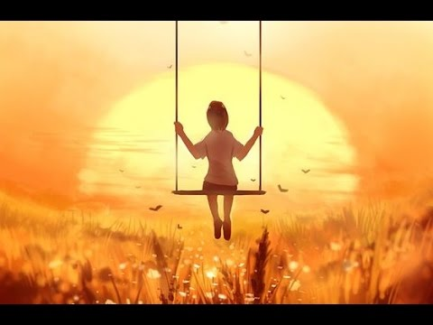
‘Evening’ by Jan Kaczmarek
From the Soundtrack to the film ‘Evening’

In the video above, the only image which is shown to accompany the music is that of a child, sitting on a swing, watching the sun go down or, perhaps, the sun rise. The child, therefore, is a witness to the beginning, or the ending of the day. (S)he observes the passing of time, as the minutes and hours of the day mark the end of one twenty-four period, a day, and the beginning of a new day.
Time, therefore, is a human construct by which we track, measure, or watch how all things are in a constant state of coming into being and passing away. Nothing is exempt from this process of change, development, growth, and decay. All phenomena are in a state of flux; everything, from the microscopic level to the macroscopic level of the cosmos, is subject to change. Ultimately, therefore, nothing is permanent.
As I watch the above video and listen to the music, the image brings to mind the recent extremely high temperatures which millions throughout the world have experienced in recent weeks, together with the wildfires which drought has brought. The image, therefore, can be regarded as being a most potent image. Although it is an image of a child on a swing, it can also be interpreted as the child witnessing what is taking place with climate change and global heating. The image, therefore, is a reminder of the tasks ahead; what needs to be done as a matter of urgency, working diligently and effectively towards net zero.
The ecological, philosophical, and spiritual vision of Thomas berry and related thinkers and activists reminds us of the importance of urgently developing new ways of seeing and being in which radical transformations in economics, ecology, science, technology, business, commerce, and education, for example, are needed to avoid a worsening present and a devastating future.
In these challenging times in which we are living, we can discern the places and spaces, the communities, and the creatives from all walks of life who point us to new ways of living, ways which encourage, inspire, and nurture us to see the world anew. This is the task of the Great Work which beckons us to a new future.

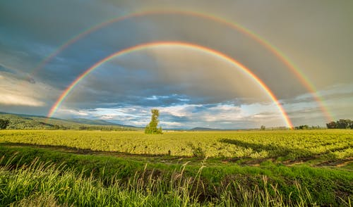
Photograph by James Wheeler
www.pexels.com

